

Public-Private Investment Splits in North of England: The Net Zero Scenario

Technical Report – June 2024

Final report – August 2023



Cambridge Econometrics’ mission is to provide clear and useful insights, based on rigorous and independent economic analysis, to address the complex challenges facing society.

www.camecon.com

Cambridge Econometrics Limited is owned by a charitable body, the Cambridge Trust for New Thinking in Economics.

www.neweconomicthinking.org

Contributors

Adam Brown

[alb@camecon.com](mailto:alb@camecon.com)

Jen Dicks

[jd@camecon.com](mailto:jd@camecon.com)

(Cambridge Econometrics)

Authors

Ornella Dellaccio [od@camecon.com](mailto:od@camecon.com)

Yshabella Reyes [yr@camecon.com](mailto:yr@camecon.com)   
(Cambridge Econometrics)

Contact person

Adam Brown

[alb@camecon.com](mailto:alb@camecon.com)

Project director

Adam Brown

[alb@camecon.com](mailto:alb@camecon.com)

Contents

1. Background and Aim of the Study 2

2. Energy 3

3. Built Environment 5

4. Transport 7

5. Industry 10

6. Land 12

7. Conclusions 14

8. References 16

# Background and Aim of the Study

In 2023 Cambridge Econometrics produced a set of modelled scenarios describing the future evolution of the North of England between 2025 and 2050 (Cambridge Econometrics, 2023). To do this, we took investment figures from the UK Government’s “Build Back Greener” Net Zero plan (HM Government, 2021) for each component of Net Zero, broadly described as: Energy, Built Environment, Transport, Industry, and Land. We then distributed these figures over the 25-year period with a suitable ramp-up phase and estimated, using a range of heuristics, how much of this investment would be spent in the North of England and into which of its economic sectors.

The resulting figures were used as input for the “Net Zero” scenario in our Local Economy Forecasting Model (LEFM), and as a component of the later “New Transformational” Scenario, which brought in other policy elements. The outputs of the modelling estimated the investment’s economic and social impacts over time, including impact on GDP, employment, productivity, wages, etc., as well as the environmental impacts in terms of reduced emissions. As part of this work, we also calculated the public-private share of investment for each Net Zero component. Although this wasn’t required as a model input, it was necessary for estimating public cost and thus Benefit-Cost Ratios (BCR) for the scenario. This allows us to understand the extent to which investments would “pay for themselves” over the long run.

Given time and resource constraints, we applied the Proportionality Principle: we broadly estimated the likely necessary public sector contributions into individual sub-components of each decarbonisation (e.g. costs of grid upgrading, or incentives for heat pump rollout) and then added these together to give an overall estimate of the public sector contribution. This approach is deliberately conservative to avoid overplaying the economic impacts and BCR. The final figure estimated was a 45:55 public to private ratio, or expressed another way, a 1.22 leverage ratio (for every £ the public sector invested, the private sector would invest £1.22).

The aim of this new study is to re-examine these assumptions in considerably more detail, by examining both the overall public-private split and the split over time. This will not affect the overall scale of the investment required or the sectors involved, and so will not impact the model results, the economic impact estimated for the North of England, or the pathway to Net Zero. However, it will impact the likely estimated cost to the public sector and resulting BCR.

In the following sections we discuss the evidence for each of the five broad decarbonisation areas in turn, and then conclude by using these updated estimates to provide an overall estimate of public-private sector investment ratios.

# Energy

## Evidence Reviewed

In 2019 net UK greenhouse gas (GHG) emissions from the energy sector reached 58 MtCO2e, accounting for 11% of total net UK GHG emissions (DESNZ, 2022). Achieving a net zero energy sector, as highlighted in the Net Zero Strategy (DESNZ, 2022), requires substantial decarbonisation of the power sector through a shift from the use of fossil fuels towards low carbon energy generation. Specifically, decarbonisation of the energy sector entails upscaling renewable energy capacity, upgrading the UK electricity network (including transmission and distribution infrastructure), and the development of supporting technologies, including: nuclear, power Carbon Capture and Utilisation Storage (CCUS), interconnectors, electricity storage, and demand-side response mechanisms.

To fully decarbonise the power sector at the required pace, both public and private investments need to be raised. Given the scale of investments required to develop a decarbonised power system and the current pressure on public finances, leveraging private investments is essential to achieve net zero goals in this sector in an efficient and timely way.

Based on figures from the UK Office for Budget Responsibility (OBR), Energy UK & Oxford Economics (2023) approximate that in the UK over 70% of clean energy investment will have to come from the private sector, whilst the remaining 30% will be covered by public finances.

**Figure 1:** Estimated Sources of Finance from IEA (left) and IRENA (right) Studies

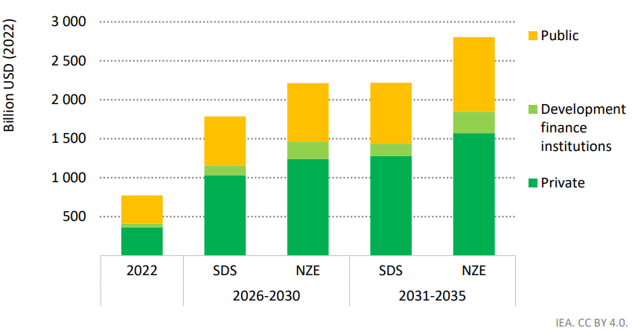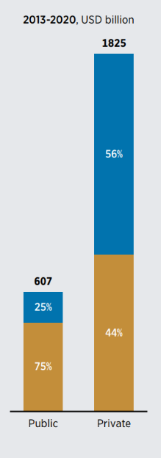

Sources: Left: IEA, (2022); Right: IRENA (2023)

Likewise, a global study conducted by the International Energy Agency (IEA) shows that the majority of financing needs in the energy sector are expected to be met by the private sector (IEA, 2022). In a “Net Zero Emissions by 2050” scenario private investments are expected to account for 62% of the necessary investments between 2025 and 2035 (IEA, 2022). As illustrated in Figure 1., this suggests an accelerated growth rate in private investment.

Shifting the focus to renewable energy capacity, data from the International Renewable Energy Agency illustrates that the private sector is the primary contributor to global investments in this field, accounting for approximately 75% of the total from 2013 to 2020 (IRENA, 2023), this is shown in Figure 1. The share of public versus private investments varies by context and technology. Typically, lower shares of public finance are devoted to renewable energy technologies that are commercially viable and highly competitive, which makes them attractive for private investors.

For example, in 2020 83% of investment in solar PV came from private finance, meanwhile geothermal and hydropower relied mostly on public finance; only 32% and 3% of investments in these technologies, respectively, came from private investors in 2020 (IRENA, 2023).

## Key Takeaways

Every data source examined for the energy sector highlights the significant role of private investment in meeting the required funding to decarbonise the energy sector. For the context of this study, we expect public and private investments to account for 30% and 70% of the required investments, respectively, as stated by Energy UK & Oxford Economics (2023). Whilst other data sources present comparable figures, we deem it crucial to reference a UK-specific source. Moreover, the chosen data source provides a holistic view of the energy sector, rather than concentrating solely on individual components.

**Of the £10bn pa of investments in the energy sector allocated to the North of England, we assume £3bn is public investment (primarily in direct funding of national energy generation and supporting low-income households in the energy transition) and £7bn is private investment.**

# Built Environment

## Evidence Reviewed

According to the Net Zero Strategy (DESNZ, 2022), the UK has around 30 million buildings and includes some of the oldest building stock in Europe. Overall, buildings account for approximately 17% of total UK greenhouse gas emissions, with the majority of these emissions stemming from heating systems. When considering the emissions from producing the energy used for heating buildings, the overall emissions related to the built environment reach about 21% of all UK emissions (DESNZ, 2022). Decarbonising the UK building sector will require phasing out polluting heating systems, and replacing them with clean heating technologies, improving the fabric efficiency of both residential and commercial buildings.

Given the scale of the decarbonisation challenge and the relatively short timeframe available to deploy efficiency improvements in the built environment sector, both public and private finances will need to be raised to ensure net zero goals are achieved in a timely manner. Fabric efficiency and replacement of polluting heating systems can be expected to account for around 80% of investments in the sector, with the remaining 20% referring to efficiency appliances (UNFCC, 2022).

However, efforts to decarbonise the built environment sector in the UK are significantly off track. The UK has recorded the lowest number of heat pumps installed per capita in 2022 compared to neighbouring countries (CCC, 2023), this is partly attributable to the fact that, due to their high upfront costs, only a minority of homeowners can afford the installations of energy efficiency measures (Citizens Advise, 2023). Therefore, it will be crucial for the UK Government to accelerate initial investments in retrofits and clean heating technologies, in order to leverage further private resources. Alongside financial incentive, the UK Government is expected to leverage further private finance through the role of regulation, namely, mandating energy efficiency standards and phasing out polluting heating systems.

When considering the residential built environment sector, the Energy Efficiency Infrastructure Group (EEIG, 2019) has estimated that public investment will play a crucial role in ensuring that individuals with the least ability to pay can afford the transition to greener and warmer buildings, while also leveraging substantial private funds. They claim that in order to achieve net zero goals, additional public capital investments of £1.7bn should be allocated to fully support low-income households in the net-zero challenge within the built environment sector. Furthermore, an additional £3.5bn is expected to be raised from private investments, particularly from private landlords and those able to pay. This results in a 1:2 ratio for public to private investments. In other words, it can be expected that 33% of the investment will be covered by the UK government, while 67% will be contributed by households and businesses, this is illustrated in Figure 2.

**Figure 2:** Evidence Reviewed on Public and Private Finances in the UK (left) and in Eurasia (right)

Sources: Left: EEIG (2019); Right: UNFCC (2022)

There are limited studies specifically on commercial buildings, but it would be expected that the public sector covers the cost of decarbonising public buildings. When considering both residential and commercial buildings, as illustrated in Figure 2., currently in Eurasia the majority of financing for buildings retrofits comes from households and businesses, which either own the buildings or carry out retrofits on behalf of other building owners. In the years leading up to 2050, private funds are expected to remain the most significant financing sources, and the relative public versus private investment split is expected to remain the same at about 20% to 80% (UNFCC, 2019).

Further examples from Europe show that France’s zero interest loan for home energy improvements is costing €40 million in interest rate subsidy over the lifetime of loans issued in 2016 and has supported €400 million of additional private investment – a ratio of 1 to 10. Similarly in Germany in 2016, the federal cost of interest rate subsidy for renovation loans issued through the KfW bank and associated capital subsidies amounted to €1.7bn and drove €10.1bn in energy renovation that year – a ratio of 1 to 6 (EEIG, 2019).

## Key Takeaways

The evidence reviewed, both in the UK and international context, shows that the bulk of the required investments in the built environment sector will be carried out by the private sector. Specifically, it can be expected that 33% of residential investment will be covered by the UK government, while households and businesses contribute the remaining 67%. For commercial buildings, we estimate that the public sector will only cover 20%, with building owners expected to cover the remaining 80%.

**£3bn pa in investment in the built environment sector is allocated to the North of England. Of this, we expect £0.8bn to be covered by public investments (primarily in decarbonising public buildings and supporting low-income households in the transition to green buildings) and the remaining 2bn is expected from private investment.**

# Transport

## Evidence Reviewed

Domestic road transport is accountable for the largest share of UK greenhouse gas emissions of any sector across the economy, according to the Net Zero Strategy (DESNZ, 2022). The majority of these emissions (55%) are associated with passenger cars, contributing 68 MtCO2, followed by heavy goods vehicles and light goods vehicles contributing 19 MtCO2e (16%) and 19 MtCO2e (16%), respectively. The remaining emissions in domestic shipping, rail, and domestic aviation contribute a combined further 16 MtCO2e (13%) (DESNZ, 2022).

Decarbonising the UK transport sector requires efforts to phase out traditional vehicles and replace them with a more efficient electric fleet. It also involves enhancing the infrastructure for public transport (i.e., bus, rail) and active travel facilities, as well as supporting a shift from fossil fuel usage towards low-carbon fuels. Both public and private finances will need to be mobilised to ensure the transport sector achieves its decarbonisation objectives in a timely manner. However, the public versus private investment split in this sector is expected to vary substantially, depending on whether the investment is targeted at constructing and upgrading the transport infrastructure, or whether it is aimed at decarbonising other components of the sector, such as vehicle fleet and fuel switching:

* Building and upgrading the existing public and active **transport infrastructure**, ranging from bus, rail, walking, and cycling facilities, is crucial to ensure technological development progresses at pace in these subsectors. Our reviews show that investments in public and active transport infrastructure are expected to be raised almost entirely from the public sector. As illustrated in Figure 3., around 77% of the required transport infrastructure investment will be covered by public finances from 2022 onwards, with the remaining 23% raised through public-private partnerships (House of Commons, 2023 & Infrastructure and Projects Authority, 2021). Similarly, a previous study shows that from 2016 onwards public funds accounted for 90% of total infrastructure investments (Figure 3.). At a global level, the World Bank reports that 88% of transport infrastructure projects are typically covered by public finances, including central governments and state-owned enterprises, with most of the investments directed to railway and road infrastructure (World Bank, 2017).
* **Non-infrastructure investment** refers to the deployment of an electric vehicle (EV) fleet and the related EV chargers, fuel switching, and development of Lo-Carbon solution for aviation and maritime transport. It has been estimated that between 2022 and 2040 around 86% of the required investment in these subsectors will be covered by private finance, with the remaining 14% instead funded by government (UNFCC, 2022). In this context, public investment will play a crucial role in accelerating the adoption of green transport technologies and ensuring that low-income households are supported in the transition to a decarbonised transport sector, along with enhanced access to public transport.

When specifically considering investments in EV chargers in Europe, although current public investment is estimated to cover approximately 44% of the required needs between 2025 and 2050, this contribution is expected to decrease to an average of 24% as investment grows to an attractive size and government involvement drops off (UNFC, 2022). It follows that the remaining 76% of required investment in EV infrastructure in Europe is covered by private investment (UNFCC, 2022). As a matter of fact, corporations and commercial financial institutions are expected to take a greater role in addressing the required investment need. Households and businesses are expected to cover most of the required investment to purchase electric passenger vehicles and trucks, while being supported by loans from financial institutions. Similarly, corporations instead are expected to invest directly on greener technology for aviation and maritime transport.

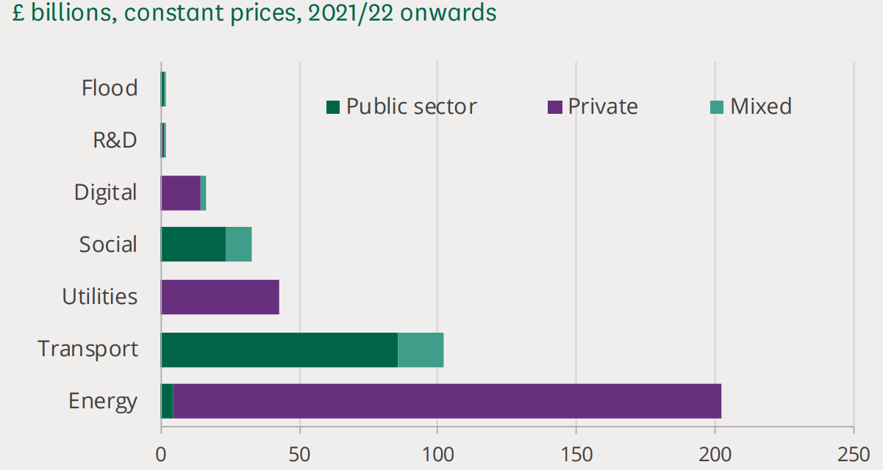**Figure 3:** Funding Mix Transport Infrastructure in the UK according to House of Commons (above) and Institute for Government (below)

## Key Takeaways

The Sixth Carbon Budget from the Climate Change Committee (2020) indicates that, on average, 15% of the investment in the transport sector will be dedicated to the construction and enhancement of essential infrastructure. The remaining 75% will be directed towards efforts to decarbonise various modes of transport, including trains, buses and aviation (Climate Change Committee, 2020). After reviewing the evidence, we have determined that an accurate split of public-private investment in the transport sector can be inferred by averaging the reviewed public-private investment splits. The average is then weighted according to the volume of investments needed for infrastructure and non-infrastructure investments.

Investment in transport infrastructure has been predominantly driven by public finances, accounting for 77% of the total with the remaining 23% funded by private capital, according to the latest data from the UK (House of Commons, 2023). In addition, the financial requirements for the adoption of electric vehicles and fuel switching are projected to be covered primarily by private capital (86%), with public finances contributing the remaining 14% (UNFCC, 2022). Consequently, when considering the transport sector as a whole, the sources of investments are estimated to be 30% public and 70% private.

**We assume that £4bn pa investments in the transport sector are allocated to the North of England, of which £1.2bn is public investments (primarily in upgrading public and active transport infrastructure at the required scale and pace) and £2.8bn is private investment.**

# Industry

## Evidence Reviewed

In the UK, industrial sectors produce 16% (72 Mt CO2e) of UK emissions and around half of these emissions are concentrated in industrial clusters. The Industrial Decarbonisation Strategy (BEIS & DESNZ, 2021) sets out how the manufacturing industry should seek to shift away from fossil fuel sources of energy, adopt carbon capture and storage technologies, and make efficient use of energy and materials, including how materials are used, repaired and recycled. However, the adoption of these abatement measures represents an economic burden for firms. A report by Frontier Economics for E3G and WWF suggests that whilst the government could help fund abatement measures, the manufacturing and construction sectors, among others, would require most of its decarbonisation investment to come from the private sector (Frontier Economics, 2022). Specifically regarding Manufacturing and Construction industries, the report identified that abatement measures like fuel switching to hydrogen, electrification, and the adoption of carbon capture and storage would require both capital and revenue support for investors, with the expectation that the majority of funding will come from private sources.

However, our main evidence comes from *The Race to Zero: Net Zero Financing Roadmaps* report, as presented at the UN Climate Change Conference in 2020. In this report, the investments needed to achieve net zero globally by 2050 were set out, and the investment roles and opportunities for private and public actors to drive this transition identified, as shown in Figure 4. The report stated that for the industrial sector globally, around 30% of industry decarbonisation investments could flow from corporations themselves, whilst government financing might support the development of immature technologies through initial co-investment to help commercialise and reduce costs through deployment (Climate Champions, 2021). Following the methodology of this report, it is estimated that the government, including expenditure and funding from development and state-owned financial institutions, would account for 20% of decarbonisation investments, whilst around 80% would come from the private sector[1], which includes: private equity/venture capital, corporations, infrastructure funds, and commercial financial institutions as part of the private sector.

**Figure 4.** Adaptation of Investment Distributions of Race to Zero roadmaps to the UK; Annual bn in USD

## Key Takeaways

By considering the adaptations to the UK context of *The Race to Zero: Net Zero Financing Roadmaps* report, we consider that 20% of investments to decarbonise the industrial sector would come from the public sector, whilst the remaining 80% would come from private investors. Although these figures are not specific to the UK, they are consistent with UK studies (Frontier Economics, 2022) which indicate that most funding would come from the private sector.

**Of the £4bn pa of the investments in the industry sector allocated to the North of England, we assume 20% (£0.8bn) is public investment (primarily to funding publicly owned CCUS and hydrogen infrastructure and grants/tax incentives to accelerate fuel switching) and 80% (£3.2bn pa) from the private sector.**

# Land use

## Evidence Reviewed

The Agriculture, Forestry and Other Land Use sector (AFOLU) is composed of the agriculture sector and the Land Use, Land Use Change and Forestry sector (LULUCF) (Climate and Land Use Alliance, 2014). The agricultural sector is estimated to have been responsible for 11% of greenhouse gas emissions in the UK in 2021, with GHG emissions around 47 MtCO2 (BEIS, 2023). The LULUCF sector had net emissions of 1.1 MtCO2e in 2021 (BEIS, 2023). Achieving the net zero goal for these sectors requires a multifaceted approach, including increasing tree planting, reducing food waste, and cutting down on the consumption of carbon-intensive foods (CCC, 2020). Determining who should bear the greater responsibility for investing in net zero goals and the extent of their intervention creates a dilemma, as there are various actors benefitting from land use and natural resources. Farmers benefit economically from sustainable land use, whilst governments are tasked with ensuring broader societal benefits associated with the sustainable management of natural habitats (i.e., encompassing benefits such as recreational spaces, improved air quality, and flood risk mitigation).

A report by the Climate Change Committee analysing the Sixth Carbon Budget in the UK suggests that measures aimed at reducing land-based emissions in the Balanced Net Zero Pathway[2], such as afforestation, peatland restoration, bioenergy crops, agroforestry, and hedges, are often not cost-effective for farmers or land managers (CCC, 2020). The private costs of these measures tend to outweigh the private benefits and often involve high upfront costs (CCC, 2020). This finding aligns with a United Nations Environment Programme report estimating that total annual finance flows to Nature-based Solutions[3] (NbS) in 2022 were approximately US$200bn [£157 billion], with public finance constituting 82% (US$165 billion) [£129.6 billion] and private finance making up a modest 18% (US$35bn) [£27.4 billion] worldwide (UNEP, 2023).

Furthermore, one of the Glasgow Financial Alliance for Net Zero’s case studies about a forest, mangrove, and peatland restoration project in Central and South America shows that average investment is projected to be approximately 60% from the public sector and 40% from the private sector through a carbon offsetting market, between 2021 and 2040 (UNFCC,2022) (see Figure 5.). In addition, a report made by the UK Infrastructure Bank suggests that only around 10% of total investment in nature will be covered by the private sector between now and 2050 (UKBI, 2022).

**Figure 5**. Evidence Reviewed on Public and Private Finances in the GFANZ Financing Roadmaps

Source: Glasgow Financial Alliance for Net zero.

However, *The Race to Zero: Net Zero Roadmaps* report presents a countervailing viewpoint; it suggests that corporations, including agri-food companies, could actually provide over 50% of global investments and be very active in financing the decarbonisation of agriculture particularly, and that a range of corporates and land owners may invest in nature-based offsets.

## Key Takeaways

Some reports have suggested that slightly more public sector funding would be required than private sector, and other reports have reversed this. Even though we did not find UK specific data sources, by calculating an average of the suggested splits between the public and private sectors in the reviewed literature, on balance we think 50% of investment in decarbonising the land use sector would come from public funding and the remaining 50% from the private sector.

**We assume £1bn pa of investments for decarbonising the land use sector are allocated to the North of England, of which 50% (£0.5bn) is public investment (primarily in directly funding environmental restoration and grants to encourage sustainable land use practices) and the remaining 50% (£0.5 bn, primarily in sustainable agriculture and offsetting) would be private investment.**

# Conclusions

**1**

Energy

**In the energy sector, public investments will constitute 30% of the necessary funding, with the remaining 70% expected to be covered by private investments.** Of the £10bn energy investments allocated to the North of England, £3bn is public investment (primarily in direct funding of renewable energy generation and supporting low-income households in the energy transition) and £7bn is private investments.

footprint of an individual born today in Nigeria

**4**

Industry

**In the industrial sector, public investments will constitute 20% of the necessary funding, with the remaining 80% expected to be covered by private investments.** Of the £4bn pa industry investments allocated in the North of England, 20% (£0.8bn) would come from public funding (primarily to funding publicly owned CCUS and hydrogen infrastructure and grants/tax incentives to accelerate fuel switching), and £3.2bn from private sector.

**3**

Transport

**Investments from public finances will be responsible for 30% of the required investments in the transport sector, while the remaining 70% will be covered by households and businesses.** Assuming £4bn investments in the transport sector are allocated to the North of England, £1.2bn will be covered by public investments (primarily in upgrading the required public and active transport infrastructure at the required scale and pace) and £2.8bn by private funds.

**2**

Built Environment

**Investments from the UK government will account for 20% of the required investments, while households and businesses will cover the remaining 80%.** Of the £3bn investments in the built environment sector allocated to the North of England, £0.8bn is public investment (primarily in decarbonising public buildings and supporting residential adoption of heat pumps) and £3.2bn is private investments.

4

**6**

All Sectors

**Based on the public-private splits identified for each sector of the economy, we estimated that public budget will need to account for the 27% of the investments required to put the UK in a path to net zero, while private funds are expected to cover the remaining 73%.** This outcome is in line with research from the United Nations Climate Change, stating that private actors could provide 70% of the required net zero financing. The remaining 30% can be covered by public and institutional action, helping to realize the full potential of private capital. This equates to a leverage ratio of 1:2.65 – that is for every £1 of government spending, an additional £2.65 of private investment may be expected.

**5**

Land Use

**Public and private investments can each be expected to account for 50% of the required investments respectively.** Of the £1bn pa investments in the North, £0.5bn would be public investment (primarily in direct funding of environmental restoration and grants to encourage sustainable agricultural practices) and around £0.5bn would be covered by the private sector.

# References

BEIS & DESNZ, 2021. Industrial decarbonisation strategy. Available at: [Industrial decarbonisation strategy (accessible webpage) - GOV.UK (www.gov.uk)](https://www.gov.uk/government/publications/industrial-decarbonisation-strategy/industrial-decarbonisation-strategy-accessible-webpage#annex-4-industry-decarbonisation-pathways-technical-annex)

Cambridge Econometrics, 2023: Economic Scenarios for the Northern Powerhouse Independent Economic Review. Available at: [Economic scenarios for the Northern Powerhouse Independent Economic Review (transportforthenorth.com)](https://transportforthenorth.com/wp-content/uploads/Economic-Scenarios-for-the-NPIER-Final-Report-for-Publishing.pdf)

Citizens Advise, 2023. Demand: Net zero. Tackling the barriers to increased homeowner demand for retrofit measures

Climate Change Committee, 2023. Progress towards reaching Net zero in the UK. Available at: [Progress towards reaching Net zero in the UK - Climate Change Committee (theccc.org.uk)](https://www.theccc.org.uk/uk-action-on-climate-change/progress-snapshot/)

Climate Change Committee, 2020. Sixth Carbon Budget. Available at: [Sixth Carbon Budget - Climate Change Committee (theccc.org.uk)](https://www.theccc.org.uk/publication/sixth-carbon-budget/)

Climate Policy Initiative, 2023. Global Landscape of Climate Finance 2023. Available at: [Global-Landscape-of-Climate-Finance-2023.pdf (climatepolicyinitiative.org)](https://www.climatepolicyinitiative.org/wp-content/uploads/2023/11/Global-Landscape-of-Climate-Finance-2023.pdf)

DESNZ, 2021. Net zero Strategy: Building Back Greener. Available at: [Net zero Strategy: Build Back Greener - GOV.UK (www.gov.uk)](https://www.gov.uk/government/publications/net-zero-strategy)

EEIG, 2019. Making energy efficiency a public and private infrastructure investment priority. Available at: [EEIG_NET-ZERO_LITMUS_TEST_2019.pdf (nea.org.uk)](https://www.nea.org.uk/wp-content/uploads/2020/12/EEIG_NET-ZERO_LITMUS_TEST_2019.pdf)

Energy UK & Oxford Economics, 2023. The clean growth gap. How low carbon energy investment can transform the UK. Available at: [Clean-Growth-Gap-How-low-carbon-energy-investment-can-transform-the-UK.pdf (energy-uk.org.uk)](https://www.energy-uk.org.uk/wp-content/uploads/2023/07/Clean-Growth-Gap-How-low-carbon-energy-investment-can-transform-the-UK.pdf)

Frontier Economics, 2022. The UK’s Net zero Investment Gaps. Available at: [Net-zero-investment-gap-22.10.26-Final-STC.pdf (e3g.org)](https://www.e3g.org/wp-content/uploads/Net-zero-investment-gap-22.10.26-Final-STC.pdf)

House of Commons, 2023. Funding for major infrastructure projects. Available at: [CDP-2023-0096.pdf (parliament.uk)](https://researchbriefings.files.parliament.uk/documents/CDP-2023-0096/CDP-2023-0096.pdf)

IEA, 2022. Scaling up Private Finance for Clean Energy in Emerging and Developing Economies. Available at: [Scaling up Private Finance for Clean Energy in EMDEs (iea.blob.core.windows.net)](https://iea.blob.core.windows.net/assets/a48fd497-d479-4d21-8d76-10619ce0a982/ScalingupPrivateFinanceforCleanEnergyinEmergingandDevelopingEconomies.pdf)

Infrastructure and Projects Authority, 2021. Analysis of the National Infrastructure and Construction Pipeline 2021. Available at: [Analysis of the National Infrastructure and Construction Pipeline 2021 (publishing.service.gov.uk)](https://assets.publishing.service.gov.uk/media/613e4d03d3bf7f05b166a595/Analysis_of_the_National_Infrastructure_and_Construction_Pipeline_2021.pdf)

IRENA, 2023. Scaling up energy transition investments to meet the 1.5C goal. Available at: [Detail (irena.org)](https://www.irena.org/Digital-content/Digital-Story/2023/Mar/Scaling-up-energy-transition-investments-to-meet-the-1-point-5-degrees-celsius-goal/detail#:~:text=Globally%2C%20the%20private%20sector%20committed,PV%20came%20from%20private%20finance.)

The Climate Change Committee, 2020. The Sixth Carbon Budget: Agriculture and land use, land use change and forestry. Available at: [Sector-summary-Agriculture-land-use-land-use-change-forestry.pdf (theccc.org.uk)](https://www.theccc.org.uk/wp-content/uploads/2020/12/Sector-summary-Agriculture-land-use-land-use-change-forestry.pdf)

United Nations Environment Programme, 2023. State of Finance for Nature. Available at: [State of Finance for Nature 2023 | UNEP - UN Environment Programme](https://www.unep.org/resources/state-finance-nature-2023).

UNFCC, 2022. Net zero Financing Roadmap. Available at: [Financing Roadmaps (gfanzero.com)](https://www.gfanzero.com/netzerofinancing/)

UK Infrastructure Bank, Our role in Natural Markets. Available at: [Microsoft Word - Natural capital - discussion paper (ukib.org.uk)](https://www.ukib.org.uk/sites/default/files/2022-11/Natural-capital-discussion-paper.pdf)

World Bank, 2017. Who sponsors infrastructure project? Disentangling public and private contributions. Available at: [SPIReport_2017_small_interactive.pdf (worldbank.org)](https://ppi.worldbank.org/content/dam/PPI/documents/SPIReport_2017_small_interactive.pdf)

1. Assuming that the UK no longer has State-owned Enterprises, and Multilateral Climate Funds (MCFs)
2. The Balance Pathway is a scenario for achieving Net Zero emissions in the UK by 2050.
3. Nature-based Solutions are actions to protect, conserve, restore, sustainably use and manage natural or modified terrestrial, freshwater, coastal and marine ecosystems, which address social, economic and environmental challenges effectively and adaptively, while simultaneously providing human well-being, ecosystem services and resilience and biodiversity benefits (United Nations Environment Assembly [UNEA])