Trends in GCSE attainment pre- and post-pandemic by ethnicity, disadvantage, region, and their intersections

Professor George Leckie

Centre for Multilevel Modelling

School of Education

University of Bristol

Wednesday, 23 October 2024

# Foreword by Lord Jim O’Neill

At the Northern Powerhouse Partnership, we have been consistent in our focus on addressing the productivity gap between the North of England and other parts of the country. A key element of this is to ensure that we have the highly skilled workforce we need to deliver the high productivity jobs of the future and that begins with our education system.

Our previous research has focused on the gap in attainment and progress, especially for those from the most disadvantaged backgrounds. A report also produced by Professor George Leckie at Univeristy of Bristol (Leckie and Prior, 2024) showed that when pupil backgrounds are taken into account, London’s high Progress 8 score more than halves and our northern regions ‘narrow the gap’ somewhat. This tells us that the difference in outcomes is not just about the quality of teaching or leadership in schools, but is a result of the societal issues in our more deprived communities, beyond the school gates.

This report analyses the trends in GCSE English and Maths attainment broken down by a number of characteristics but also considers how this has changed since the covid pandemic. It shows that the gap between those eligible for free school meals for four years in a row and those never eligible for free school meals widened by a quarter of a grade per subject between 2019 and 2023. While this is not a purely northern issue as persistent disadvantage is found across the country, the North East has the highest (and a growing) proportion of its pupils in this category.

Northern Powerhouse Partnership has consistently suggested that the government should invest more in early years support for children from disadvantaged families as well as providing additional Pupil Premium from the start of primary school for those from long-term disadvantaged backgrounds. As the Education Policy Institute have also argued, the level of pupil premium has fallen behind in real terms in recent years. We would back their call for uplifting the primary premium from £1,455 to £1,693 per pupil, and for secondary pupils from £1,035 to £1,218. Additionally a long term disadvantage premium of £308 in primary, and £255 in secondary should be introduced. They estimate a total cost of £640 million, which could be funded from the projected £1bn reduction in school funding as the number of primary school children is expected to reduce by 200,000 by 2028/29. We also support the proposal to introduce a new 16-19 pupil premium to support disadvantaged pupils in further education, at a cost of circa £290m.

Allocating additional funds to schools who serve long term deprived children would be helpful to recognising the role that these schools and colleges actually play in tackling issues both inside and beyond the classroom, and could be used as part of a broader shift of celebrating impactful practice in the most challenging contexts.

# Executive Summary

## Context

* Ethnic, economic disadvantage, and regional inequalities in pupil attainment have increased post-pandemic (Education Policy Institute, 2024).
* Each of these inequalities is typically discussed in isolation. However, many pupils experience not one but multiple disadvantages and will therefore have fallen even further behind relative to their multiply advantaged peers. For example, pupils who are not only in lower attaining ethnic groups, buy are also economically disadvantaged, or who live in lower attaining regions will have fallen especially behind versus pupils from higher attaining ethnic groups, who are economically advantaged, and living in the highest attaining regions.
* This report seeks to draw attention to the changing nature of pupil attainment at the end of secondary schooling at the intersections of ethnicity, economic disadvantage, and region. We ask: How have patterns of attainment across ethnic groups and regions played out differently over the pandemic for economically disadvantage pupils relative to their more advantaged peers? Put differently, has the disadvantage gap widened more for some ethnic groups than others or in some regions more than in others?
* As such, we focus on changes in GCSE attainment between 2019 and 2023. We measure GCSE attainment by pupils’ average 9-1 grade in English and Maths GCSE.

## Ethnicity

* There is substantial variation in attainment across ethnic groups. However, the gap between the highest and lowest attaining ethnic groups remained constant across the two years at 4.50 grades.
* Chinese, Indian, then pupils of Any Other Asian Background are the highest attaining groups in both years, while pupils of Unknown, Traveller of Irish Heritage, and Gypsy / Roma ethnicity are the lowest attaining groups in both years.
* In 2019, White British pupils showed the 11th highest attainment out of 19 ethnic groups, but dropped 13th highest in 2023. They were overtaken by Pakistani and Any Other White Background pupils.
* Among those ethnic groups already ahead of White British pupils, Indian, Bangladeshi, and Black African pupils all increased their attainment over White British pupils by 0.30 grades or more. Among those ethnic groups below White British pupils, only White and Black Caribbean and Traveller of Irish Heritage pupils failed to catch up.

## Disadvantage

* Persistent FSM pupils (those eligible for Free School Meals for four years in a row) saw their average attainment fall between 2019 and 2023 by 0.19 grades to an average attainment of just 3.55 grades, almost half a grade below the grade 4 standard pass boundary. Never FSM pupils (those never eligible for FSM) saw their average attainment improve by 0.07 grades to 5.11 grades, a value exceeding the grade 5 strong pass boundary.
* These changes led the disadvantaged gap between Persistent FSM and Never FSM pupils to widen from 1.30 grades in 2019 to 1.56 grades in 2023. Thus, post-pandemic, pupils who experienced long-term disadvantage have fallen even further behind their more advantaged peers.

## Region

* Regional inequalities are far smaller than disadvantage , and especially ethnic inequalities, but are still important.
* Post-pandemic, London remains the highest attaining region and saw the largest increase in average attainment between 2019 and 2023 of 0.15 grades, resulting in an average attainment of 5.27 grades. London is the only region where pupils on average attain a strong pass.
* Only two other regions, the North East and East of England, saw increases in their average attainment and these increases were slight. The remaining five regions saw their average attainment fall.
* The gap between the highest and lowest attaining regions widened from 0.47 grades in 2019 to 0.60 grades in 2023. This widening was principally driven by London pulling further ahead of all other regions.

## Ethnicity and disadvantage

* Among Never FSM pupils, 16 out of 19 ethnic groups, saw their average attainment increase between 2019 and 2023. In contrast, among Persistent FSM pupils, 13 out of 19 ethnic groups saw their average attainment decrease.
* In both 2019 and 2023, Persistent FSM gaps were around three times larger for White Irish, White British, and White groups than they were for Gypsy / Roma, Chinese, and Bangladeshi groups.
* The impact of Persistent FSM in 2023 was generally larger than it was in 2019 and it also became more distinctly worse from the impact of Shorter-Term FSM.
* The Persistent FSM gap widened for all ethnic groups apart from Chinese. The degree to which these gaps widened varied substantially from around 0.10 grades for Black African, White and Asian, and Black Caribbean pupils to 0.60 grades or higher for Any Other Asian Background, Traveller of Irish Heritage, and White Irish pupils.
* 10 out of 19 ethnic groups saw their disadvantage gaps increase by over a quarter of a grade, and four groups saw their gaps increase by over half of a grade.

## Region and disadvantage

* The Persistent FSM gap also widened in every region. The smallest widening was seen in Yorkshire and the Humber where the gap increased by 0.16 grades. The largest widening was seen in London where the gap increased by 0.34 grades.

# Data and Variables

## Data

* We analyse the National Pupil Database (NPD), a census of all pupils in state-maintained schooling in England. We analyse these data via the Office for National Statistics (ONS) Secure Research Service (SRS).

## Sample

* We analyse two cohorts of pupils who took their GCSE examinations in 2019 and 2023, respectively. The 2019 cohort were the last cohort to take their GCSE examinations before the COVID-19 pandemic. There were no examinations in 2020 or 2021. The 2020 Centre Assessed Grades (CAGs) and 2021 Teacher Assessed Grades (TAGs) that were assigned to pupils in lieu of actual examination grades were considerably higher than in normal years (Ofqual, 2024). There were GCSE examinations in 2022, but grades were deliberately generous (Ofqual, 2021). The distribution was set halfway between those assigned in 2020 and 2021 and normal years. The 2023 GCSE examinations are the first “normal” year post-pandemic (Ofqual, 2022). We therefore focus on changes in GCSE attainment between 2019 and 2023.
* We observe 534,567 pupils in the 2019 cohort and 596,194 pupils in the 2023 cohort.

## GCSE Attainment

* We measure GCSE attainment by the average grade pupils attained in their English and maths GCSEs.
* Most pupils take English language and English literature. As with Attainment 8 we record the higher of their two grades as their grade for English.
* GCSEs are scored on a 9-1 scale. This scale was introduced in 2017 and replaced the old A*-G scale. A grade 4 is considered a standard pass, while a grade 5 is considered a strong pass. As some readers will be more familiar with the latter, Table 1 show how the 9-1 scale relates to the old A*-G scale.

Table : Equivalency of the new 9-1 and old A*-G GCSE grade scales

|  |  |
| --- | --- |
| New 9-1 GCSE grade scale | Old A*-G GCSE grade scale |
| 9 | Higher than A* |
| 8 | Mid to high A* |
| 7 | A |
| 6 | High B |
| 5 | High C to Low B (strong pass) |
| 4 | C (standard pass) |
| 3 | D |
| 2 | E |
| 1 | F and G |

* The average grade across two GCSEs also ranges from 0 to 9 but can take half grade values. For example, where a pupil attained a grade 4 in English and a grade 5 in maths their average grade is calculated as 4.5 grades.
* Figure 1 plots the distribution of attainment (average grade in English and Maths GCSE), by year.

Figure : The distribution of attainment by year.

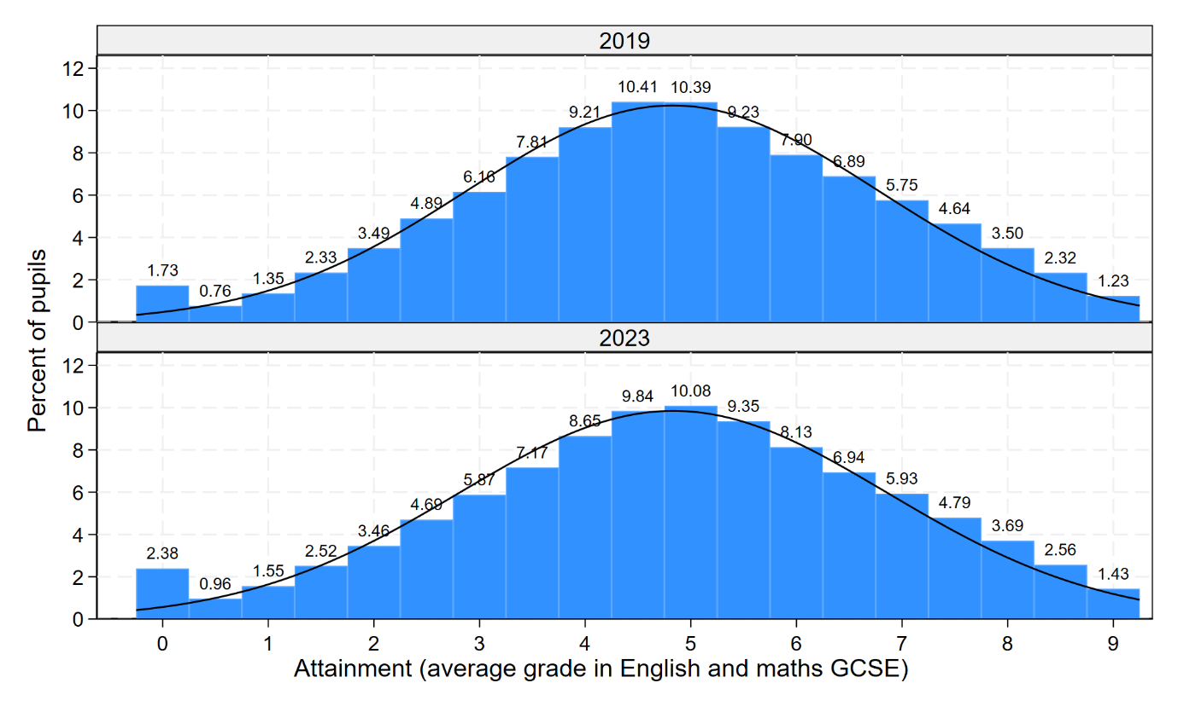

* The attainment distribution is very similar across both 2019 and 2023. The national average attainment was 4.83 grades in both years. The national spread in attainment increased slightly from 1.95 to 2.03 grades between 2019 and 2023. A slightly higher percentage of pupils were recorded with an attainment of 0 In the 2023 cohort (2.38%), compared to the 2019 cohort (1.73%).

## Ethnicity

* We measure ethnicity by 19 ethnic groups: White British, White Irish, Traveller of Irish Heritage, Any Other White Background, Gypsy / Roma, Black Caribbean, Black African, Any Other Black Background, Indian, Pakistani, Bangladeshi, Any Other Asian Background, Chinese, White and Black Caribbean, White and Black African, White and Asian, Any Other Mixed Background, Any Other Ethnic Group, and Unknown.
* These ethnic groups are very similar to those used by the Office for National Statistics (ONS) in the 2021 and earlier censuses. Key differences from the 2021 census are as follows. First, there is no “Arab” group in our data. Second, in our data the separate ONS “Gypsy” and “Roma” groups are recorded as a single combined “Gypsy / Roma” group. Third, in our data the combined ONS “Gypsy and Irish Traveller” group does not appear. The “Gypsy” subgroup appears as part of the “Gypsy / Roma” group in our data while the “Irish Traveller” subgroup is recorded as its own distinct group “Traveller of Irish Heritage” in our data. Last, we define an “Unknown” ethnic group in our data for those pupils’ whose ethnicity is recorded as “Information Not Yet Obtained”, “Refused”, or is otherwise missing. Note that that this “Unknown” group will contain an unknown number of White British pupils as well as pupils from the 17 remaining minority ethnic groups.
* Previous work has identified seven ethnic groups where persistent economic disadvantage has an especially “High Impact” on attainment (Treadaway, 2017): White British, White Irish, Traveller of Irish Heritage, Gypsy / Roma, Black Caribbean, White and Black Caribbean, and Unknown.
* Figure 2 plots the distribution of pupils in 2019 and 2023, by ethnicity. The ethnic groups are sorted by their size in 2019. High Impact ethnic groups are denoted with a * after their labels.

Figure : Distribution of pupils, by ethnicity in 2019 and 2023

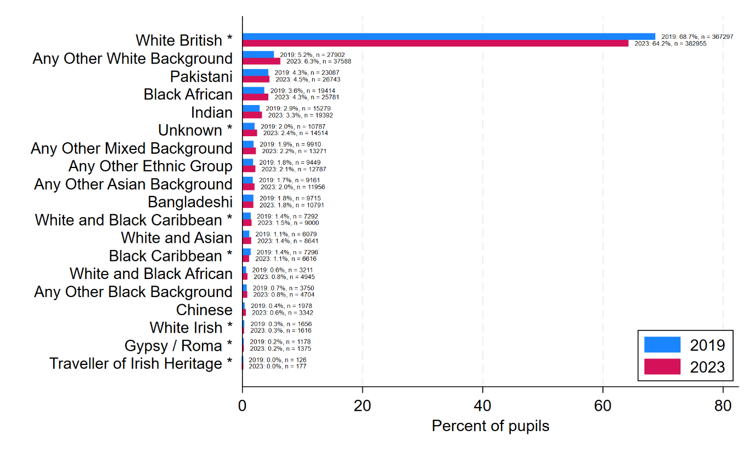

* In the 2019 cohort, 68.7% of pupils were White British. The percentage shares for the 18 minority ethnic groups were small, ranging from 0.0% for Traveller of Irish Heritage pupils (126 pupils) to 5.2% for Any Other White Background pupils.
* In the 2023 cohort, 64.2% of pupils were White British. The percentage shares for the 18 minority ethnic groups ranged from 0.0% for Traveller of Irish Heritage pupils (177 pupils) to 6.3% for Any Other White Background pupils.
* Thus, across the two cohorts, the percentage of White British pupils decreased by 4.5 percentage points from 68.7% to 64.2%, while the percentage of minority pupils increased by 4.5 percentage points from 31.3% to 35.8%.
* The relative distribution of pupils across the 17 minority ethnic groups in 2023 was broadly similar to that in 2019.
* The High Impact ethnic groups are dominated by White British pupils. Of the remaining six High Impact ethnic groups, Unknown, White and Black Caribbean, and Black Caribbean are each sizeable with over 5,000 pupils in each cohort. In contrast White Irish and Gypsy / Roma each only have around 1,500 pupils per cohort, and Traveller of Irish Heritage only around 150 pupils per cohort.

## Disadvantage

* The standard way to measure economic disadvantage in education administrative data is by pupil FSM eligibility, a proxy for low income. FSM eligibility is recorded annually allowing us to distinguish pupils that are eligible for FSM every year from those that are intermittently.
* An important issue, however, is that the definition of FSM eligibility has changed over the period we are analysing leading the percentage of pupils eligible for FSM to increase more than any true increase in poverty. Specifically, the roll out of Universal Credit has led to more pupils being defined as FSM over time than would otherwise have been the case (Education Policy Institute, 2024). Left unchecked, this issue will distort our results when we come to measuring and comparing disadvantage gaps across the 2019 and 2023 cohorts.
* The solution we implement is to define pupil disadvantage using the FSM eligibility data from a common time span: 2016-2019. For the 2023 cohort this corresponds to academic years 8-11. For the 2019 cohort this corresponds to academic years 4 to 7.
* We define those pupils will were never eligible for FSM over these four years as “Never FSM”. We define those pupils that were eligible for one to three years as “Shorter-Term FSM”, and those pupils who were eligible in all four years as “Persistent FSM”.
* Figure 3 presents the distribution of pupils in 2019 and 2023 by their disadvantage status.

Figure : Distribution of pupils, by disadvantage in 2019 and 2023

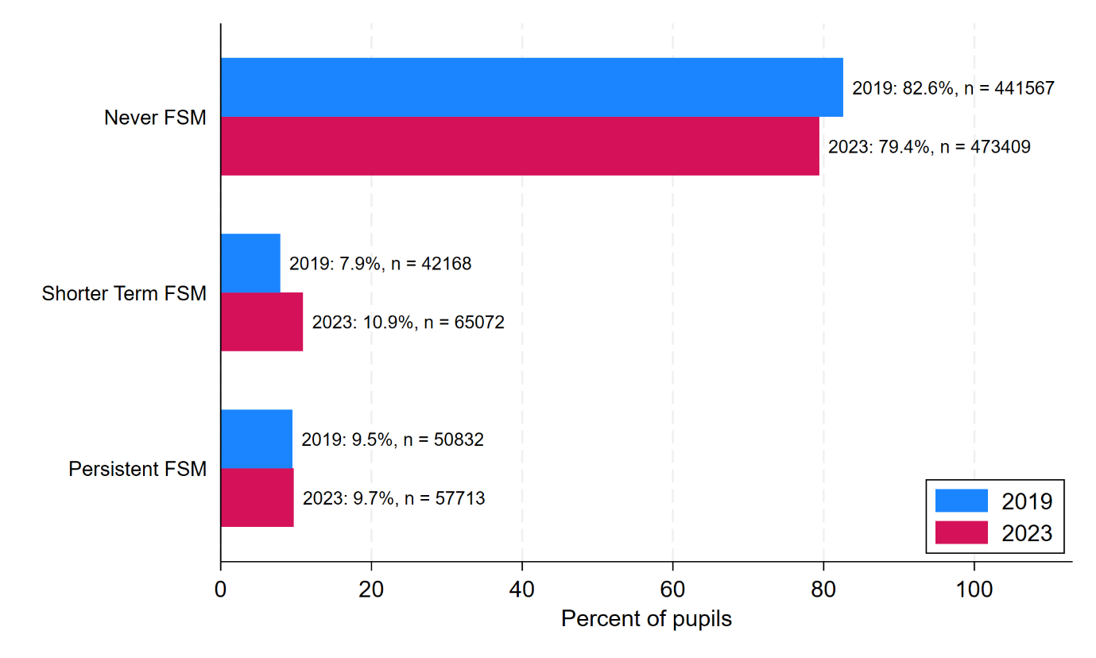

* In the 2019 cohort, 82.6% of pupils were Never FSM, 7.9% were Shorter-Term FSM, and 9.5% were Persistent FSM.
* In the 2023 cohort, 79.4% of pupils were Never FSM, 10.9% were Shorter-Term FSM, and 9.7% were Persistent FSM.
* Thus, across the two cohorts, there is some indication that the 2023 cohort was somewhat poorer as evidenced by a slightly higher percentage of pupils classified as Persistent FSM and a higher percentage of pupils classified as Shorter-Term FSM.
* See Figure 29 in the Appendix for the version of this figure where we instead define disadvantage using pupils’ FSM eligibility over the final four years of secondary schooling: academic years 8-11. The 2019 cohort are still defined on the 2016-2019 data, but the 2023 cohort are now defined on the 2019-2023 data. The figure suggests a much higher percentage of Persistent FSM pupils in 2023 at 16.7% (compared to the 9.7% shown in Figure 3). Thus, defining disadvantage using pupils’ FSM eligibility over the final four years of secondary schooling naively suggests that there has been a large increase in the percentage share of long term disadvantage pupils between the two cohorts, but as we have shown here, this higher rate is nearly all an artefact of the changing FSM eligibility requirements in recent years.

## Region

* We measure geography by the nine government office regions: North East, North West, Yorkshire and the Humber, East Midlands, West Midlands, East of England, London, South East, and South West. Figure 4 presents the distribution of pupils in 2019 and 2023 by region. The regions are sorted by their size in 2019.

Figure : Distribution of pupils, by region in 2019 and 2023

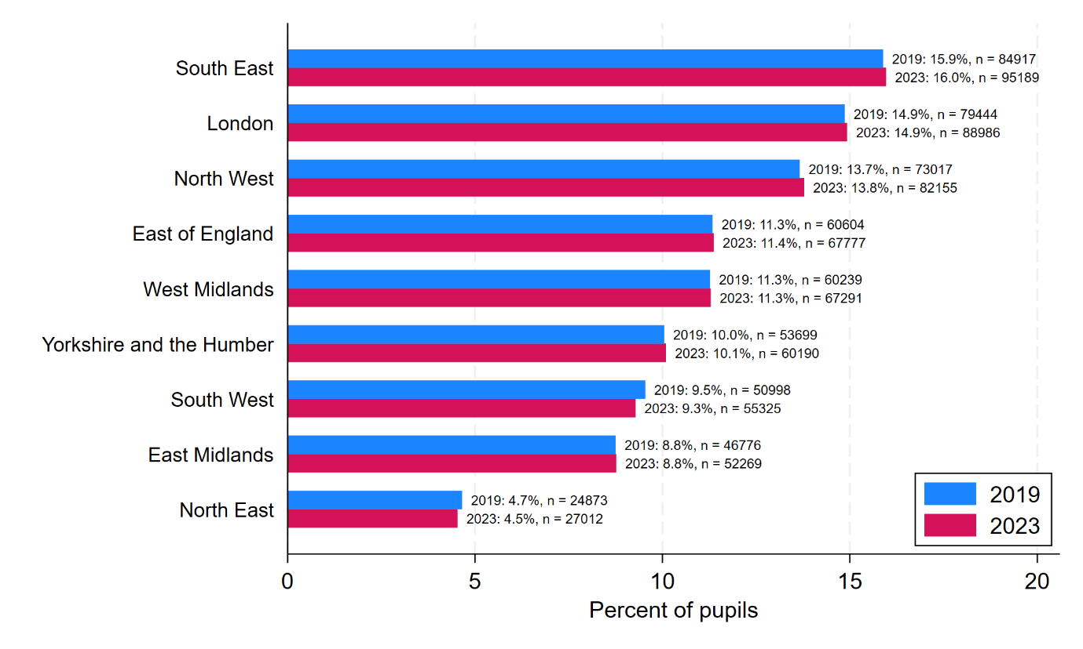

* In the 2019 cohort, the percentage of pupils residing in the nine regions of England ranged from a low of 4.7% in the North East to a high of 15.9% in the South East.
* We see effectively the same percentage shares in the 2023 cohort.
* Thus, the distribution of pupils residing across the nine regions was largely unchanged across the two cohorts.

## Ethnicity and disadvantage

* Some ethnic groups are poorer than others. Figure 5 presents the distribution of disadvantage pupils in 2019 and 2023 by ethnicity. High Impact ethnic groups are denoted with a * after their labels. The bars show the percentage share of Never FSM, Shorter-Term FSM, and Persistent FSM pupils in each year within each ethnic group. The ethnic groups are sorted by their percentage share of Persistent FSM pupils in 2019.

Figure : The distribution of pupils by disadvantage in each ethnic group in 2019 and 2023

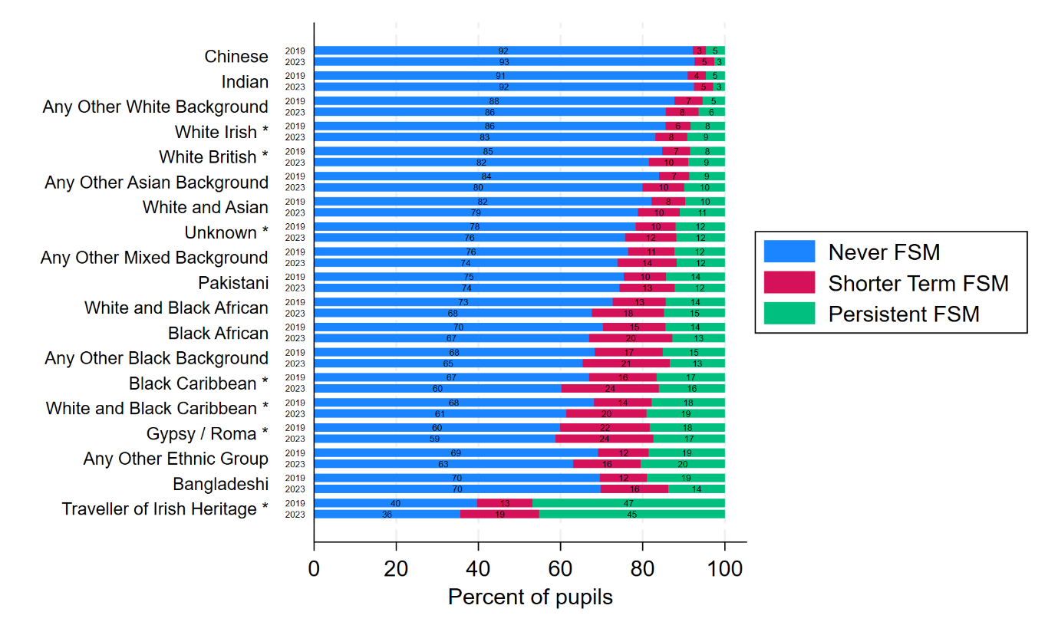

* In the 2019 cohort, 8% of White British pupils were Persistent FSM. This percentage ranged from 3% among Chinese pupils to 47% among Traveller of Irish Heritage pupils. The latter is especially high. The next highest ethnic group was Bangladeshi pupils whose percentage Persistent FSM was less than half this at 19%.
* In terms of Never FSM, In the 2019 cohort, 85% of White British pupils were Never FSM. This percentage ranged from 92% among Chinese pupils to 40% among Traveller of Irish Heritage pupils. The latter is again especially high. The next highest ethnic group was Gypsy / Roma pupils whose percentage Never FSM was 60%.
* The patterns for the 2023 cohort are similar to those for the 2019 cohort.
* An important point to note is that mean income associated with Never FSM, Shorter-Term FSM, and Persistent FSM will vary across the ethnic groups, especially among the Never FSM. That is, for some ethnic groups, the mean income of the Never FSM is notably higher than it is for other ethnic groups. This also means that the difference in mean income between the Persistent FSM and Never FSM will also vary across the ethnic groups. These points should be borne in mind when interpreting the results in this report.

## Region and ethnicity

* Regions differ in their ethnic composition. Figure 6 presents the distribution of disadvantage pupils in 2019 and 2023 by ethnicity. High Impact ethnic groups are denoted with a * after their labels. The regions are sorted by their percentage of White British pupils in 2019

Figure : The distribution of pupils by ethnicity in each region in 2019 and 2023

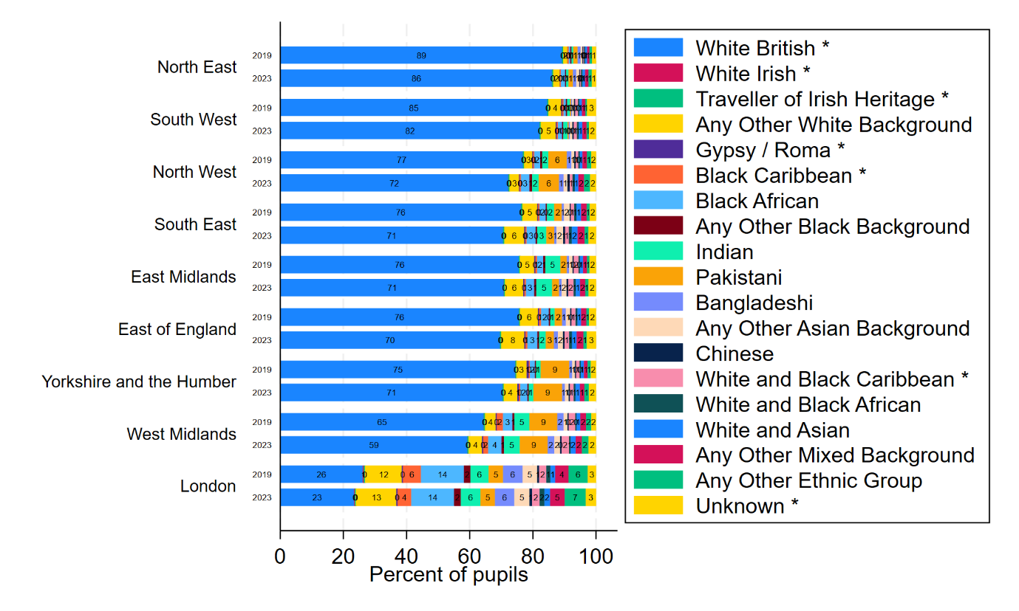

* In the 2019 cohort, the percentage of White British pupils ranges from 26% in London to 89% in the North East.
* An important point to note is that the differential composition of ethnic groups across the regions is part of the explanation for why some regions perform higher than others. In particular, the higher average attainment seen in London is in part attributed to the much higher percentage shares it has of high attaining ethnic minority groups than in other regions. The so-called “London effect” (Department for Education, 2020).
* By 2023, the percentage of White British students had dropped in every region.
* Figure 7 presents the distribution of ethnicity in 2019 and 2023 by region excluding White British. This allows us to she the percentage share of each minority ethnic group in each region. The regions are presented in their standard ordering.

Figure : The distribution of pupils by ethnicity in each region in 2019 and 2023 excluding White British

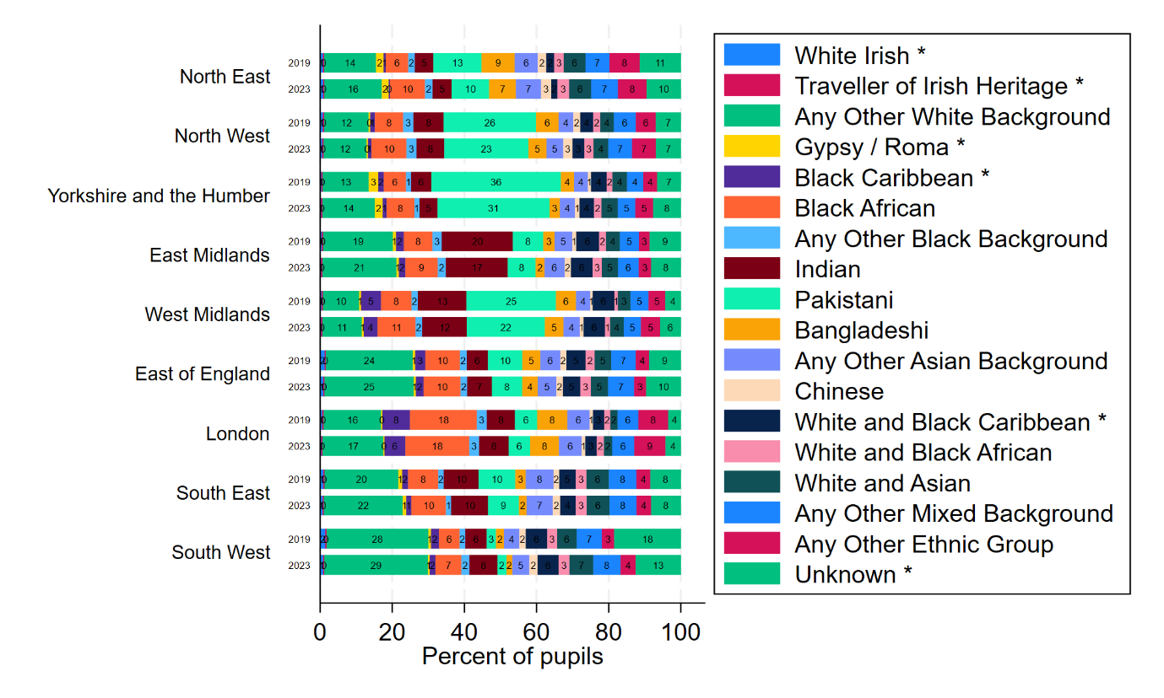

* The percentage shares of Any Other Whit Background pupils are highest in East of England and South West. The percentage of Black African pupils is highest in London. The percentage shares of Indian pupils are highest East Midlands followed by the West Midlands. The percentage share of Pakistani pupils highest in Yorkshire and the Humber, followed by North West and West Midlands.
* Figure 30 in the Appendix presents the distribution of regions in 2019 and 2023 by ethnicity. This allows one to see where in England each ethnic group is geographically concentrated.

## Region and disadvantage

* Some regions are poorer than others. Figure 5 presents the distribution of disadvantage pupils in 2019 and 2023 by region. The bars show the percentage share of Never FSM, Shorter-Term FSM, and Persistent FSM pupils in each year within each region. The regions are sorted by their percentage share of Persistent FSM pupils in 2019.

Figure : The distribution of pupils by disadvantage in each region in 2019 and 2023

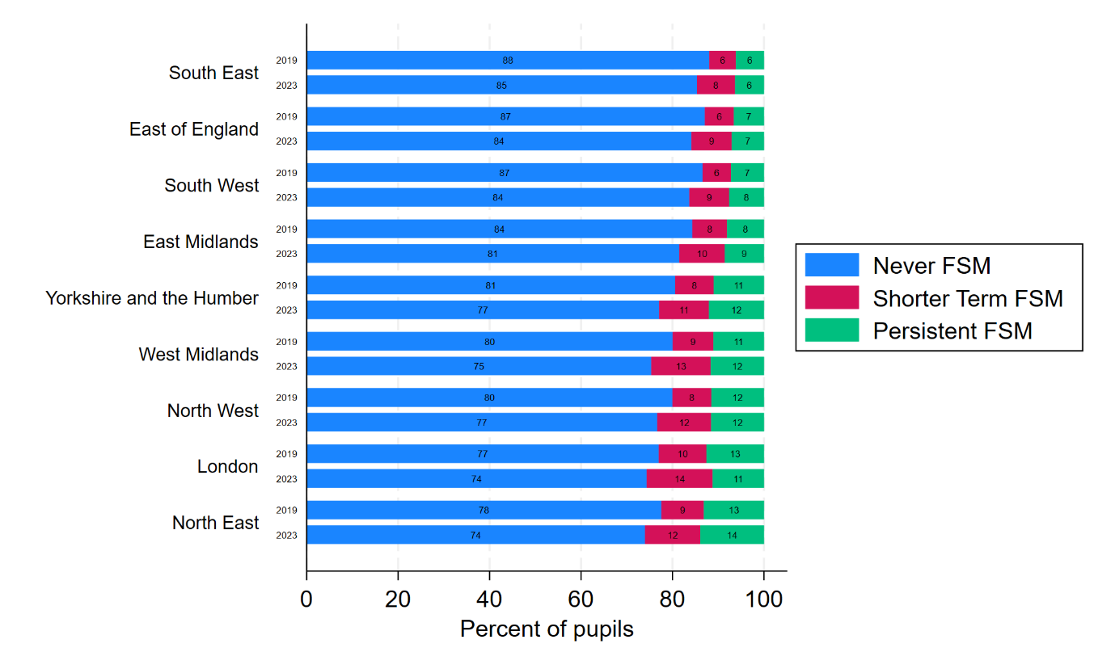

* In the 2019 cohort, the percentage of Persistent FSM ranged from 6% in the South East to 13% in London and the North East.
* The patterns for the 2023 cohort are similar to those for the 2019 cohort.
* An important point to note is that mean income associated with Never FSM, Shorter-Term FSM, and Persistent FSM will vary across the regions, especially among the Never FSM. That is, for some regions, the mean income of the Never FSM is notably higher than it is for other regions. This also means that the difference in mean income between the Persistent FSM and Never FSM will also vary across the regions. These points should be borne in mind when interpreting the results in this report.

# Ethnicity

* In this section, we first report average attainment in 2019 and 2023 by ethnicity. We then report change in average attainment across the two years by ethnicity. Next, we report ethnic attainment gaps in 2019 and 2023 relative to White British pupils in each year. Last we report how these ethnic attainment gaps changed over time.

## Attainment

* Figure 9 presents average attainment in 2019 and 2023 by ethnicity. The ethnic groups are sorted by their average attainment in 2019. High Impact ethnic groups are denoted with a * after their labels.

Figure : Average attainment in 2019 and 2023 by ethnicity.

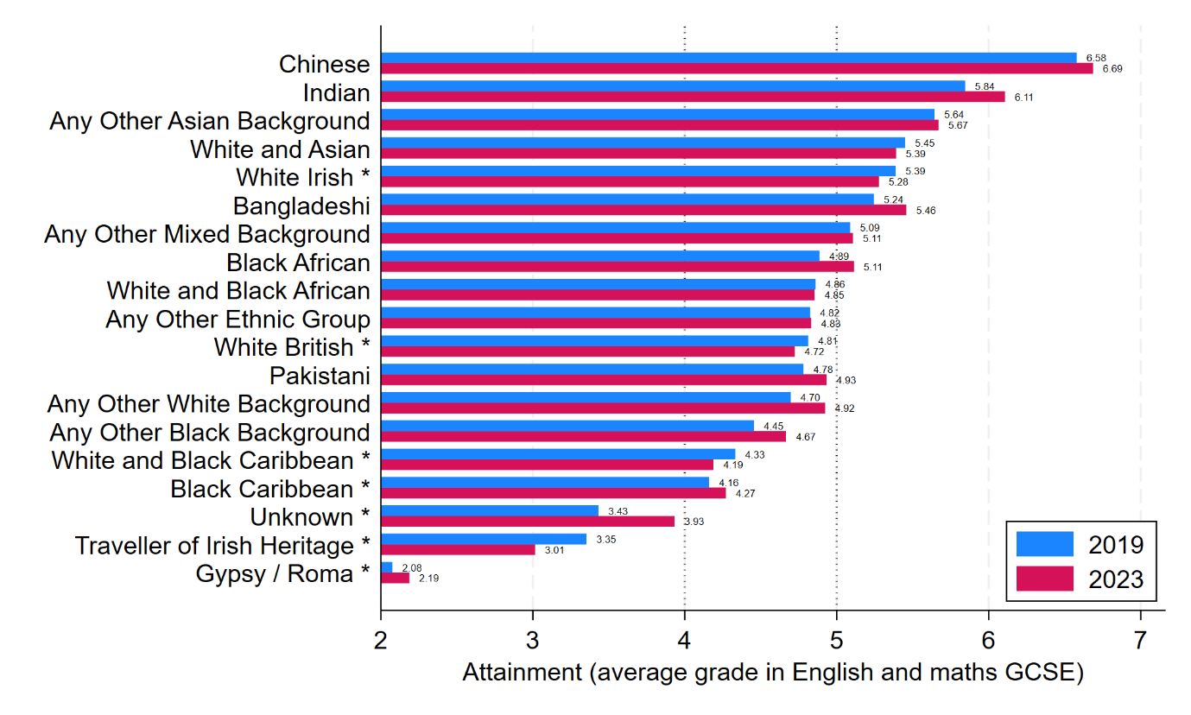

* In the 2019 cohort, average attainment for White British pupils was 4.81 grades and ranged from a low of 2.08 grades for Gypsy / Roma pupils to a high of 6.58 grades for Chinese pupils, a range of 4.50 grades.
* In the 2023 cohort, average attainment for White British pupils was 4.72 grades and ranged from a low of 2.19 grades for Gypsy / Roma pupils to a high of 6.69 grades for Chinese pupils, a range of 4.50 grades.
* Average attainment exceeded a grade 5 (strong pass) in both cohorts in the top seven ethnic groups (Chinese, Indian, Any Other Asian Background, White and Asian, White Irish, Bangladeshi, Any Other Mixed Background), but was less than a grade 4 (standard pass) in the bottom three ethnic groups (Unknown, Traveller of Irish Heritage, Gypsy / Roma).
* White British were ranked 11th highest out of 18 on average attainment in the 2019 cohort, dropping to 13th highest out of 18 in 2023. They were overtaken by Pakistani and Any Other White Background.
* The High Impact ethnicities attained notably lower than other ethnic groups. Indeed, the five lowest scoring ethnic groups in both years are all High Impact ethnic groups. White Irish was the only High Impact ethnic group whose average attainment exceeded a grade 5 (strong pass) in both cohorts.

## Changes in attainment

* Figure 10 presents change in average attainment between 2019 and 2023 by ethnicity. High Impact ethnic groups are denoted with a * after their labels.

Figure : Change in average attainment between 2019 and 2023 by ethnicity.

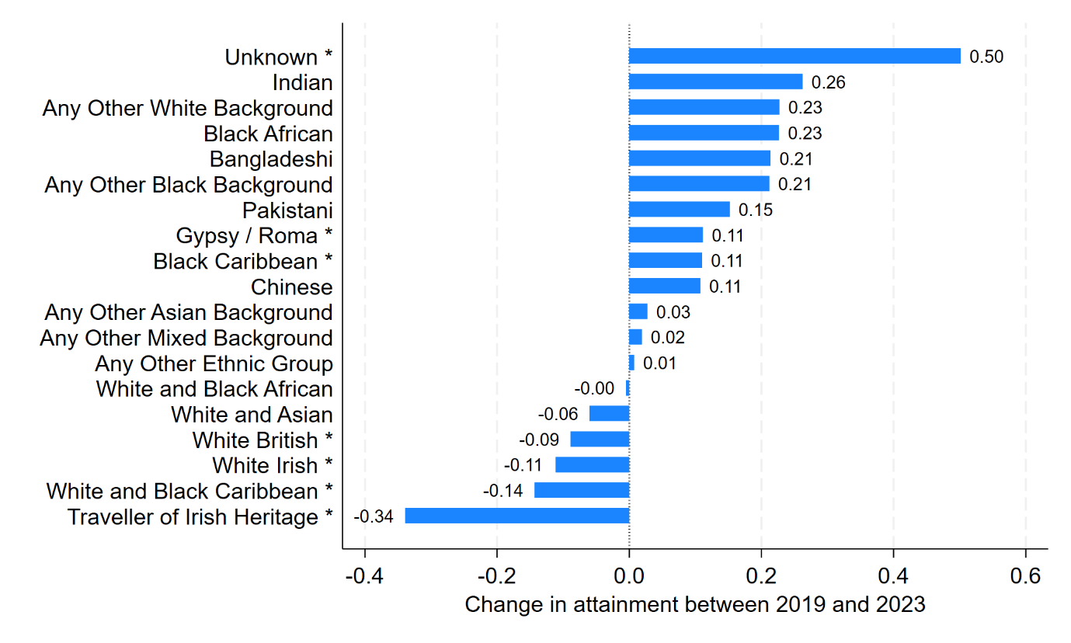

* The change in average attainment ranged from a decrease of 0.34 grades for Traveller of Irish Heritage pupils (from 3.35 to 3.01) to an improvement of 0.50 grades for Unknown pupils (from 3.43 to 3.93).
* The majority of ethnic groups (13 out of 19 groups) increased their average attainment between 2019 and 2023.
* This was not the case, however, for White British pupils whose average attainment decreased by 0.09 grades. More generally, four out of the seven High Impact ethnic groups saw their average attainment drop.
* The large average improvement made by Unknown pupils of 0.5 grades may reflect a change in the composition of the unknown ethnic groups that make up that category to a higher attaining mix.

## Attainment gaps

* We define ethnic attainment gaps relative to White British. Specifically, we define ethnic attainment gaps as the average attainment of each minority ethnic group minus the average attainment of the majority White British ethnic group. A positive gap meant that average attainment is higher for that ethnic group relative to White British pupils, while a negative gap means that average attainment is lower for that ethnic group relative to White British pupils.
* Figure 11 presents ethnic attainment gaps relative to White British in 2019 and 2023. The ethnic groups are sorted by their attainment gap in 2019. High Impact ethnic groups are denoted with a * after their labels.

Figure : Ethnic attainment gaps relative to White British in 2019 and 2023

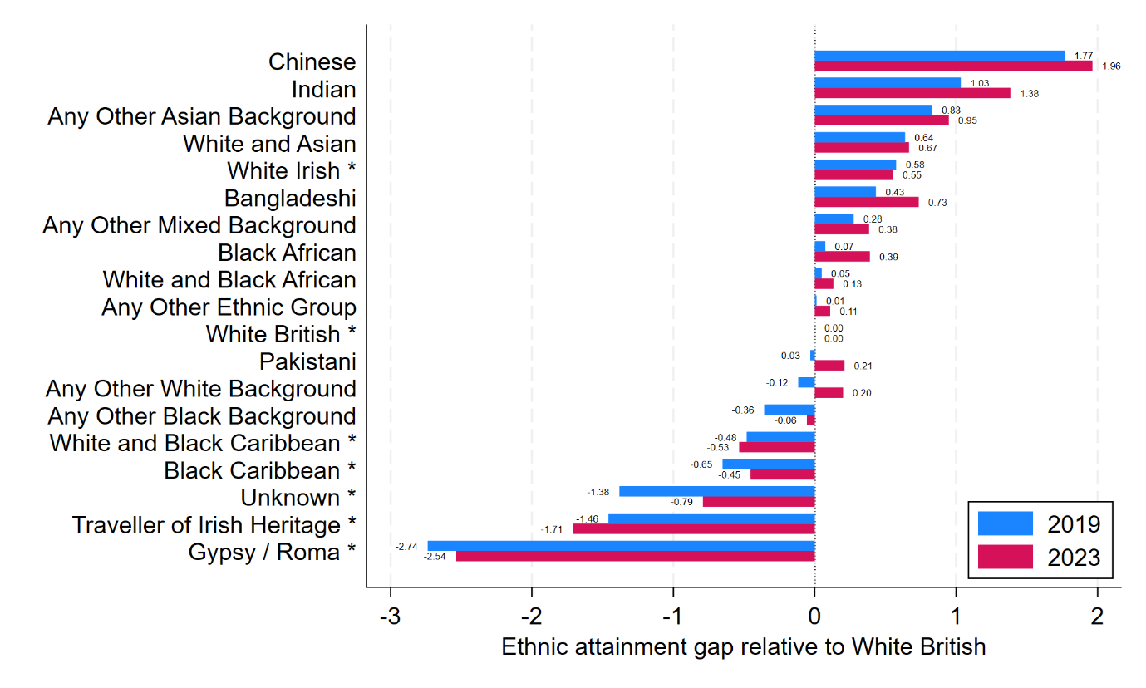

* In the 2019 cohort, ethnic attainment gaps ranged from Gypsy / Roma pupils being -2.74 grades behind White British pupils to Chinese pupils being 1.77 grades ahead of White British pupils.
* By the time of the 2023 cohort, the gap between Gypsy / Roma and White British pupils had narrowed slightly to 2.54 grades, but the gap between Chinese and White British pupils had widened to 1.96 grades.

## Change in attainment gaps

* We define the change in each ethnic attainment gap between 2019 and 2023 as the ethnic attainment gap in 2023 minus the ethnic attainment gap in 2019.
* Figure 12 presents change in ethnic attainment gaps between 2019 and 2023. High Impact ethnic groups are denoted with a * after their labels. This Figure should be read in consultation with Figure 11 as to interpret the magnitude of the change in the ethnic attainment gap, one needs to note what the gap was in each year.

Figure : Change in ethnic attainment gaps between 2019 and 2023.

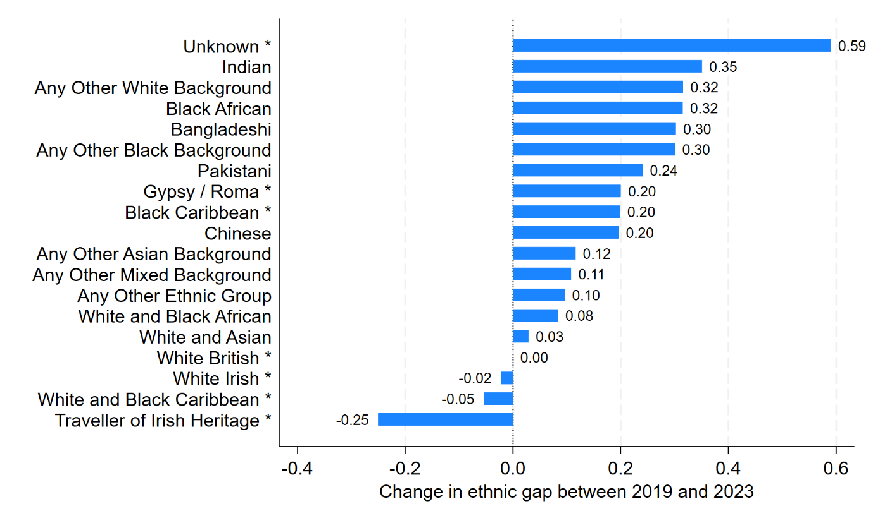

* Between 2019 and 2023, the Unknown attainment gap narrowed by 0.59 grades from Unknown pupils being 1.38 grades behind White British pupils in 2019 to being 0.79 grades behind in 2023.
* Between 2019 and 2023, the Indian attainment gap widened by 0.35 grades from Indian pupils being 1.03 grades ahead of White British pupils in 2019 to 1.38 grades ahead in 2023.
* Between 2019 and 2023, the Any Other White Background attainment gap changed by 0.32 grades from Any Other White Background pupils being behind by 0.12 grades behind White British pupils in 2019 to being 0.20 grades ahead in 2023.
* At the other end of the distribution, between 2019 and 2023, the Traveller of Irish Heritage gap widened by 0.25 grades from Traveller of Irish Heritage pupils being 1.46 grades behind White British pupils in 2019 to 1.71 grades behind in 2023.

# Disadvantage

In this section, we first report average attainment in 2019 and 2023 by disadvantage. We then report change in average attainment across the two years by disadvantage. Next, we report disadvantage attainment gaps in 2019 and 2023 relative to Never FSM pupils in each year. Last we report how these disadvantage attainment gaps changed over time.

## Attainment

* Figure 13 presents average attainment in 2019 and 2023 by disadvantage.

Figure : Average attainment in 2019 and 2023 by disadvantage.

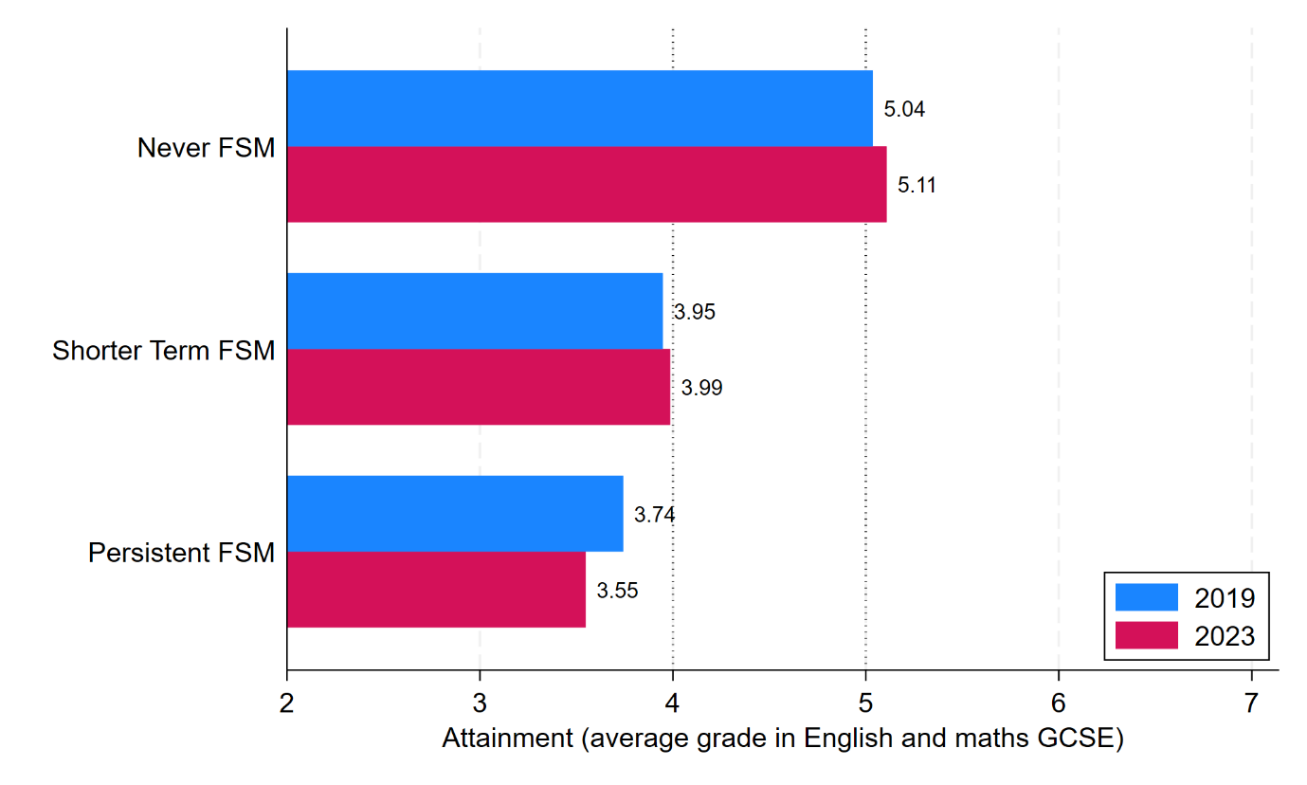

* In the 2019 cohort, average attainment ranged from a low of 3.74 grades for Persistent FSM pupils to a high of 5.04 grades for Never FSM pupils, a range of 1.30 grades.
* In the 2023 cohort, average attainment ranged from a low of 3.55 grades for Persistent FSM pupils to a high of 5.11 grades for Never FSM pupils, a range of 1.56 grades.
* In both cohorts, the average attainment of Shorter-Term FSM pupils lies between that for Persistent FSM and Never FSM, but is much closer to the former.
* On average, Never FSM pupils attained a strong pass (Grade 5) in both years, Shorter-Term FSM pupils almost attained a standard pass (Grade 4), but Persistent FSM pupils attained a quarter to a half a grade lower than a standard pass.
* Inequalities with respect to disadvantaged pupils have widened from 2019 to 2023. Persistent FSM pupils have gone backwards (their average attainment has dropped from 3.74 to 3.55 grades), while Never FSM pupils have gone forwards (their average attainment has increased from 5.04 to 5.11 grades).

## Changes in attainment

* Figure 14 presents change in average attainment between 2019 and 2023 by disadvantage.

Figure : Change in average attainment between 2019 and 2023 by disadvantage.

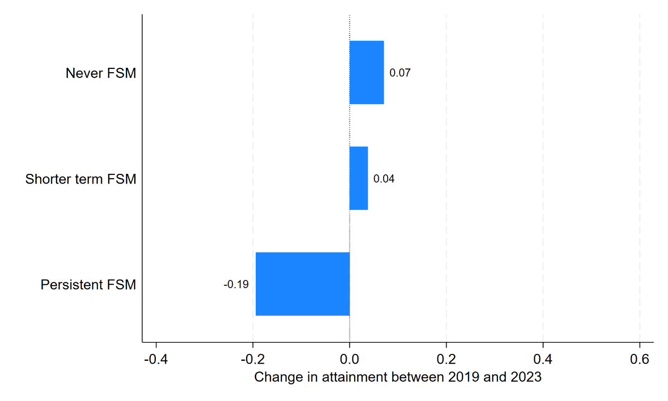

* The change in average attainment ranged from a decrease of 0.19 grades for Persistent FSM pupils (from 3.74 to 3.55) to an increase of 0.07 grades for Never FSM pupils (from 5.04 to 5.11).

## Attainment gaps

* Figure 15 presents disadvantage attainment gaps relative to Never FSM in 2019 and 2023.

Figure : Disadvantage attainment gaps relative to Never FSM in 2019 and 2023.

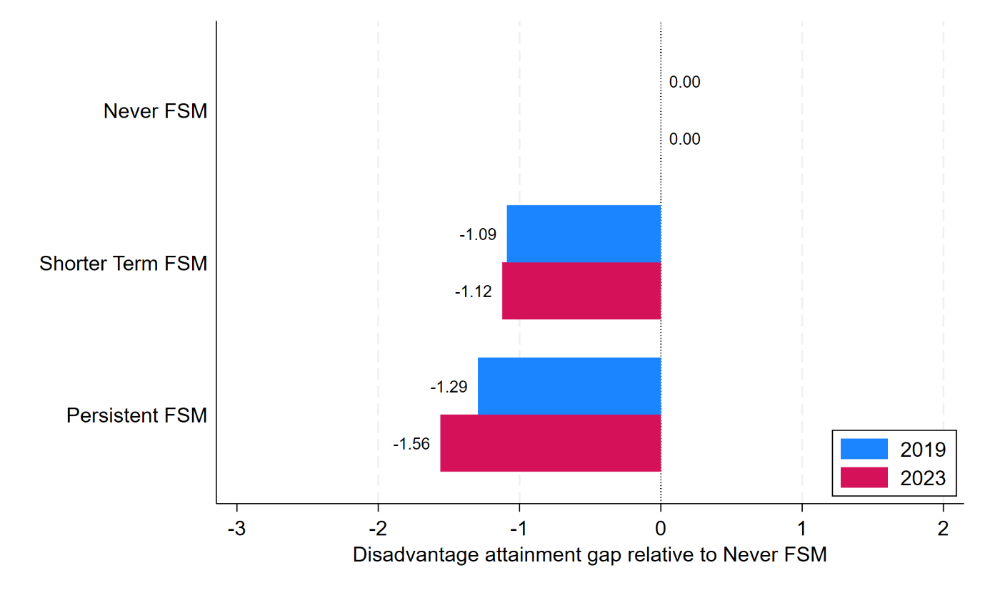

* In the 2019 cohort, Shorter-Term FSM pupils were 1.09 grades behind Never FSM pupils, while Persistent FSM pupils were 1.29 grades behind Never FSM pupils.
* By the time of the 2023 cohort, these disadvantaged attainment gaps had widened such that Shorter-Term FSM pupils were now 1.12 grades behind Never FSM pupils (an increase of 0.03 grades) while Persistent FSM pupils were 1.56 grades behind Never FSM pupils (an increase of 0.44 grades).
* Thus, the disadvantage achievement gap has widened over time, especially for those who are Persistent FSM.

## Change in attainment gaps

* We define the change in each disadvantage attainment gap between 2019 and 2023 as the disadvantage attainment gap in 2023 minus the disadvantage attainment gap in 2019.
* Figure 16 presents change in disadvantage attainment gaps between 2019 and 2023. This Figure should be read in consultation with Figure 15 as to interpret the magnitude of the change in the disadvantage attainment gap, one needs to note what the gap was in each year.

Figure : Change in disadvantage attainment gaps between 2019 and 2023.

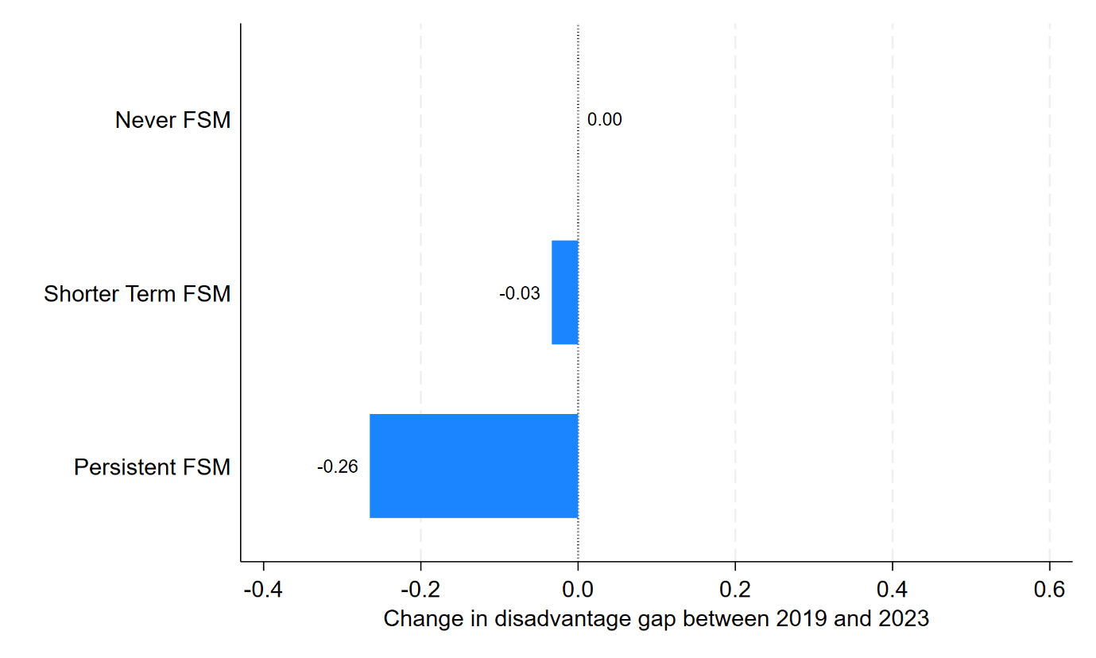

* The Shorter-Term FSM gap has widened over time by 0.03 grades (from -1.09 to -1.12), while the Persistent FSM gap has widened by 0.26 grades (from -1.29 to -1.56).

# Region

In this section, we first report average attainment in 2019 and 2023 by region. We then report change in average attainment across the two years by region. Next, we report regional attainment gaps in 2019 and 2023 relative to London pupils in each year. Last we report how these regional attainment gaps changed over time.

## Attainment

* Figure 17 presents average attainment in 2019 and 2023 by region. The regions are sorted by their average attainment in 2019.

Figure : Average attainment in 2019 and 2023 by region.

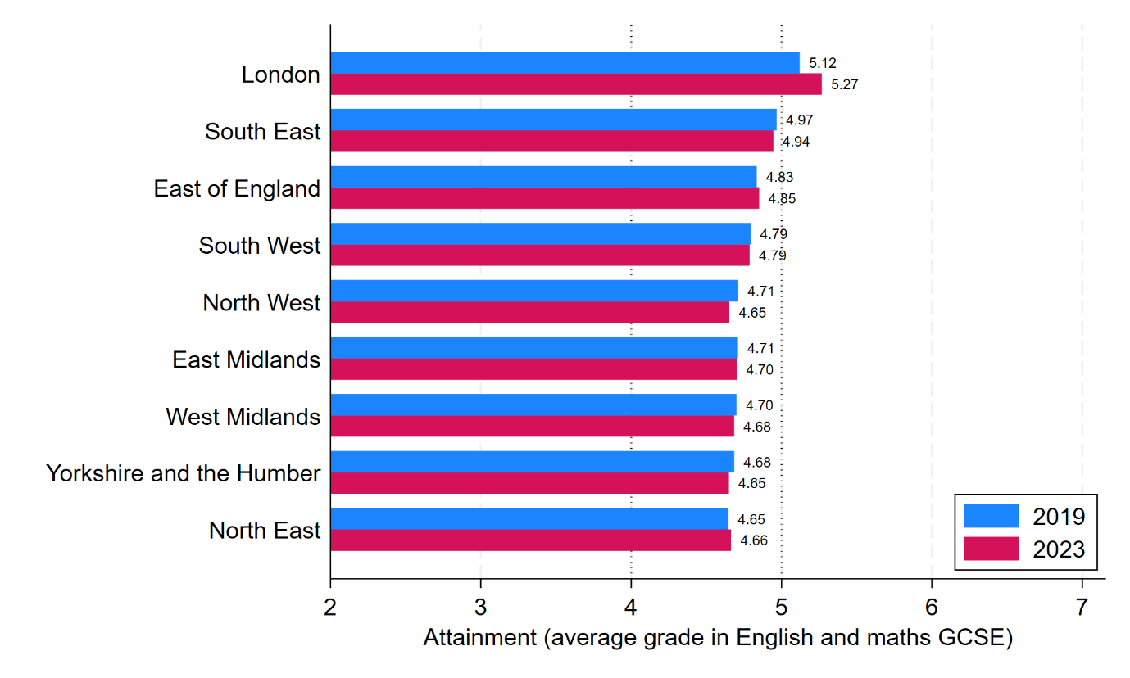

* In the 2019 cohort, average attainment ranged from 4.65 grades in the North East to 5.12 grades in London, a range of 0.47 grades.
* In the 2023 cohort, average attainment ranged from 4.65 grades in Yorkshire and the Humber to 5.27 grades in London, a range of 0.61 grades.
* On average, only pupils in London attained a strong pass (Grade 5) in both years. The most notable change also relates to London where average attainment increased by 0.15 grades from 5.12 to 5.27 grades.
* The range in average attainment across regions (0.47 and 0.61 grades in 2019 and 2023) is far less than it is across ethnicity (4.50 and 4.50) or disadvantaged (1.30 and 1.56), however it has still increased.

## Changes in attainment

* Figure 18 presents change in average attainment between 2019 and 2023 by region.

Figure : Change in average attainment between 2019 and 2023 by region. 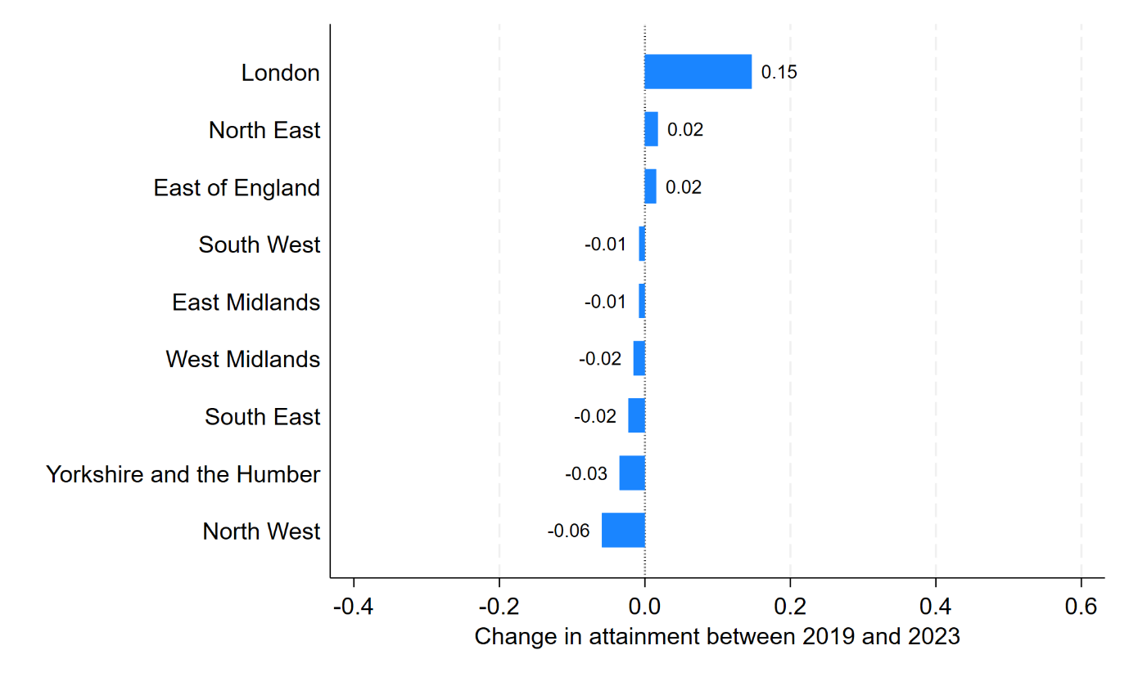

* The change in average attainment ranged from a decrease of 0.06 grades for pupils in the North West (from 4.71 to 4.65) to an improvement of 0.15 grades for pupils in London (from 5.12 to 5.27).
* London pupils improved their average attainment by 0.15 grades between 2019 and 2023, notably more than the two closest regions, the North East and East of England which each improved their average attainment by just 0.02 grades. All other regions saw their average attainment worsen by between 0.01 grades in the South West and East Midlands and 0.06 grades in the North West. Thus, London pulled away from all other regions.

## Attainment gaps

* Figure 19 presents regional attainment gaps relative to London in 2019 and 2023.

Figure : Regional attainment gaps relative to London in 2019 and 2023.

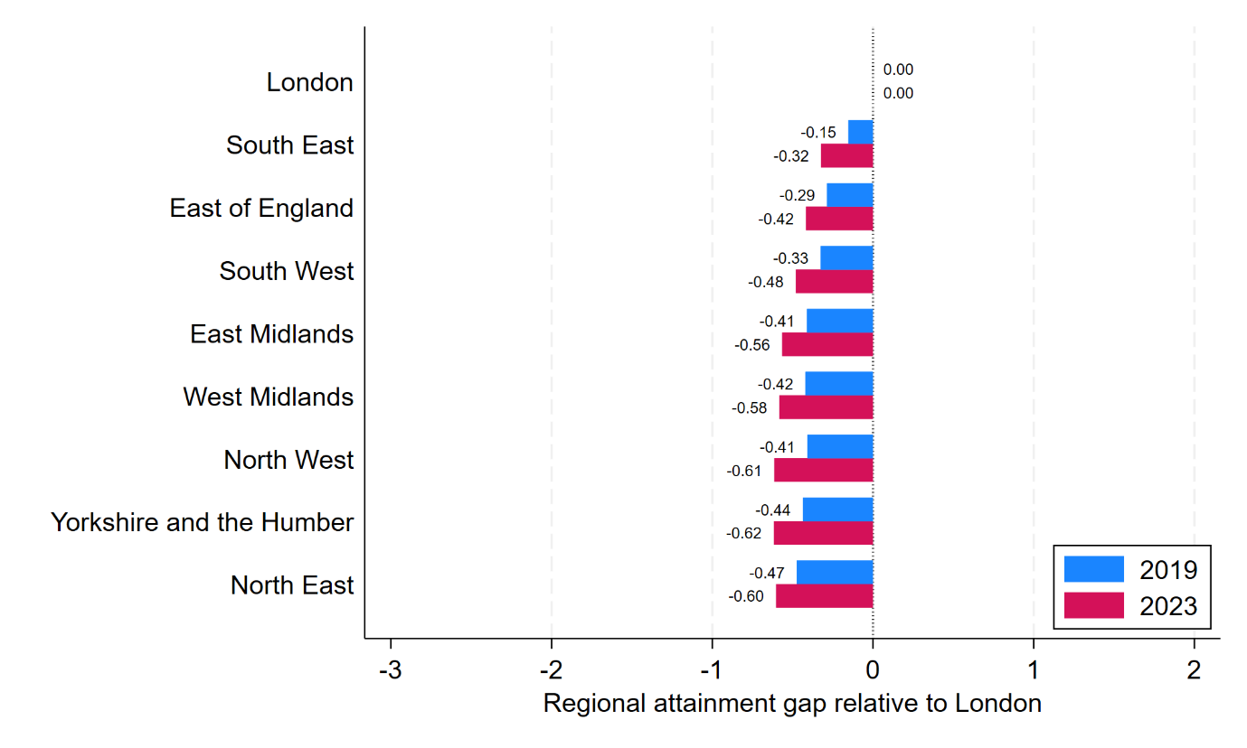

* In the 2019 cohort, regional attainment gaps relative to London ranged from pupils being on average 0.15 grades behind in the South East to 0.47 grades behind in the North East. Thus, every region lagged behind London.
* By the time of the 2023 cohort, regional attainment gaps relative to London had widened to range from 0.32 grades behind in the South East to 0.62 grades behind Yorkshire and the Humber.

## Change in attainment gaps

* We define the change in each regional attainment gap between 2019 and 2023 as the regional attainment gap in 2023 minus the regional attainment gap in 2019.
* Figure 20 presents change in regional attainment gaps between 2019 and 2023. This Figure should be read in consultation with Figure 19 as to interpret the magnitude of the change in the regional attainment gap, one needs to note what the gap was in each year.

Figure : Change in regional attainment gaps between 2019 and 2023.

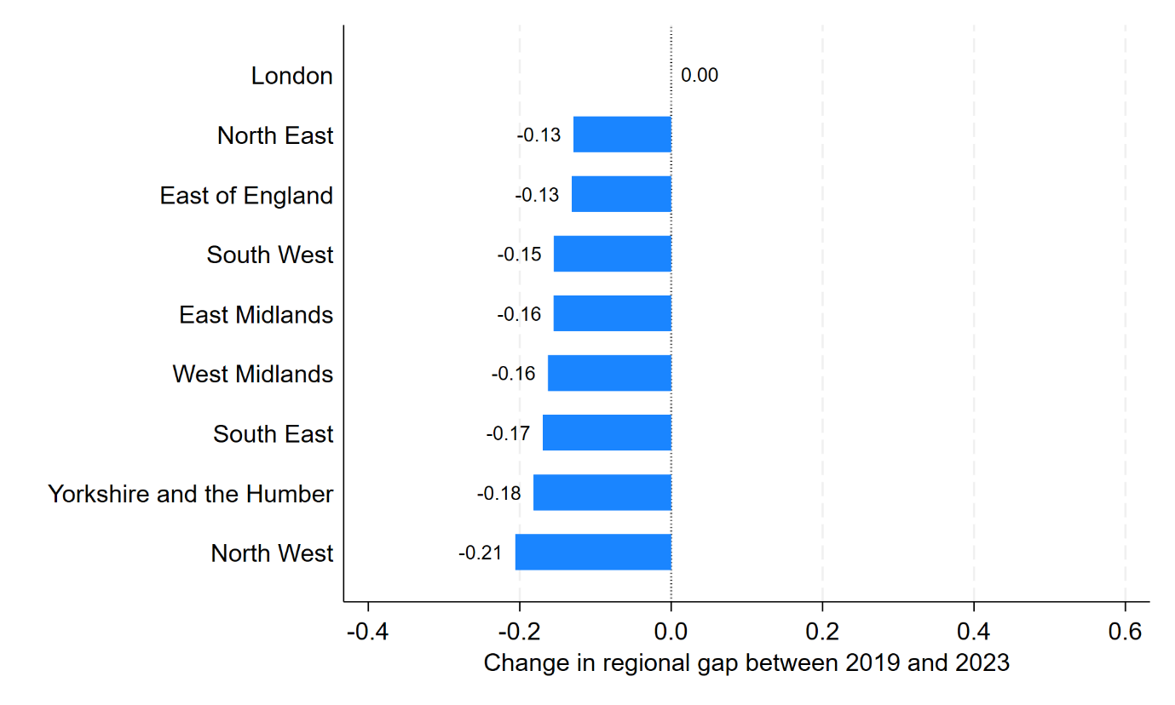

* Regional gaps widened over time by between 0.13 grades (from -0.47 to -0.60) in the North East and 0.21 grades in the North West (from -0.41 to -0.61).

# Ethnicity and disadvantage

In this section, we first report average attainment in 2019 and 2023 by ethnicity and disadvantage. We then report change in average attainment across the two years by ethnicity and disadvantage. Next, we report Persistent FSM and Shorter-Term disadvantage attainment gaps in 2019 and 2023 relative to Non FSM pupils in each year by ethnicity. Last, we report how these disadvantage attainment gaps changed over time by ethnicity.

## Attainment

* Figure 21 presents average attainment in 2019 and 2023 by ethnicity and disadvantage. The ethnic groups are sorted by their average attainment for Never FSM pupils in 2019. High Impact ethnic groups are denoted with a * after their labels.

Figure : Average attainment in 2019 and 2023 by ethnicity and disadvantage.

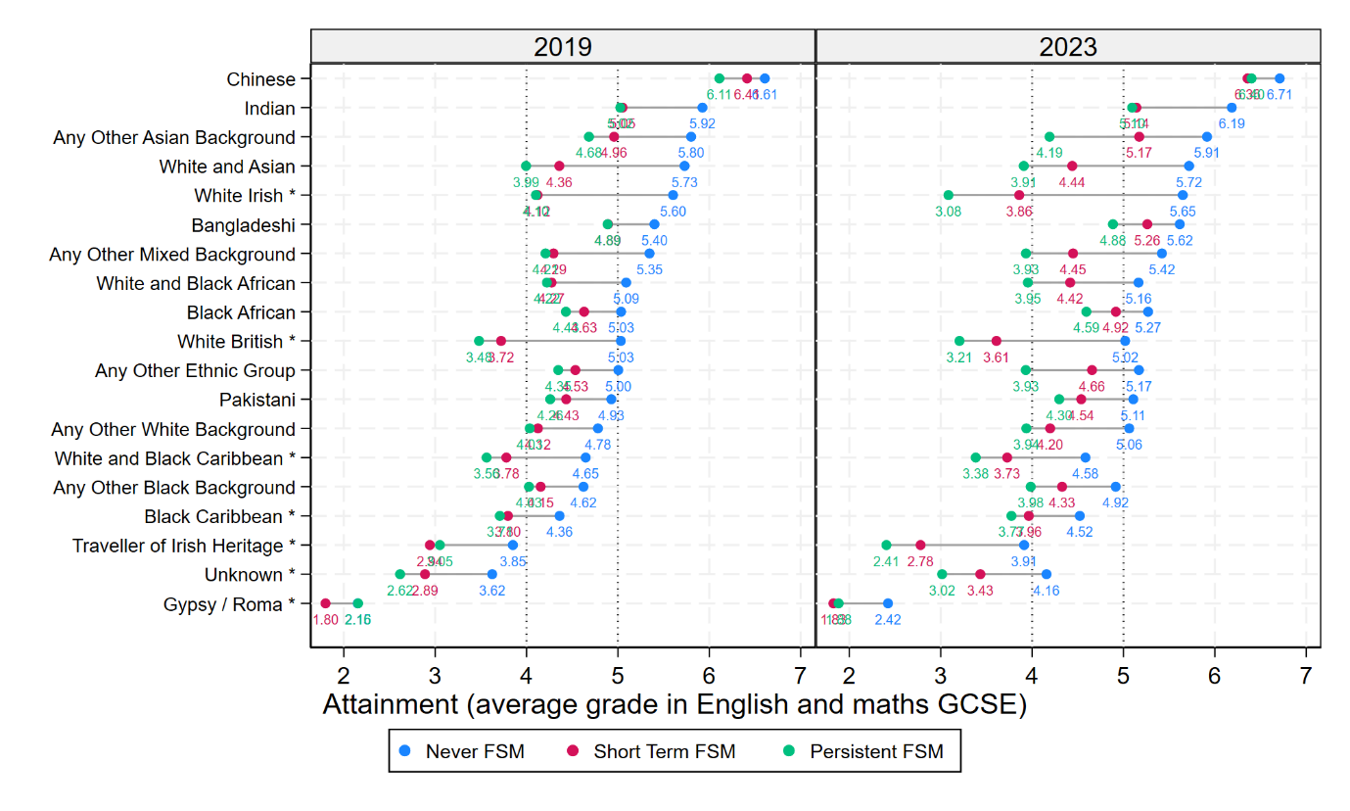

* In the 2019 cohort and for Never FSM pupils, 11 out of 19 ethnic groups were on average attaining grade 5 or higher (strong passes), five were on average attaining grade 4 or higher (standard pass), and three were on average attaining less than a grade 4. The latter three were Traveller of Irish Heritage, Unknown, and Gypsy / Roma.
* In the 2019 cohort and for Shorter-Term FSM pupils, 2 out of 19 ethnic groups were on average attaining grade 5 or higher (strong passes), 11 were on average attaining grade 4 or higher (standard pass), and six were on average attaining less than a grade 4. The two high performing ethnic groups despite experiencing Shorter-Term FSM were Chinese and Indian pupils.
* In the 2019 cohort and for Persistent FSM pupils, 2 out of 19 ethnic groups were on average attaining grade 5 or higher (strong passes), 10 were on average attaining grade 4 or higher (standard pass), and seven were on average attaining less than a grade 4. The two high performing ethnic groups despite experiencing Persistent FSM were again Chinese and Indian pupils.
* In the 2023 cohort and for Persistent FSM pupils, the number of groups on average attaining less than a grade 4 increased from seven in 2019 to 13 in 2023.
* In the 2019 cohort, Persistent and Shorter-Terms FSM pupils showed much more similar performance to one another, than either group did with Never FSM pupils. In the 2023 cohort, disadvantage attainment gaps appear notably wider, a point we will return to below.

## Changes in attainment

* Figure 22 presents change in average attainment between 2019 and 2023 by ethnicity and disadvantage. High Impact ethnic groups are denoted with a * after their labels.

Figure : Change in average attainment between 2019 and 2023 by ethnicity and disadvantage.

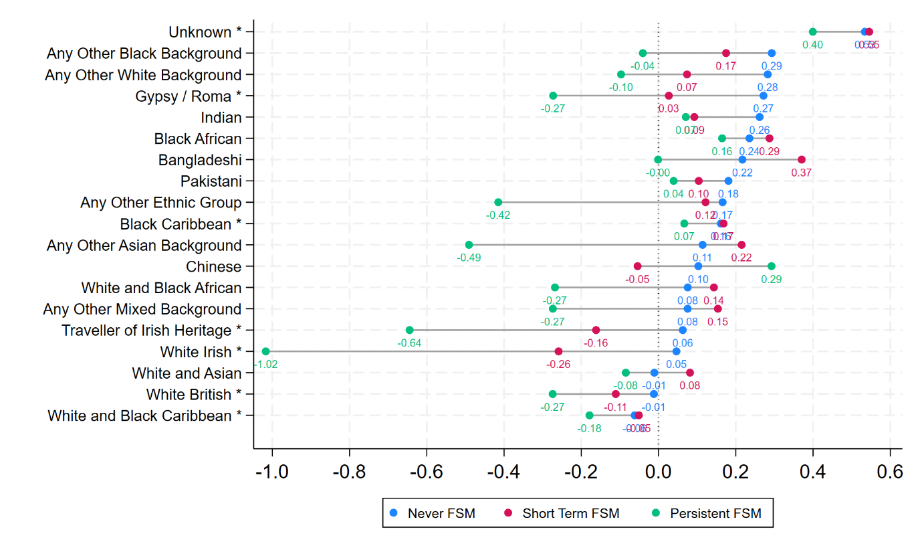

* For Never FSM pupils, 16 out of 19 ethnic groups, saw their average attainment increase between 2019 and 2023. The three exceptions were White and Asian, White British, and White and Black Caribbean.
* For Shorter-Terms FSM pupils, 14 out of 19 ethnic groups, saw their average attainment increase between 2019 and 2023. The five exceptions were Chinese, Traveller of Irish Heritage, White Irish, White British, and White and Black Caribbean. Thus, five groups saw their average attainment decrease.
* For Persistent FSM pupils, six out of 19 ethnic groups saw their average attainment increase between 2019 and 2023. These were, Unknown, Indian, Black African, Pakistani, Black Caribbean, Chinese. Thus, 13 groups saw their average attainment decrease.

## Attainment gaps

* Figure 23 presents disadvantage attainment gaps relative to Never FSM in 2019 and 2023 by ethnicity. High Impact ethnic groups are denoted with a * after their labels.

Figure : Disadvantage attainment gaps in 2019 and 2023 by ethnicity.

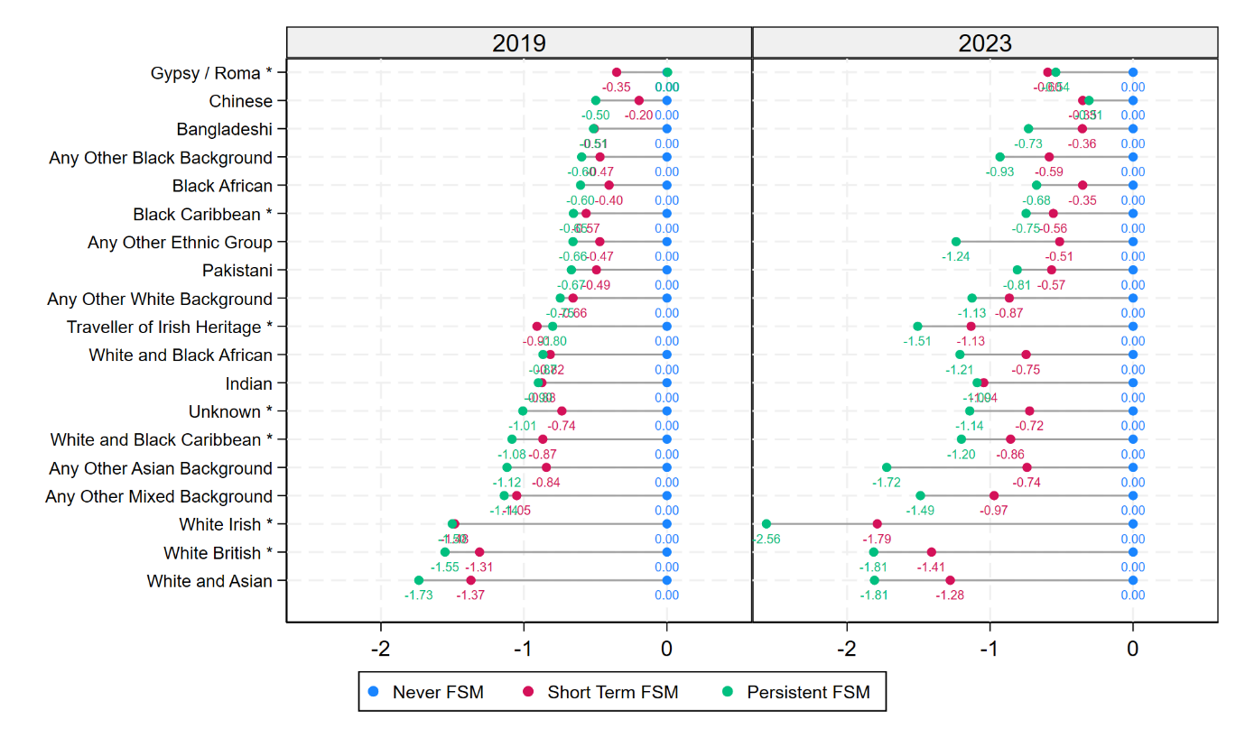

* In the 2019 cohort, the impact of Persistent FSM relative to Never FSM on attainment ranges from -0.35, -0.50, and -0.51 grades for Gypsy / Roma, Chinese, and Bangladeshi pupils to -1.53, -1.55 and -1.73 grades for White Irish, White British, and White and Asian. The magnitude of the latter gaps are three times those of the former.
* An important point to note is that while Gypsy / Roma and Chinese pupils may be similar in showing a smaller impact of Persistent FSM than all other ethnic groups, they are highly dissimilar in that Gypsy / Roma and Chinese pupils show the lowest and highest average attainment across all ethnic groups.
* In contrast, White British and White and Asian pupils are not only similar a larger impact of Persistent FSM than all other ethnic groups, but are also broadly similar in their average attainments.
* The patterns in 2023 are broadly similar, those ethnic groups where Persistent FSM had a larger impact in 2019 tended to still show larger impacts in 2023. So, Gypsy / Roma and Chinese are again among the three groups which show the lowest impact of Persistent FSM, and White British and White and Asian are again among the three groups which show the highest impact of Persistent FSM. However, the impact of Persistent FSM is generally larger than it was in 2019 and is also now more distinct from the impact of Shorter-Term FSM.

## Change in attainment gaps

* We define the change in each disadvantage attainment gap between 2019 and 2023 as the disadvantage attainment gap in 2023 minus the disadvantage attainment gap in 2019. We report this separately by ethnicity.
* Figure 24 presents change in disadvantage attainment gaps between 2019 and 2023 by ethnicity. High Impact ethnic groups are denoted with a * after their labels. This Figure should be read in consultation with Figure 23 as to interpret the magnitude of the change in the disadvantage attainment gap, one needs to note what the gap was in each year.

Figure : Change in disadvantage attainment gaps between 2019 and 2023 by ethnicity.

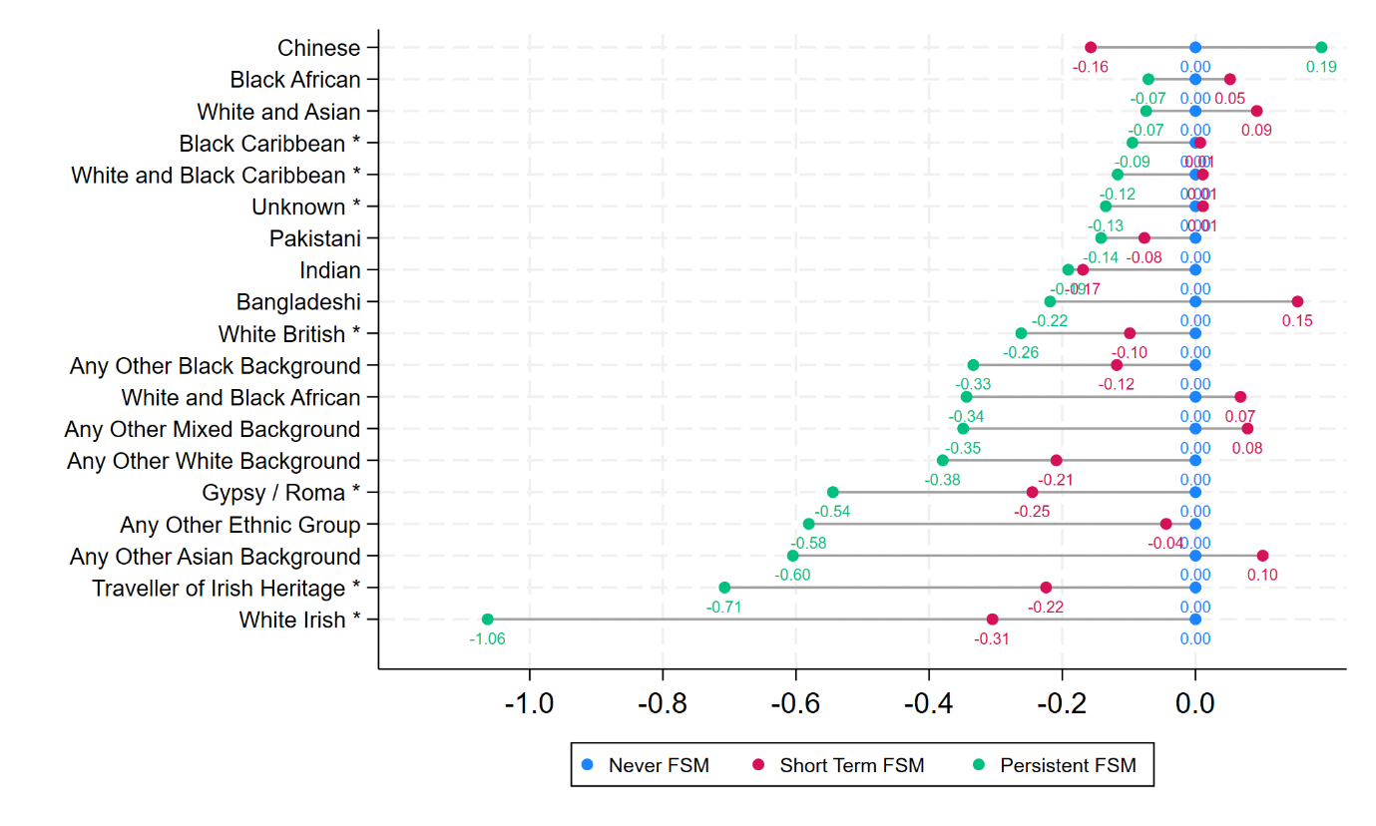

* The Persistent FSM gap has widened for all ethnic groups apart from Chinese, for whom it narrowed by 0.19 grades. For all other ethnic groups, the Persistent FSM gap widened between 0.07, 0.07, and 0.09 grades for Black African, White and Asian, and Black Caribbean pupils, to 0.60, 0.71 and 1.06 grades for Any Other Asian Background, Traveller of Irish Heritage, and White Irish pupils. Thus, in almost every ethnic group, Persistent FSM pupils are falling behind their Never FSM peers, but by far more for some ethnic groups than others. Indeed 10 out of 19 ethnic groups saw their disadvantage gaps increase by over a quarter of a grade, and four groups saw their gaps increase by over 0.5 of a grade.
* The Shorter-Term FSM gap has widened for 10 ethnic groups and narrowed for nine ethnic groups. Where gaps have widened, they have in general done so by a larger amount than where they have narrowed.

# Region and disadvantage

In this section, we first report average attainment in 2019 and 2023 by region and disadvantage. We then report change in average attainment across the two years by region and disadvantage. Next, we report Persistent FSM and Shorter-Term disadvantage attainment gaps in 2019 and 2023 relative to Non FSM pupils in each year by region. Last, we report how these disadvantage attainment gaps changed over time by region.

## Attainment

* Figure 25 presents average attainment in 2019 and 2023 by region and disadvantage. The regions are sorted by their average attainment for Never FSM pupils in 2019.

Figure : Average attainment in 2019 and 2023 by region and disadvantage.

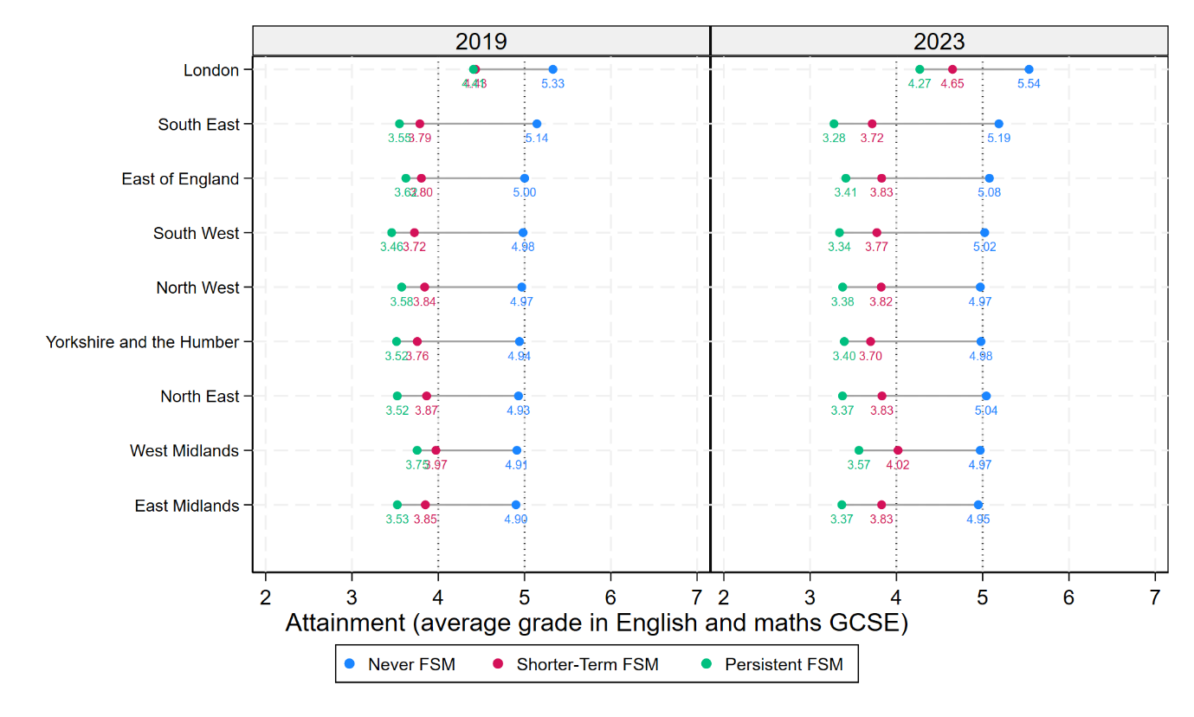

* In both years, average attainment is notably higher in London than the other regions, especially for Never FSM and Shorter-Term FSM.
* Attainment gaps worsened across the board in 2023.

## Changes in attainment

* Figure 26 presents change in average attainment between 2019 and 2023 by region and disadvantage.

Figure : Change in average attainment between 2019 and 2023 by region and disadvantage.

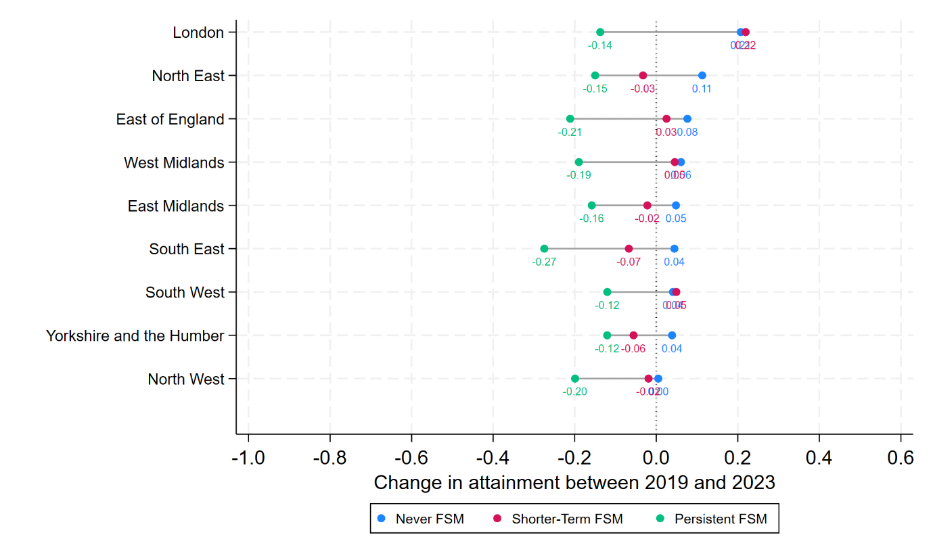

* Among Never FSM pupils, Average attainment increased in every region, especially London.
* Among Shorter-Term FSM pupils, average attainment increased in four out of the nine regions. The largest increase was again in London.
* Among Persistent FSM pupils, average attainment decreased in all regions with decreases in the range of 0.12 to 0.27 points. London is notable here in not being the best performing of the regions. Decreases were slightly smaller in the South West and Yorkshire and Humber at 0.12 grades compared to the decrease of 0.14 grades seen in London.

## Attainment gaps

* Figure 27Figure 23 presents disadvantage attainment gaps relative to Never FSM in 2019 and 2023 by region.

Figure : Disadvantage attainment gaps in 2019 and 2023 by region.

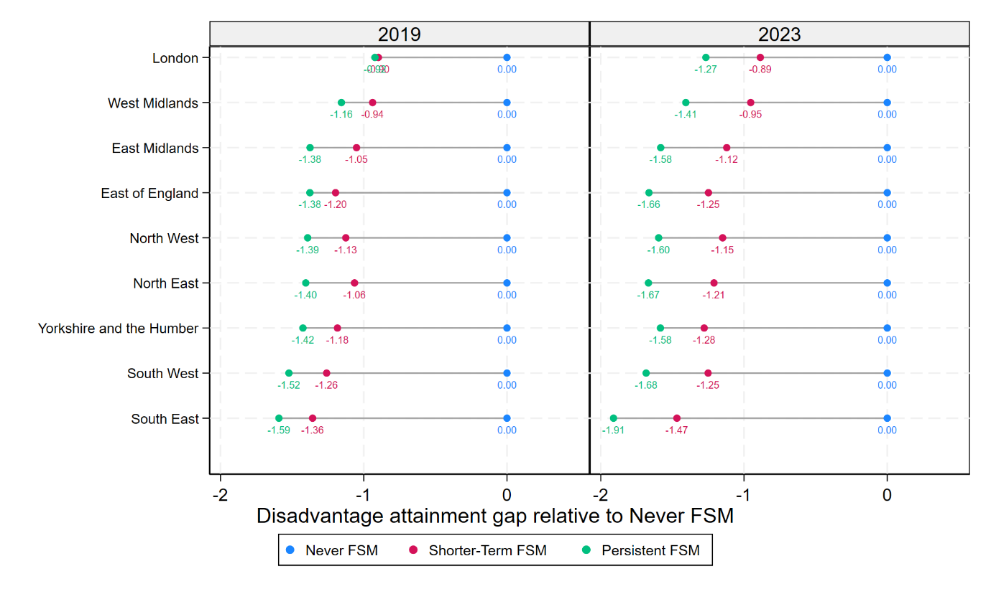

* In the 2019 cohort, the disadvantage gap was smallest in London and widest in the South East. This pattern persisted in 2023.

## Change in attainment gaps

* We define the change in each disadvantage attainment gap between 2019 and 2023 as the disadvantage attainment gap in 2023 minus the disadvantage attainment gap in 2019. We report this separately by region.
* Figure 28 presents change in disadvantage attainment gaps between 2019 and 2023 by region. This Figure should be read in consultation with Figure 23 as to interpret the magnitude of the change in the disadvantage attainment gap, one needs to note what the gap was in each year.

Figure : Change in disadvantage attainment gaps between 2019 and 2023 by region.

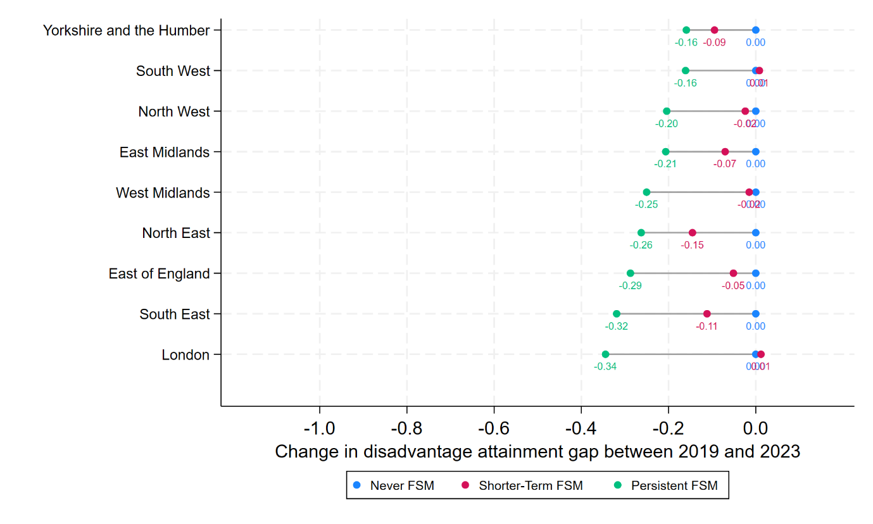

* The Persistent FSM gap has widened for all regions. The smallest widening was seen in Yorkshire and the Humber where the gap increased by 0.16 grades. The largest widening was seen in London where the gap increased by 0.34 grades. Thus, the widening the Persistent FSM gap in London was double that in Yorkshire and the Humber.
* The Shorter-term FSM gap widened somewhat in some regions, but not others.

# Data note

This work was undertaken in the Office for National Statistics Secure Research Service using data from ONS and other owners and does not imply the endorsement of the ONS or other data owners.

# References

Department for Education (2020). *Examining the London advantage in attainment: evidence from LSYPE*. London: HMSO.

Education Policy Institute (2024). *Annual Report 2024*. URL: <https://epi.org.uk/publications-and-research/annual-report-2024/>.

Leckie, G. and Prior, L. (2024). *Report on Adjusted Progress 8, 2023*. University of Bristol. URL: https://www.northernpowerhousepartnership.co.uk/wp-content/uploads/2024/11/Fairer-Schools-Index-Report-1.pdf.

Ofqual (2021). *Ofqual’s approach to grading exams and assessments in summer 2022 and autumn 2021*. URL: <https://www.gov.uk/government/speeches/ofquals-approach-to-grading-exams-and-assessments-in-summer-2022-and-autumn-2021>.

Ofqual (2022). *Grading exams and assessments in summer 2023 and autumn 2022*. URL: <https://www.gov.uk/government/speeches/grading-exams-and-assessments-in-summer-2023-and-autumn-2022>.

Ofqual (2024). *GCSE outcomes in England*. URL: <https://analytics.ofqual.gov.uk/apps/GCSE/Outcomes/>.

Treadaway (2017) *Long-term disadvantage, part three: Ethnicity, EAL and long-term disadvantage.* [Online]. URL: <https://ffteducationdatalab.org.uk/2017/07/long-term-disadvantage-part-three-ethnicity-eal-and-long-term-disadvantage/>.

# Appendix

Figure : Distribution of pupils, by disadvantage in 2019 and 2023 (where we define disadvantage using FSM eligibility over the final four years of secondary schooling)

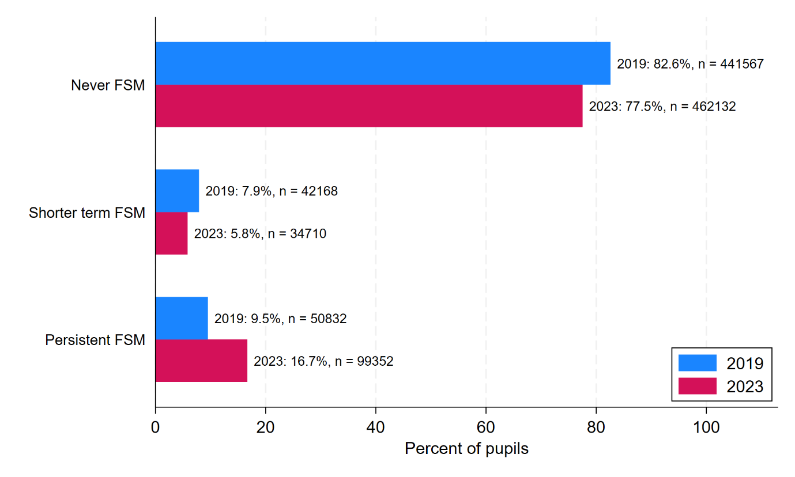

Figure : The distribution of region by ethnicity in 2019 and 2023

