­

Innovation in the North

SUB HEADER GOES HERE

June 2025

# /01. Contents

/01. Contents 2

/02. Introduction 3

/03. Innovation in the North: assets and opportunities 5

/04. R&D Spending 10

/05. Methodology 14

/06. Analysis 22

/07. Case Studies 35

/08. Policy Recommendations 37

# 

# /02. Introduction

The 2016 Northern Powerhouse Independent Economic Review (NPIER)[1] examined strategies to reduce the economic disparity between the North of England and the wider United Kingdom. Strengthening the economic performance of the North is of national significance, ensuring a more balanced and resilient UK economy.

The review concluded that lower productivity rates in the North are a primary driver of lower earnings and living standards, which in turn contribute to other inequalities such as educational outcomes, health, and life expectancy.

The 2016 review identified four ‘prime capabilities’; highly productive mega-sectors where the North held a competitive advantage, offering opportunities to export and attract inward investment. These were advanced manufacturing, energy, health innovation and digital. In addition, three enabling capabilities were identified, which were key to supporting the growth of the primes; these were financial and professional services, logistics and education (primarily higher education). These sectors would lead the way under a transformational economic future for the North. However, for this transformational scenario to become a reality, there needed to be “substantial improvements in the skills base, in innovation performance, and in transport connectivity.”[2] In analysing the economic performance gap in 2016, the NPIER noted a lower rate of patents per worker and lower rates of R&D spending[3].

The NPIER was always intended as an initial look at the opportunities available, and so the review fell short of providing any specific recommendations of how the innovation of the economy of the Northern Powerhouse could be improved, though it did make some general comments about “better commercialisation of university research”, “ better management skills, including the uptake of innovation” and attracting inward investment that would provide “access to leading technologies”[4].

A refresh of the NPIER was undertaken in 2023, given significant changes since the original work, including Brexit and the COVID-19 pandemic, which had substantial effects on the local, national and international economic outlook. A new transformational scenario was produced with an estimated ‘prize’ of increased GVA in the Northern Powerhouse economy of £118bn per year by 2050 above a business-as-usual scenario, and an additional one million jobs[5].

The 2023 review improved upon the 2016 work through the development of four scenarios focused on technology and innovation, inclusive productivity, development supply and net zero. Though the other scenarios, such as net zero, will require innovative activity, we focus on the technology and innovation scenario here. Like the 2016 NPIER, the 2023 review scenario focuses specifically on “increasing investment in R&D”, “technology diffusion” and “capacity for adoption”[6].

In this report we will not repeat the analysis undertaken for this scenario other than to reference that £6bn per annum should be invested into technology and innovation [from public spending]. £3bn of this was allocated to “direct spending on research and innovation” with two examples provided of funding 20 new “institutes of research and training, incubators accelerators or innovation hubs” and an increase in R&D tax and expenditure credits. The remaining £3bn was then allocated to a matched funding pot for start-ups and SMEs targeted at “technology adoption, process improvement, product development, and market expansion, including support for exporting.” This investment of £6bn per annum was forecast to lead to additional GVA of £22bn per year above the baseline by 2050, the third highest of the four scenarios considered in the review, despite producing the greatest increase in productivity. The scenario is also forecast to provide the lowest increase in total additional GVA between 2025 and 2050 (almost half the level of that forecast for the net zero scenario), has the second lowest cost-GVA and the lowest forecast total of potential increased government revenues.

Taking a step back and casting a critical eye over these results, a total cost to total additional GVA ratio of 2.06 (£149bn vs £291bn) appears a poor return for an area that has such a direct a critical role in determining productivity gains. This report therefore considers the innovation ecosystem, particularly in the North of England, how it impacts on productivity and what potential gains could be seen in future GVA increases.

# /03. Innovation in the North: assets and opportunities

The North of England is home to a range of universities including the N8 Group of research intensive institutions, and significant industrial asserts across the prime capabilities. From research through to innovation, there is a huge opportunity. However, there are several barriers and challenges which inhibit the innovation ecosystems of the North from reaching their full potential and playing their role in increasing UK productivity.

Innovation through the creation of new products, optimisation of processes, innovation diffusion, and enhanced collaboration contributes to long-term productivity growth. The importance of public and private investment in innovation is clear; research by the Innovation Caucus showed that for every £1 Innovate UK invests in businesses, there is a 73p increase in the VA of the recipient and this incentivises private investment. For every £1 of Innovate UK grant funding, business R&D spend increases by 34p[7].

Despite the UK’s undoubted strength in pure research, including both the Golden Triangle and the North, respectively, when it comes to commercialising innovations and diffusing them, we fall short and consequently fail to connect world-class institutions to regional economic growth in a way that maximises their impact.

In terms of the North of England’s strengths, research on patents data found that the North specialises in patents in chemistry, materials, textiles and process engineering[8]. Moreover, there are city region strengths in digital health information systems in West Yorkshire, offshore wind energy in the North East and chemicals and process industry in the North West, anchored by strong public entities/firms, which have developed research infrastructure and strong talent pools[9]. However, access to this talent and collaboration across the North is still constrained. There are lessons internationally, with Research and Technology Organisations set up to harness the distinctive characteristics of their respective regions. For example, the National Institute of Advanced Industrial Science and Technology (AIST) in Japan focuses on bridging the gap between innovation and commercialisation. This consists of regional research bases relevant to local industrial strengths, training, consulting and R&D[10].

The Productivity Institute have made the case that examples such as the AIST demonstrate that the UK is missing regional institutes to support high value local industrial clusters by focusing on innovation capability development in a broader sense than just research knowledge development[11]. This report hopes to capture those key industrial strengths for innovation and look at existing capabilities, such as the catapult network with the AMRC in Sheffield and Lancashire as well as the Offshore Renewable Energy catapult with locations in Blyth and Grimsby as part of its footprint across the UK.

## Policy Choices

Research policy has typically been conducted at a national level and followed the so-called excellence approach but has paid little attention to privately funded R&D in places nor the industrial base in places. To stimulate regional economic growth, it has long been the view of the Northern Powerhouse Partnership that place-based innovation policy could better connect private and public sector capabilities than can be done nationally. The following table is not an exhaustive list but provides a good picture of the range of policy instruments previously used across innovation (so including R&D right through to commercialisation and diffusion of technologies to make them more generally applied).

|  |  |  |  |
| --- | --- | --- | --- |
| Policy | Summary | Benefits | Challenges |
| R&D Tax Credits | Allows businesses to deduct more than 100% of eligible R&D costs from taxable profits. | Incentivises R&D Spending.  Encourages investment. | Tax credits would be challenging to implement. If certain regions were given more generous tax breaks firms could register activities there even if they don’t have significant economy activity in that area[12]. |
| R&D Spending | Government and Private Expenditure on R&D. | Product Innovation.  Supports breakthroughs in research.  Knowledge Spillovers. | Unevenly distributed, most R&D spending is concentrated in the Golden Triangle[13].  Awards funding based on research excellence[14].  Factoring in the potential of place this leads to the ‘Matthew Effect’[15]. |
| Catapult Centres | Centres with R&D facilities and technical expertise in varying fields. | Connects universities and businesses to commercialise ideas.  Increases turnover of businesses and employment[[11]](applewebdata://798F009B-8C9B-4985-8853-2FAC2CCBC45F#_ftn11).  Potential to support regional growth. | Rules for governing funding for innovation create barriers to collaboration.  Leveraged funding requirements place too much risk on industry[16]  Imbalance between competition and collaboration in UKRI, Innovation UK and Government frameworks which complicates collaboration between Catapults and Universities[17]. |
| Patent Box Regime | Lower rate of corporation tax, 10%, for profits attributable to patents or other IP. | Encourages businesses to patent and commercialise innovations in the UK. |  |
| Strength in Places Fund | UKRI competitive funding scheme with a place-based approach. | Supports place-based innovation. |  |
| Advanced Research +Innovation Agency (ARIA) | R&D funding agency located in London. | Autonomy to operate at speed. | Long-term impact and delivery challenges are not yet known. |
| Innovation Accelerators | Pilot programme to support the West Midlands, Greater Manchester and Glasgow in becoming innovation centres. Investing £100 million across 26 projects. | Enabled city regions to become competitive innovation centres.  Attracting private investment. Glasgow’s £7.5m investment in Chemical Manufacturing has raised over £28m in funding from private investment[18]. | Long-term impact and delivery challenges are not yet known. |
| Investment Zones | Six investment zones across England which gives areas a £160 million envelope to catalyse growth and investment. | Encourages regional growth and region’s capitalising on their sectoral strengths.  Provide financial investment zones such as business rates relief, stamp duty tax relief, lower NI contributions[19]    Stimulates private investment. | Long-term impact and delivery challenges are not yet known. |

One of the key factors of the effectiveness of these policies is absorptive capacity, which is whether businesses and local economies have the skills, structure and capacity to adopt and implement innovations[20]. As set out by the Institute for Government, innovation policy primarily focuses on R&D, which mainly benefits manufacturing, high-tech and science-oriented firms. However, to drive up productivity it is likely more important to adopt existing technological innovations to improve company logistics, for example. Therefore, policies to increase an area's absorptive capacity and encourage innovation diffusion within its foundational economy sectors are also relevant areas to consider.

# /04. R&D Spending

R&D is important for the UK economy for several reasons. Firstly, R&D is considered a key driver of long-term economic growth[21], which in turn is positively associated with better productivity outcomes[22] and higher rates of innovation, measured by new patents and product development. Secondly, certain sectors such as pharmaceuticals and technology have benefited from R&D funding. For example, Rolls-Royce’s development of Small Modular Reactors (SMRs) is a major technological advancement in the renewables industry. Initial public investment helped to demonstrate the viability of the technology, acting as a catalyst and accelerating the technological progress in the nuclear field. Many other examples across emerging industries can demonstrate the impact of R&D spending in the UK, such as Siemens’ role in Digital Twin Printing and the University of Manchester’s research in Graphene, leading to innovations in electronics and advanced materials.

R&D in the UK has yielded significant advancements across various sectors, demonstrating a strong return on investment through innovation and job creation. Businesses engaged in R&D and process or product innovation exhibit around 10% higher labour productivity, highlighting the significant economic return on investment in innovation. [23]. The UK's universities and research institutions consistently rank among the top globally, producing high-quality research outputs and fostering collaboration that enhances technological advancements. The UK produces around 15% of the world’s most cited research articles, despite only holding 0.9% of the world’s population[24].

## Figure 1: Gross R&D expenditure per capita (public and private)

Source: UK Gross Expenditure on R&D and ONS population estimates (2022)

In 2022, gross expenditure on research and development in England stood at £63bn. Over 62% of this expenditure belonged to the Golden Triangle area of the South East, East of England and London, with London alone accounting for 22%. Conversely, the North of England comprised 17% of this figure, with the North West accounting for 10%. The North East had the lowest proportion in England for R&D expenditure, accounting for just 2%. Given the differing sizes of each region, adjusting to measure on a per capita basis still highlights clear disparities in gross R&D expenditure. As shown on the map above, R&D expenditure in the East of England is £1,991 per capita. This is twice as high as the North’s top-performing region, the North West, where per capita expenditure is £865. Overall, England’s average R&D expenditure per capita is £1,017 which is clearly driven by the Golden Triangle regions. The average when these regions are removed is £716 per capita which means the only region in the North which performs above average compared to more similar counterparts is the North West at £865.

Research by Richard Jones and Tom Forth in ‘The missing £4bn’[25] highlighted the mismatch between the amount spent in different regions, and how in Scotland, for example, as well as in London, private investment was low compared to the significant public funds invested. In the North West, most notably in Cheshire, the reverse was true.

Updated data and decisions since locating the Crick in London as just one example, have helped London to increase its private R&D investment levels[26]. National institutions can be anywhere in the UK, and the placing of these largely in London has crowded in private investment. The positive case that we at the Northern Powerhouse Partnership will advance is that placing ambitious bets from the public sector can and will draw in more private investment than would otherwise happen, which means that a lack of private R&D in a particular region can be addressed.

## Figure 2: R&D Expenditure by sector of performance, 2022

Source: UK Gross Expenditure on research and development, 2022

**Business and public components of R&D spending**

As seen in the graph above, both public and privately funded R&D expenditure is focused in the Golden Triangle. Despite the fact that the majority (63%) of privately funded R&D goes into the East of England, London and the South East, the majority (66%) of public R&D expenditure is also targeted into the same region. We need to critically examine if that produces the optimal outcome: is public R&D in the Golden Triangle crowding out private expenditure, is the R&D performed in this region significantly better than elsewhere in the country to justify this position, and should R&D investment also be a feature of policies to rebalance regional economic disparities given the positive spillover effects that can occur in local economies from innovative activities.

**EU regional funding and innovation**

Innovation was one of the pillars of the 2014-20 EU funding programme, with lead authorities required to prepare a supporting ‘smart specialisation' strategy. In England these tended to be incorporated into local Strategic Economic Plans, agreed between government and Local Enterprise Partnership (or combined authorities) around 2014/15 and ostensibly plans for long term growth. Innovation

With introduction of the Shared Prosperity Fund programme (The UK’s post-Brexit replacement for the EU regional funds), innovation was scaled back significantly, with university partners playing a much smaller role, to the extent that some have questioned the value of ongoing participation if SPF or something like was to continue in a similar way. Where SPF was devolved to the lowest administrative geography, a smaller proportion was allocated to innovation projects and a larger proportion allocated to “community and place” interventions. In addition, much shorter timescales and a decision to backload most of the SPF into year three of the programme, created difficulties in developing and managing a sustained programme of innovation work.

In cash terms, the shift from the EU funding programme to SPF saw a reduction in the overall value of SPF compared with the EU funds combined with a reduction in the proportion of available funding invested in innovation. A freedom of information request by Northern Powerhouse Partnership revealed that the lead authorities that responded had assigned an overall 4.7% of core SPF to innovation projects.[27] Applying this % to the total England SPF allocation suggests a total of £24.9 million per year might be spent in England on “innovation” over the course of three years of SPF. In comparison, analysis of the EU funds[28] shows £86.6 million per year was allocated to “research an innovation” over the course of the seven-year programme. This is a clearly a large reduction and, while these overall funding figures are comparatively small compared to mainstream innovation budgets controlled by central government, the locally controlled funds meet a different need, often funding smaller projects targeted at supporting innovation and growth amongst SMEs rather than large ‘pure’ science programmes.

# /05. Methodology

## Productivity Framework

Given that the aim of the NPIER and its innovation and technology scenario in the 2023 refresh was to see an improvement in productivity in the Northern Powerhouse economy, we have worked with colleagues at Durham University to develop a productivity framework showing the key innovation factors that drive productivity. A summary of these factors can be seen in Figure 3 below, which covers technology, skills, absorptive capacity and structure. This is followed by Figure 4, which illustrates the interactions between each framework component.

## Figure 3: Key Factors of Innovation

|  |  |  |  |
| --- | --- | --- | --- |
| **Factor** | **Summary** | **Benefits** | **Challenges** |
| **Technology** | A crucial driver of productivity in value chains. Tools and systems (e.g., AI, IoT, automation) optimize processes, reduce costs, and improve decision-making. | Facilitates automation, communication and data analysis.  Streamlines operations and reduces costs.  Enables data-driven decision-making. | High initial costs, cybersecurity risks, and the need for maintenance.  Potential for job displacement.  Requires a skilled workforce for adoption and infrastructure. |
| **Skills** | The expertise and capabilities of the workforce that enable efficient operations, innovation, and effective technology use. | Increases operational efficiency and quality control.  Supports adoption of new technologies.  Enhances problem-solving and adaptability. | Implementing knowledge and learning practices may face resistance to change.  Skills shortages and mismatches and resistance to upskilling.  Funding of education and training. |
| **Absorptive Capacity** | A firm’s ability to recognise, assimilate and apply external knowledge to enhance processes and innovation. | Accelerates technology adoption.  Increases ability to integrate new knowledge into value chain operations.  Enhances adaptability and resilience. | Varied access to knowledge/research dependent on region and size of firms.  Requires a skilled workforce to absorb and apply new knowledge.  Necessitated by having the infrastructure to adapt. |
| **Structure** | Includes physical (transport, logistics) and digital (broadband, cloud computing) and organisational infrastructure that is necessary for efficient value chains. | Supports efficient logistics, supply chain management and absorptive capacity.  Speeds up the movement of goods.  Digital infrastructure supports integration of IT systems and enables real-time data sharing and communication. This can optimise value chain activities. | Regional disparities in infrastructure investment.  High costs for maintenance and expansion.  Digital divide limits access in some areas. |

## Figure 4: Interactions within the productivity framework

The first stage of our research was to assess each region's performance in each of the productivity framework's components. This was done using several indicators, such as the number of patents, the number of spinoffs, the presence of incubators/accelerators/catapults, and skills shortages. Each region was assessed on these indicators relative to the national average and was evaluated as over or underperforming.

**Productivity Dashboard**

Source: Durham University

**Absorptive Capacity**

Absorptive Capacity is a firm's ability to identify and apply new technologies and innovations into its business, from acquiring new technology to having a workforce ready to integrate it. Across the North, there is a mixed picture in terms of absorptive capacity. In the North West, absorptive capacity is strong, scoring well across all underlying metrics. This is closely followed by Yorkshire and the Humber, whereby economic efficiency requires improvement with regard to productivity and GVA per hour worked. However, the North East illustrates a lack of absorptive capacity with process and operations, economic conditions and collaboration underperforming.

**Structure**

Structure includes the physical and digital capabilities existing within each region, from the number of catapults, the Higher Education density, the number of spinoffs and collaboration. Across the North, structures to support innovation in the North are underperforming on several fronts. In all regions, industry dynamics (business density, number of incubators, accelerators and catapults) underperforms relative to other English regions. Additionally, the number of spinoffs by higher education, innovative SMEs collaborating and business density is low in the North of England relative to the rest of England. On the other hand, the North East demonstrates strength in having a range of institutions which facilitate innovation from incubators, accelerators, catapults and innovation clusters.

**Technology**

Technology enables the optimisation of processes, competitive innovations and data-driven decision making. A range of metrics underscore this metric from public/private sector innovation, number of patents, spinoffs to technology absorption.

**Skills**

Skills are fundamental to a workforce's ability to both create and adapt to innovations. Across the North’s regions, skills are in need of improvement, with the degree to which they require attention varying by region. The only metric by which all three regions underperform is the amount of entry level training which indicates that this is a pan-northern challenge. In terms of pan-northern strengths, each region performs well in terms of continuing professional development and management practices.

## 

## Value Chain Analysis

The analysis presented in this paper will consider productivity impacts through the effects on value chains, broken down by industrial sector. A value chain is a series of activities a company performs that create customer value.

By analysing each component of the value chain, businesses can identify areas for improvement, cost reduction, technology adoption and several other ways to optimise processes. In this analysis, we assessed the value chains in the North in each industrial sector.

## Cluster Analysis

The next stage of our analysis was to understand the makeup of the industrial sectors of the North in terms of the number of companies, their contributions to GVA and their productivity.

To explore how productivity could be boosted through unlocking innovation in the North, we followed a three-stage process:

1. Identify mature and growth potential industrial clusters by region and sector.
2. Calculate the potential boost to GVA within each sector that would be gained by investing or allocating resources into improving absorptive capacity, technology, skills and structure of a region.
3. Produce a series of policy recommendations to achieve this outcome.

Figure 5 below illustrates how we will classify each industrial sector into one of four quadrants. These will be determined by a sector’s productivity, defined as GVA per employee and how concentrated a sector is in a region through the use of location quotients resulting in a classification of either mature, scalable, non-clustered or foundational.

To create this we utilised two metrics, the first one being total employment in a region by industry and the Gross Value Added (GVA) for that industry in 2022. Total employment was obtained from the Business Register and Employment Survey, broken down by ITL1/ITL2 region and SIC code. This was paired with GVA data from the ONS. These datasets are from robust sources and paired together provide a strong indication of the business landscape across the North of England.

Figure 5: Industrial Sector Quadrant Map

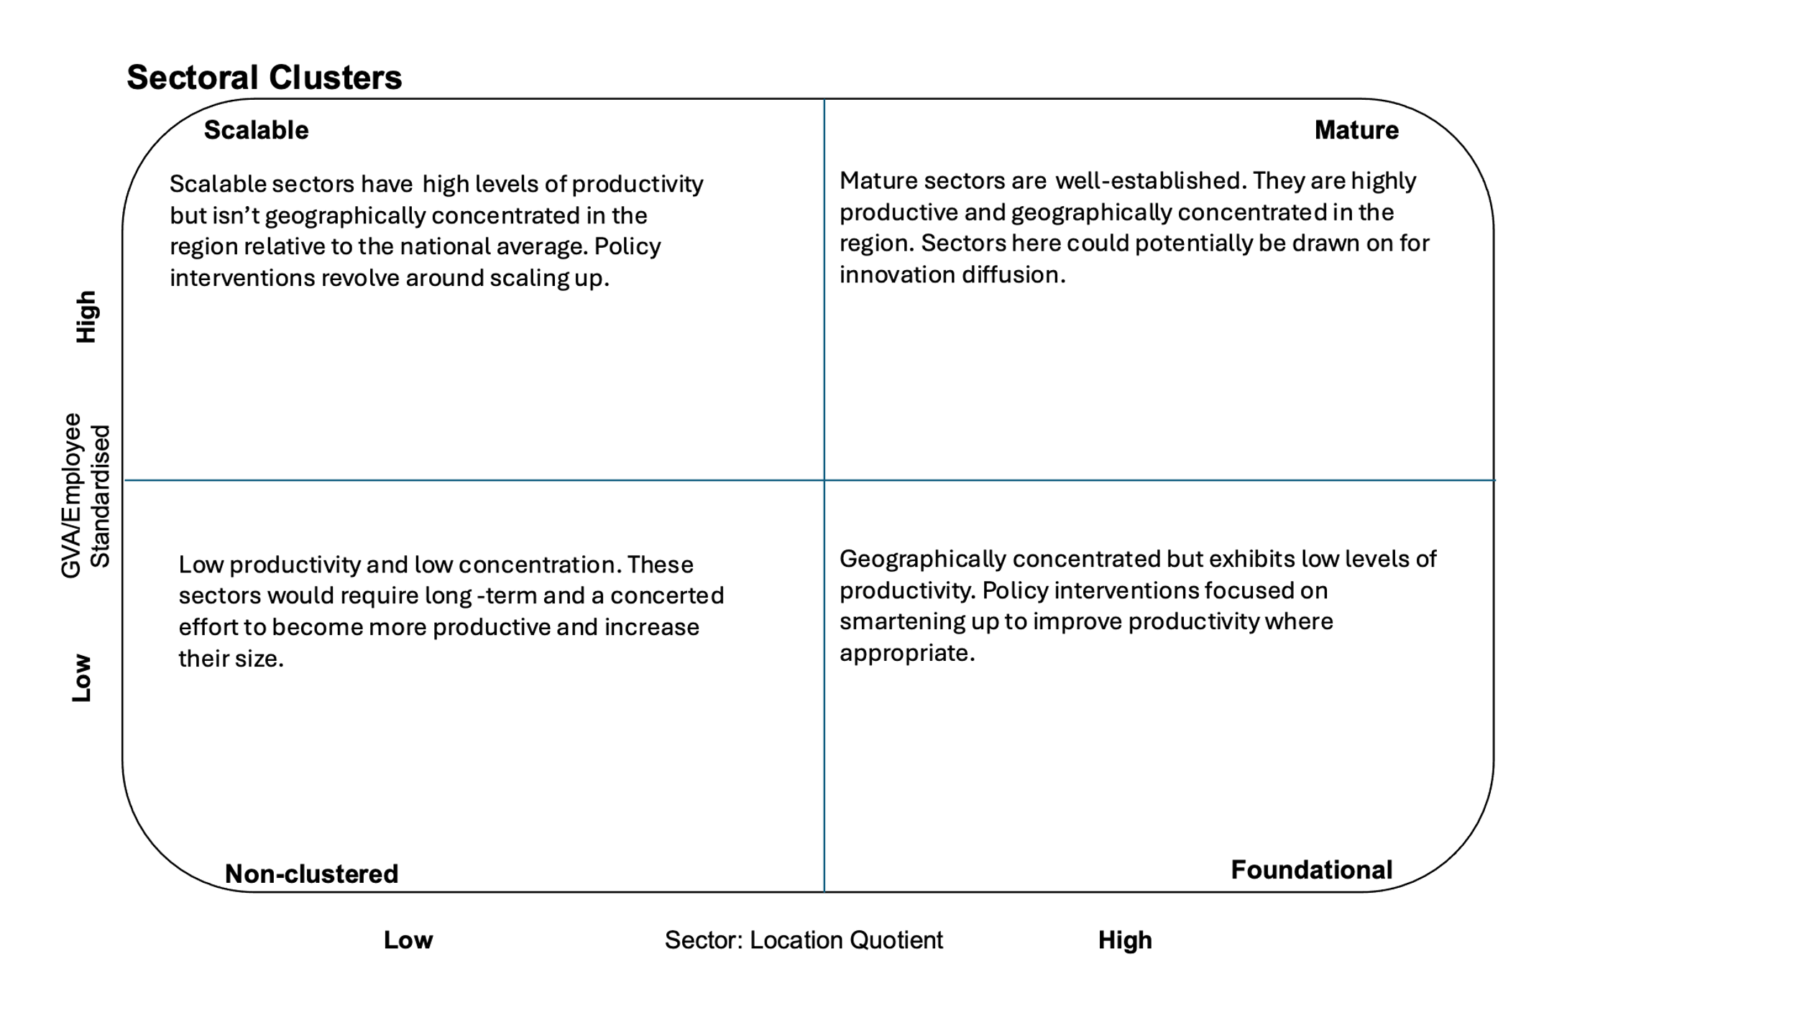

Firstly, we assess the GVA of each industrial sector in each region measured in chained volume measures in millions of pounds. Chained volume measures are a suitable metric for productivity as they reduce the potential distortions caused by inflation and provide a more accurate representation of the quantity of goods and services. The data used in this analysis is from 2022. For this analysis, the GVA went through a series of manipulations. Firstly, we divided the GVA of each sector in a region by the number of employees. This gave us a GVA per employee figure. To enable reliable comparison across regions, we then standardised the GVA per employee figure using the average and standard deviation of each subsector across the regions.

The result of this provides us with a z-score, which tells us how many standard deviations a value is from the mean. Given that a z-score of 0 represents an exact average, as it is 0 deviations from the mean, the threshold is set at 0. The following table sets out in full what the values can tell us.

|  |  |
| --- | --- |
| **Score < 0** | This represents below average productivity suggesting that the industry’s productivity is lower than the national average and therefore makes a comparatively lower economic contribution. |
| **Score = 0** | This represents the exact average value for productivity. |
| **Score > 0** | A score above 0 indicates the industry has higher productivity compared to the national average. |

For example, if Manufacturing of Textiles in Greater Manchester has a score of 2 this indicates that this industry in GM is significantly above the national average.

A location quotient was then calculated for each region relative to all other areas of England. This was done by calculating the regional proportion of employment in a subsector by region and dividing that by the national proportion.

This calculation then produced a location quotient score for all the regions’ industrial sectors which is an indicator of how specialised a region is in each sector relative to England. This results in a score of 0 and upwards, and the table below shows the meaning of each location quotient score.

|  |  |
| --- | --- |
| **LQ < 1** | A location quotient below one means a subsector is less specialised/concentrated in a region compared to the national average. |
| **LQ = 1** | A location quotient equal to 1 indicates that the given subsector in a region matches the national average. It suggests no particular specialisation or lack of. |
| **LQ > 1** | A location quotient above 1 indicates that the subsector in a region is higher than the national average. This indicates that the region has a potential cluster/ specialisation in said industry. |

For example, if London had a location quotient of 3 in financial services it would mean that financial services employment is three times as concentrated in London compared to the national average. Alternatively, if real estate activities in the North East have a location quotient 0.72 means that this subsector is underrepresented there compared to the national average.

Once both the location quotient and standardised GVA per employee have been calculated, we classified the industrial sector into the relevant quadrant by assigning each score as either high or low. For the location quotient, a score above 1 is high, and below is low. For the GVA figure, a score above 0 is high, and below is low.

The purpose of these cluster classifications is to inform us on the current state of sectors and identify which sectors need certain policy responses dependent on whether they are a mature or growth sector. For example, a mature industry needs to be maintained and supported whereas a scalable cluster may require policies which help the sector to grow and potentially develop into a mature cluster.

# /06. Analysis

## Regional Analysis

The productivity framework introduced earlier was created at a regional (ITL1) level due to the availability of data for several of the indicators considered. Our first-stage analysis was, therefore, conducted at the same level, and the resulting quadrant diagrams for each region are briefly discussed below.

Figure 6: Industrial Clusters in the North East

Of the 19 industrial sectors in the analysis, three of them are defined as mature in the North East. Of these, manufacturing would include the prime capability of advanced manufacturing from the NPIER. Health appears as a potential scalable cluster as does information and communication taken as a proxy for digital.

Figure 7: Industrial Clusters in the North West

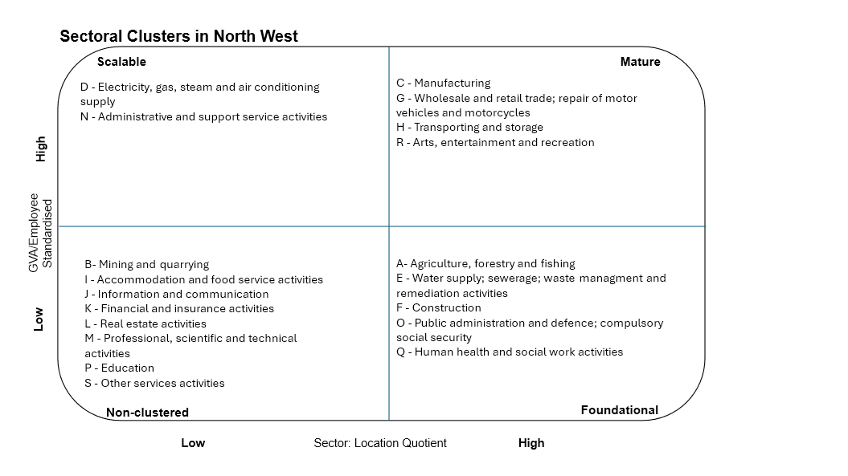

As seen in the North East, manufacturing also appears as a mature cluster in the North West. Energy appears as a scalable cluster in the region but many others appear to score low for their GVA per employee which came as a surprise.

Figure 8: Industrial Clusters in Yorkshire and the Humber

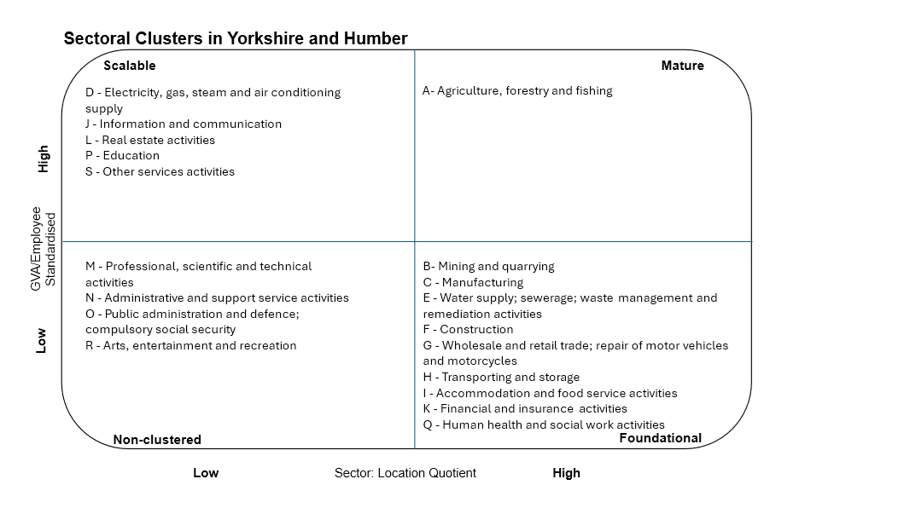Somewhat surprisingly only agriculture, forestry and fishing is classified as a mature cluster in Yorkshire and the Humber. Manufacturing which is a mature sector in the other two northern regions falls into the bottom right quadrant in Yorkshire due to low GVA per employee.

Analysis of clusters at the regional (ITL1) level of geography using SIC sectors provided a clear indication of the concentration and productivity of broad industries existing within each region. However, looking at this from a policymaker's perspective, trying to determine what to invest in and where, the broadness of SIC sections and size of ITL1 regions does not provide enough of a granular insight into industrial strengths and emerging sectors.

Therefore, we will now utilise the same methodology for sub-regional (ITL2) geographies at a more disaggregated sector level. Our previous 19 SIC sections have now become 71 sub sections. To aid presentation, rather than presenting them by geographic area, we will present them by broad industrial sector aligned to the recently published Modern Industrial Strategy.

## Subregional Results

One change in our approach to this analysis is that we have excluded all London ITL2 regions. The rationale for this is that London's dominance, especially in some sectors such as finance, skews the averages against which the significance of sectors is measured. Given that it is widely acknowledged that London has the largest concentrations of some industries, this allows us to identify those important clusters outside of the capital.

It should be noted here that it will not be surprising to see few sectors and regions in the top right ‘mature’ quadrant. We are well aware that productivity levels in the North still lag behind other areas of England, even when London is excluded, as shown in the recent NPIER refresh[29]. Focus could be given to growing those industries and locations in the top left quadrant with above average productivity, and those in the bottom right could be prioritised for measures to increase their productivity levels, given the importance of these industries to these areas.

These cluster diagrams may be difficult to read in this document and also do not show the detail of how close each data point could be to the border of another quadrant. We would therefore recommend viewing the interactive versions of these diagrams at: <https://public.flourish.studio/story/3154346/>

Figure 9: Advanced Manufacturing Industrial Clusters

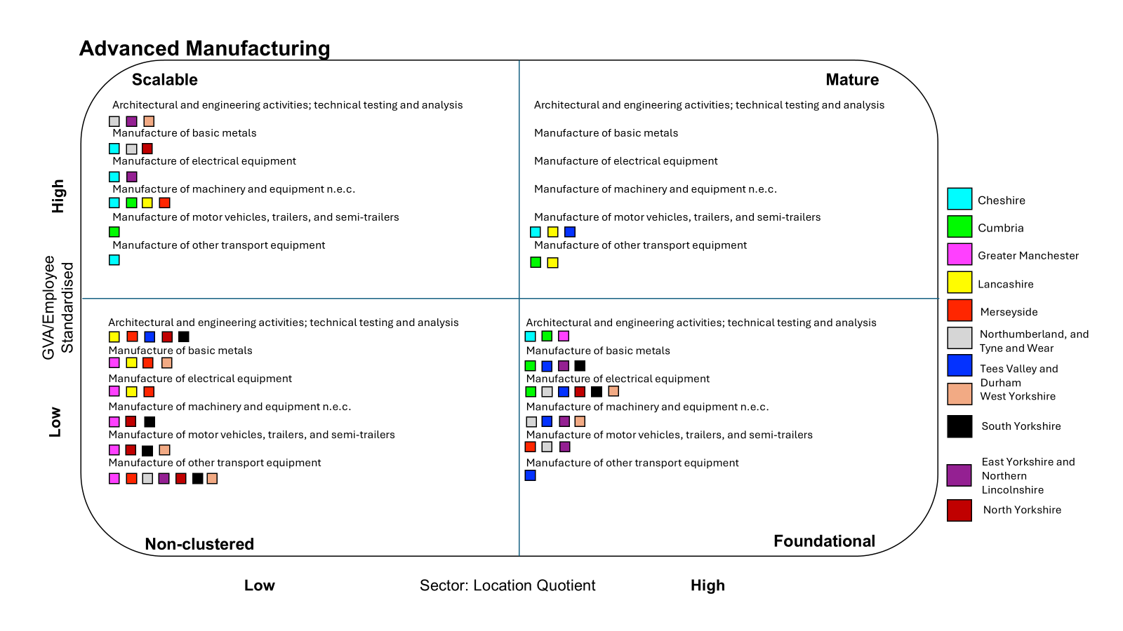

Within the advanced manufacturing sector, the manufacture of motor vehicles is a mature sector in Cheshire, no doubt recognising the presence of Bentley in Crewe and Vauxhall in Ellesmere Port. However, it is a surprise that Nissan’s Sunderland plant does not move Northumberland, and Tyne and Wear into the mature quadrant. Cheshire has several sub-sectors that show high levels of productivity, though do not yet have significant geographic presence. Within this industrial sector, Greater Manchester does not show any significant sub-sectors for an economy of its size.

Figure 10: Clean Energy Industrial Clusters

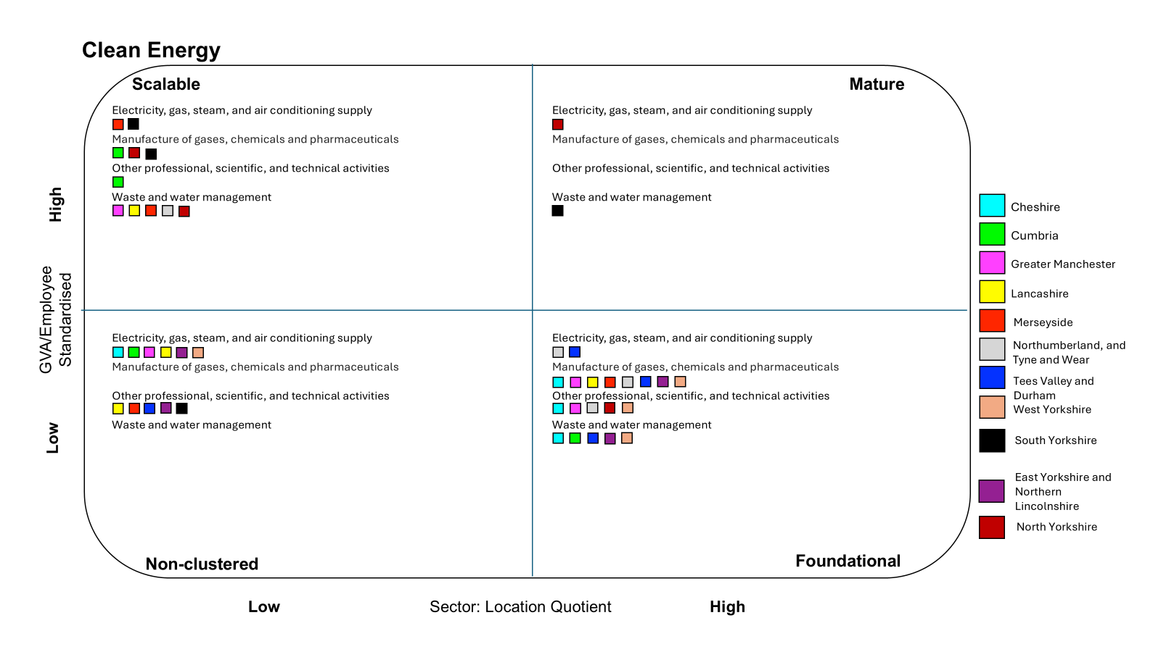

The results for the Clean Energy sector have been a surprise given the strength of green technologies in places such as the Humber. However, this could represent which parts of the value chain are located within the region. Given the number of areas appearing in the lower right quadrant, where there is a significant concentration of employment in the sub-sector but lower than average productivity, it does suggest that the region is attracting the lower value-added employment in these sectors. The appearance of North Yorkshire in the mature quadrant will reflect the presence of Drax power station in Selby, powered by biomass.

Figure 11: Health



Though the Modern Industrial Strategy focuses on a Life Sciences sector, due to the way data is presented by the ONS it is difficult to create a subregional life sciences dataset. Presented above are human health activities, which includes front line health delivery, and scientific research and development. Some areas will therefore find that their local economy is dominated by front line delivery rather than research and development with the resulting impact on levels of productivity given that research and development employment will generally be in higher value-added positions. Additionally, again due to data issues, some areas of what could be considered life sciences are represented in other parts of this analysis. The manufacture of pharmaceuticals is found within clean energy as it is grouped with the manufacture of petroleum and chemicals in the regional GVA statistics. Likewise, some aspects of analysis are found within advanced manufacturing within technical testing and analysis.

West Yorkshire appears as having the most mature human health activities sector which supports the comments made by the Secretary of State for Health referring to Leeds as a “healthcare innovation powerhouse”.

Figure 12: Digital and Technologies

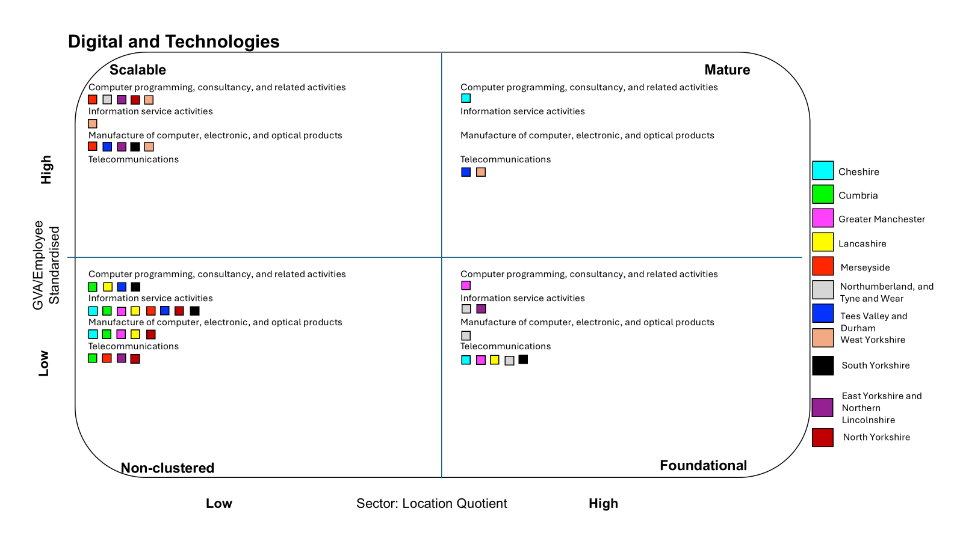

The presence of any regions strengths in the foundational category, such as computer programming and telecommunications for Greater Manchester, is an opportunity to increase this sector’s relative productivity to other regions based on the scale of these sectors. The presence of Cheshire as a neighbouring sub-region with computer programming as a mature cluster shows the opportunity to mirror that relative productivity to the average outside London with further investment.

Figure 13: Creative Industries

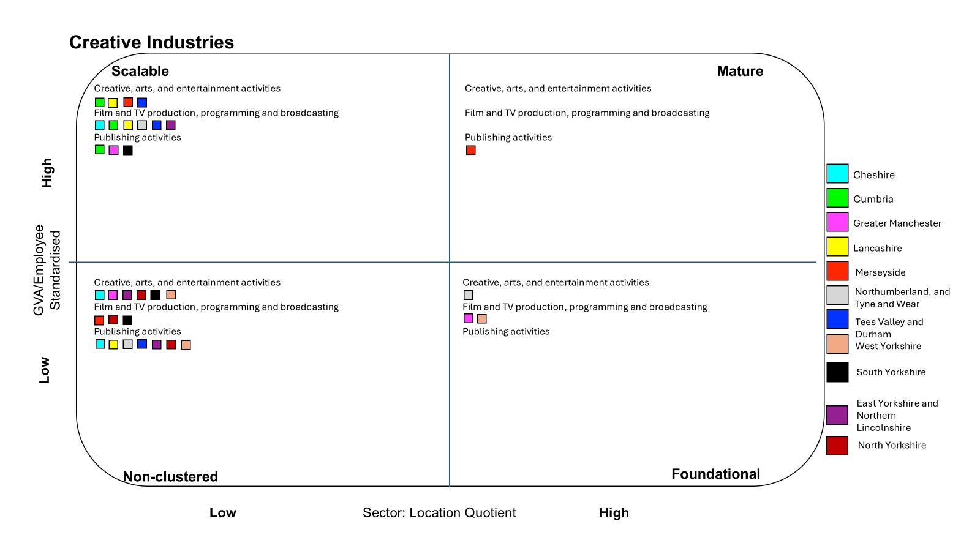

Given the presence of MediaCity in Salford, and the arrival of Channel 4 in Leeds, it is disappointing to see both areas appear in the lower right quadrant for film and TV production. Attracting scale investment does not mean that the most highly productive jobs will be secured automatically and interventions such as Tileyard North in Wakefield which give businesses considering entering the region equivalent or better facilities than available in London have only just begun to take effect. It should also be highlighted that as this analysis is based on 2022 data, the position of these areas will hopefully begin to move upwards in future years.

Figure 14: Professional and Business Services

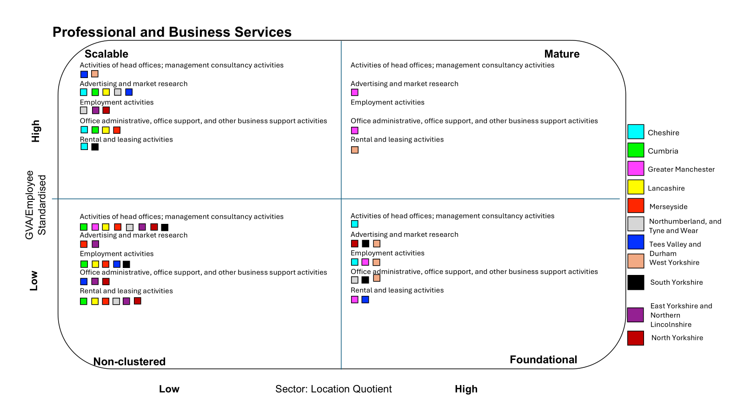

Greater Manchester appears twice in the mature quadrant with advertising and office/business support services. Legal and accountancy services could be considered part of this industrial sector, but we have placed them within the financial services sector that follows below.

Figure 15: Financial Services

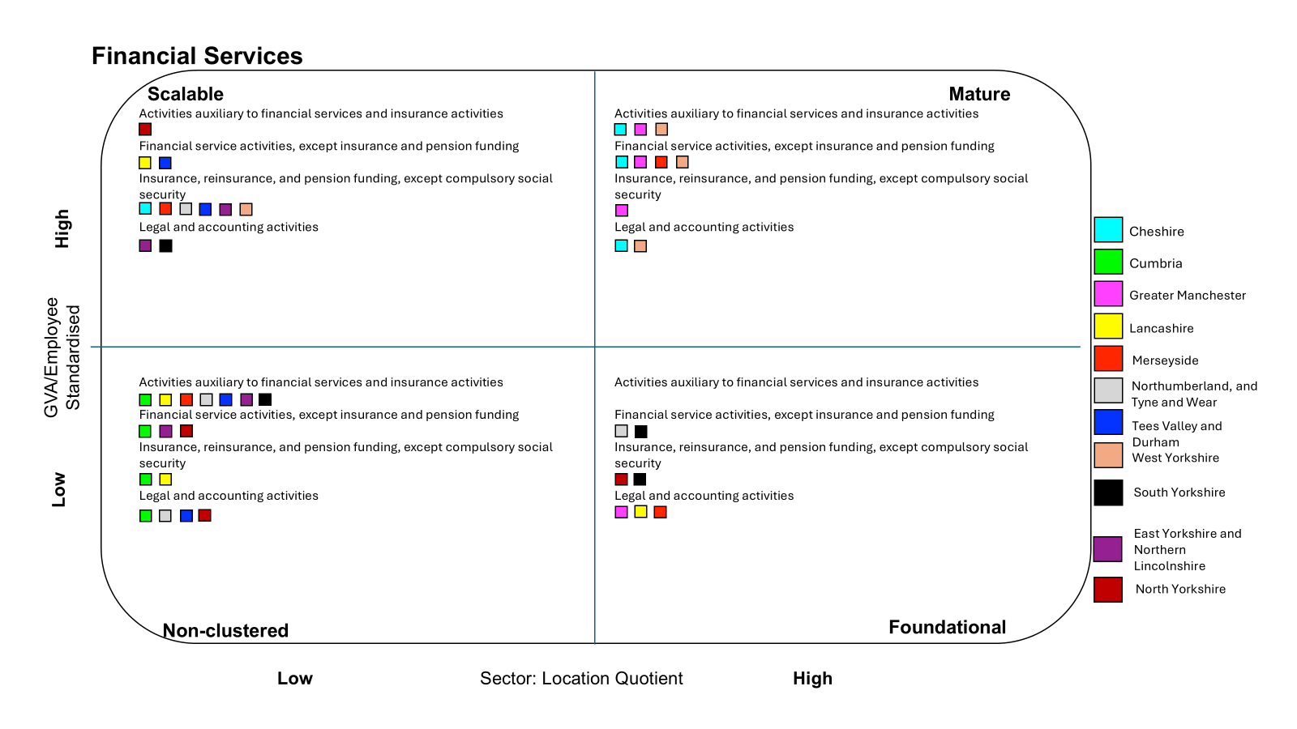

The financial services sector displays a real strength of the Northern economy, with Cheshire, Greater Manchester and West Yorkshire each appearing three times in the upper right quadrant, with Merseyside also appearing once. The decision to locate the Bank of England and the National Wealth Fund in Leeds has clearly been driven by a desire to take advantage of the talent within the labour market.

Figure 16: Defence

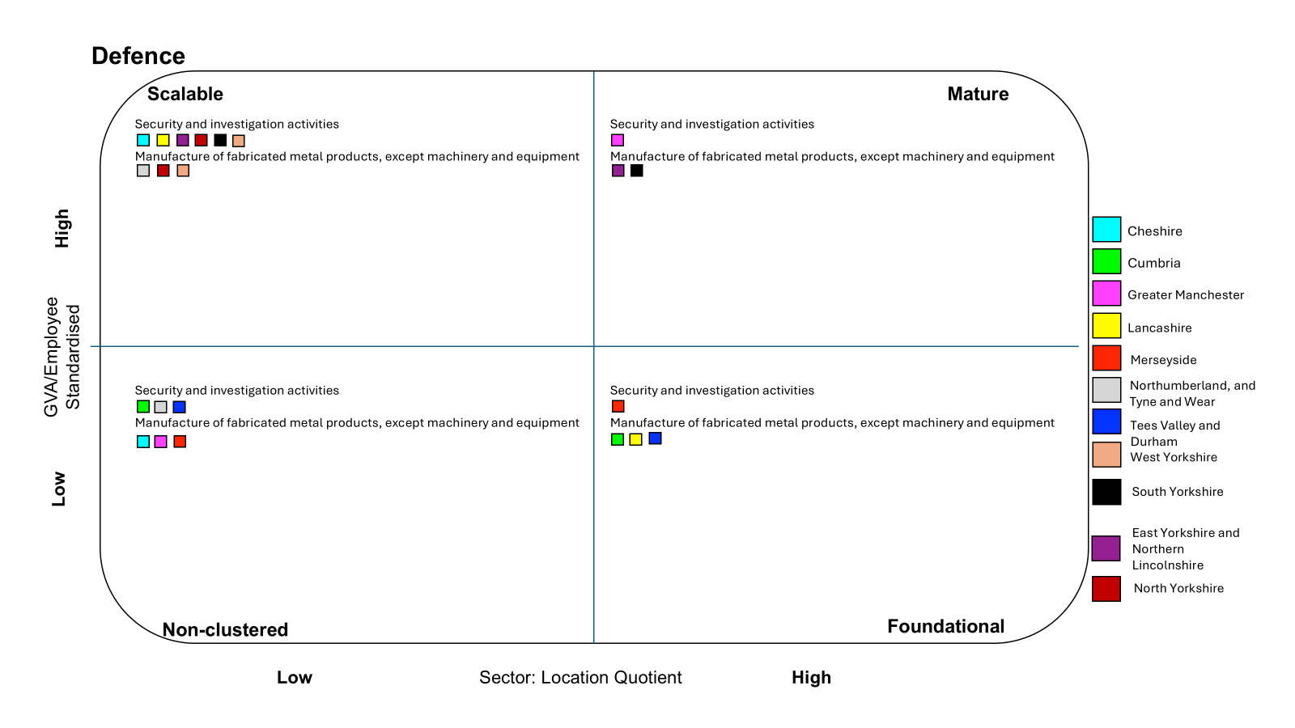

Defence is a difficult sector to classify given its very specialist nature. The two subsectors above attempt to capture some of this, though it may well be that many of the capabilities could be captured within the advanced manufacturing sector.

Figure 17: NPIER Additional Capabilities

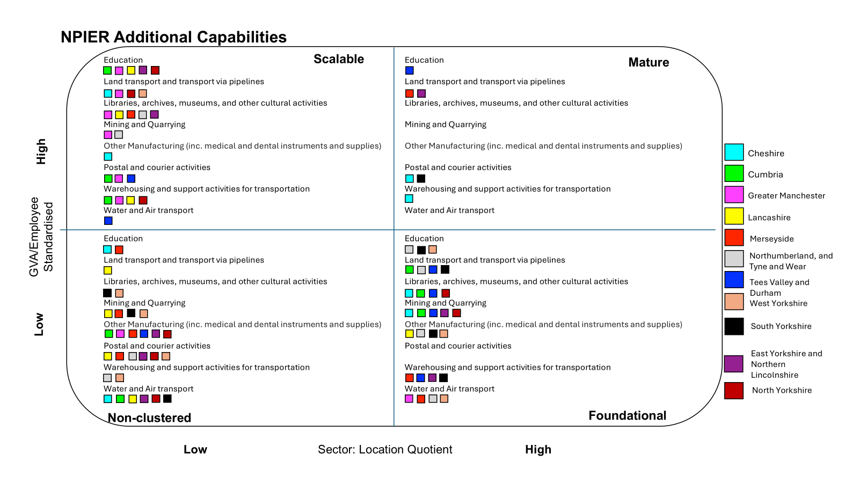

The final ‘sector’ presented here reflects the additional capabilities identified in the NPIER. Again, a significant number of areas appear in the top left and bottom right quadrants, indicating potential targets for growth or those sub-sectors that could benefit the most from programmes designed to improve productivity.

## Economic Impact

Taking the analysis presented above, we have calculated what the potential GVA uplift could be from improving the factors of productivity set out earlier in this paper. From literature reviews and past focus groups, a range of productivity improvements have been estimated for each industrial sector by region based on which quadrant it was assigned to. This uplift is based on a ten-year forward look and is therefore over a much shorter time horizon than that presented in the NPIER.

Figure 18: Overall GVA Increase – Low Estimate £m

|  |  |  |  |  |
| --- | --- | --- | --- | --- |
| **Sector** | **North East** | **North West** | **Yorkshire and the Humber** | **Total** |
| Absorptive Capacity | 2,436 | 15,208 | 1,538 | 19,001 |
| Structure | 4,815 | 23,663 | 6,992 | 35,471 |
| Technology | 6,232 | 27,566 | 11,049 | 44,846 |
| Skills | 5,250 | 20,702 | 10,956 | 36,908 |
| **Total Increase in GVA** | **18,732** | **86,960** | **30,535** | **136,226** |
| **Less BAU** |  |  |  | **64,286** |
| **Net Policy Impact** |  |  |  | **71,941** |

Figure 19: Overall GVA Increase – High Estimate £m

|  |  |  |  |  |
| --- | --- | --- | --- | --- |
| **Sector** | **North East** | **North West** | **Yorkshire and the Humber** | **Total** |
| Absorptive Capacity | 9,046 | 33,240 | 20,466 | 62,753 |
| Structure | 9,537 | 36,672 | 20,513 | 66,722 |
| Technology | 11,898 | 43,176 | 27,273 | 82,347 |
| Skills | 8,555 | 29,808 | 20,420 | 58,784 |
| **Total Increase in GVA** | **39,036** | **142,897** | **88,672** | **270,605** |
| **Less BAU** |  |  |  | **64,286** |
| **Net Policy Impact** |  |  |  | **206,319** |

As seen above, we estimate an increase in annual GVA of between £72bn and £206bn over what would have occurred without any intervention. The BAU scenario has been calculated based on average annual growth rates in each industrial sector over the past decade and assumed to continue over the next decade.

# /07. Case Studies

## Made Smarter programme

Made Smarter was the result of a review led by Professor Juergen Maier to demonstrate how applying digital technologies is key to transformational improvements in productivity, with those adopting it early already reaping the benefits. The programme set out to help SMEs adopt technologies by offering business support services and overcome the barriers to adoption. The programme was piloted in the North West and has been an incredible success engaging over 2,500 manufacturers, supporting 334 technology projects and the projected forecast in gross GVA is £242m. Not to mention that for every £1 of government investment is an £8 return[30]. This success is reflected by DSIT’s recent decision to continue funding the Made Smarter programme with up to £37 million.

## German Federation of Industrial Research Associations (AiF)

This is Germany’s leading national organisation promoting applied R&D in small and medium-sized enterprises. It consists of 100 industrial research associations with approximately 135,000 businesses and 1,200 associated research institutes[31]. This industry-driven organisation manages the public programmes of the federal government. The AIF coordinates practice-oriented research with a focus on implementing results into the economy within a short period of time. Each research association represents a certain business sector. The AIF covers a range of sectors with an emphasis on developing new technologies and knowledge transfer to strengthen innovation throughout the economy. Since 1954, the AIF has disbursed more than €10bn in funding for more than 200,000 research projects for SMEs[32].

## Germany’s Digital Strategy – De-Digital

Germany’s De-Digital strategy recognises the importance of digitalisation and data to companies and government. This initiative brings together businesses, unions, the scientific community, the government and the public to develop approaches and projects for digital transformation. This initiative was launched in 2016 and at the time of writing they quantified the benefit of digitising industry to open up potential additional cumulative value added of €425 billion in Germany alone. Projections put productivity gains at up to 30%, annual efficiency gains at 3.3% and cost reductions at 2.6% annually[33]. They estimated that the following sectors would be the highest beneficiaries; automotive industry, mechanical engineering, process industries, the electronics industry and ICT.

# /08. Policy Recommendations

Our overall theory for prioritising investment is ensuring we can affect the whole economy, particularly in the emerging and established clusters in city regions, not only focusing on businesses based directly on innovation. The bulk of additional investment should be focused on diffusion and absorption capacity, leveraging the benefits of wider investment in connectivity at the same time, provided for through NISTA’s ten-year plan.

Under the previous government, the Levelling Up White Paper set out an ambition to increase public investment in R&D outside the Greater South East by at least 40% by 2030. This led to nearer term targets to rebalance investment, and the proportion of UKRI funding invested outside of London, South East and East of England has since risen from 47% in the 2021 to 2022 financial year to 50% in the 2023 to 2024 financial year (with North West receiving some of the greatest absolute and proportional increases). However, on a per-head basis this still equates to £183 in the Greater South East and £106 outside the Greater South East in 2023/24.[34] There was a fall in the amount of funding available from the Shared Prosperity Fund as shown in recent research conducted for the Northern Powerhouse Partnership.

In the Spending Review, there is a commitment to more money being invested in R&D, with funding increasing to £22.6 billion per year by 2029‑30, an above-inflation increase. The question now is how much of this investment will come to regions of the North and the Midlands.

These five initial draft recommendations are framed on the basis that UK Government increases in innovation funding should be targeted at mega regions, including the North, with lower productivity, without needing to reduce funding in so called pure research spend either here or in the Golden Triangle. The crowding in of private investment around the longstanding concentration of public R&D funding in London gives us the evidence that this will secure significant growth through the leverage effect achieved (supporting the government’s mission).

**Policy Recommendations:**

1. Business rates on lab space, particularly to support start-ups and scale-ups, should be reduced in the review of this tax and offset by the likely increased future revenue from wider business taxation that these businesses will generate. This will stimulate investment both in the North and other regions with shortages, notably the Oxford-Cambridge corridor, to ensure affordability of new lab space built in our city regions.

2. The award of £30 million each in the Spending Review to build on the Greater Manchester innovation accelerator and extend to South Yorkshire, West Yorkshire, Liverpool City Region and North East is welcome. However, across these part devolved funds we need greater levels of ambition, and to cover these and rest of the North we project we would need a total value of £3bn a year across the North to include translational research and diffusion.

3. The Local Growth Fund, which replaces the Shared Prosperity Fund, is to be targeted at the North and Midlands and will help correct the decline in funding since we left the European Union for local adoption by businesses of innovations (specifically SMEs). We strongly support backing regions with agglomeration which in the case of the North includes all those with and awaiting devolution because as demonstrated by the NPIER the sum of the North is greater than its individual parts.

4. Support the catapults as pan-Northern as well as national institutions, to align their funding with the work they would do through innovation deals for northern SMEs and wider place specific activity.

5. Build on the Made Smarter programme to design a series of pan Northern programmes focused on adoption and diffusion explicitly, aligned with the prime capabilities, with these targeted at SMEs alongside aligned skills programmes delivered in partnership with devolved skills systems and emerging pan-regional initiatives, such as Invest Humber Estuary in the case of the energy prime capability.

1. SQW and Cambridge Econometrics (2016) *The Northern Powerhouse Independent Economic Review Final Executive Summary Report*
2. SQW and Cambridge Econometrics (2016) *The Northern Powerhouse Independent Economic Review Workstream 4 Scenarios for Future Growth in the North – Final Report*
3. SQW and Cambridge Econometrics (2016) *The Northern Powerhouse Independent Economic Review Workstream 1: Analysis of the pan-Northern Performance Gap – Final Report*
4. SQW and Cambridge Econometrics (2016) *The Northern Powerhouse Independent Economic Review Workstream 4 Scenarios for Future Growth in the North – Final Report*
5. SQW and Cambridge Econometrics (2023) *Economic scenarios for the Northern Powerhouse Independent Economic Review Final Report*
6. SQW and Cambridge Econometrics (2023) *Economic scenarios for the Northern Powerhouse Independent Economic Review Final Report*
7. Dimos, C. and Vorley, T (2023) *Innovate Uk Grants and R&D Returns: Impact on Business and Economy*, Innovation Caucus.
8. Cambridge Econometrics and Transport for the North (2023) *Research and Innovation in the North of England*
9. Cambridge Econometrics and Transport for the North (2023) *Research and Innovation in the North of England*
10. E. O’Sullivan, R.Jones, G. Anzolin(2024) *The role of intermediate Research, Development and Innovation Institutes in building regional and sectoral innovation capabilities*, Productivity Insights Paper No.034, The Productivity Institute.
11. E. O’Sullivan, R.Jones, G. Anzolin(2024) *The role of intermediate Research, Development and Innovation Institutes in building regional and sectoral innovation capabilities*, Productivity Insights Paper No.034, The Productivity Institute.
12. Pope, T., Hourston, P., and Shearer, E. (2022) *Levelling up and Innovation, How R&D and other policy can reduce regional inequality*, Institute for Government
13. NPP analysis of the ONS Gross Expenditure on Research and Development 2022
14. Pope, T., Hourston, P., and Shearer, E. (2022) *Levelling up and Innovation, How R&D and other policy can reduce regional inequality*, Institute for Government
15. Tom Forth, Richard A.L. Jones, *The Missing £4 billion, Making R&D work for the whole UK*, Nesta
16. Science and Technology Committee (2021) *Catapults: bridging the gap between research and industry*
17. Science and Technology Committee (2021) *Catapults: bridging the gap between research and industry*
18. UK Research and Innovation (2024) *Innovation Accelerator pilot fuels local growth*
19. Institute for Government (2022) *Investment Zones*
20. Pope, T., Hourston, P., and Shearer, E. (2022) *Levelling up and Innovation, How R&D and other policy can reduce regional inequality*, Institute for Government
21. D Sarpong et al (2023) *The three pointers of research and development (R&D) for growth-boosting sustainable innovation system,* Technovation, volume 122. Available at: <https://www.sciencedirect.com/science/article/pii/S0166497222001286>
22. TechUK (2022) *Are we getting closer to achieving the target for the K to invest 2.4% of GDP in R&D by 2027.* Available at: <https://www.techuk.org/resource/are-we-getting-closer-to-achieving-the-target-for-the-uk-to-invest-2-4-of-gdp-in-r-d-by-2027.html>
23. ONS (2021) *Management practices and innovation, Great Britain.* Available at: <https://www.ons.gov.uk/economy/economicoutputandproductivity/productivitymeasures/articles/managementpracticesandinnovationgreatbritain/2021-08-23>
24. Elsevier (2013) *International Comparative Performance of the UK Research Base – 2013*
25. Tom Forth, Richard A.L. Jones, *The Missing £4 billion, Making R&D work for the whole UK*, Nesta
26. Tom Forth (2024) *Regional research and development subsidies are working.* [Online] Available at: <https://tomforth.co.uk/regionalrand/>
27. We have defined innovation as SPF interventions codes E19, E20 and E21 <https://www.gov.uk/government/publications/uk-shared-prosperity-fund-interventions-outputs-and-indicators/interventions-list-for-england>
28. Philip Brien (2002) The UK Shared Prosperity Fund. House of Commons Library <https://researchbriefings.files.parliament.uk/documents/CBP-8527/CBP-8527.pdf>
29. SQW and Cambridge Econometrics (2023) *Economic scenarios for the Northern Powerhouse Independent Economic Review Final Report*
30. Made Smarter (2023) *Delivering Impact How Made Smarter inspires digital transformation*
31. DWIH Sao Paulo, German Federation of Industrial Research Associations (AIF) <https://www.dwih-saopaulo.org/en/supporter/german-federation-of-industrial-research-associations-aif/>
32. [Department for Business and Trade](https://www.gov.uk/government/organisations/department-for-business-and-trade) and [Department for Business, Energy & Industrial Strategy](https://www.gov.uk/government/organisations/department-for-business-energy-and-industrial-strategy) (2017) *Made Smarter Review* 
33. Federal Ministry for Economic Affairs and Energy (2016) *Digital Strategy 2025* 
34. UK Research and Innovation (2025) *Geographical distribution of UKRI funding, financial years 2022 to 2023 and 2023 to 2024*