

Decarbonisation
in & beyond the Northern Growth Corridor

SECURING GROWTH FROM THE NET ZERO TRANSITION.

January 2026

Table of contents
Table of Contents
1: Executive Summary 3
2: The net zero economy and the North of England 6
3: The scale and composition of the net zero economy in the North of England 8
3.1 ITL2 distribution: scale and specialisation 9
3.2 ITL3 distribution: geographic concentration 11
4: Productivity and value in the net zero economy 14
4.1 ITL2 productivity distribution 14
4.2 ITL3 productivity distribution 15
4.3 Relationships between employment, output and productivity 15
4.4 Implications for economic structure 16
5: Investment in the net zero economy 19
5.1 Strategic roles at ITL2 level 19
5.2 Local differentiation at ITL3 level 20
5.3 Aligning investment approaches to place-based roles 21
5.4 Implications for public and private investment 21
5.5 From analysis to delivery 22
6: Case studies: net zero delivery in the North of England 23
Bioenergy with carbon capture at Drax Power Station 23
Industrial decarbonisation and carbon capture in the Humber 24
Lessons for net zero delivery in the North 25
7: Barriers to growth in the net zero economy 26
8: Policy implications for the net zero economy in the North of England 28
Appendix A: Methodology 30
Appendix B: Northern ITL2 Areas Full Table 31
Appendix C: Northern ITL3 Areas Full Table 32

1: Executive Summary
The net zero economy is already a significant and strategically important component of the North of England’s economy. This report provides a detailed assessment of its scale, structure and performance, drawing on new analysis of employment, output and productivity across the North. It shows that the North plays a critical role in national net zero delivery, but that activity is highly concentrated, uneven in its economic impact, and dependent on effective coordination between public and private investment.
The scale of the net zero economy in the North
The North of England hosts over 8,500 net zero sites, supporting around 140,000 jobs and generating an estimated £13.3 billion of gross value added (GVA). This represents just over one fifth of Great Britain’s net zero employment and output, despite the North accounting for a smaller share of overall economic activity.
Net zero employment accounts for 1.97% of total employment in the North, broadly in line with the nation’s average, while net zero activity contributes a slightly higher share of total GVA in the region than nationally. This indicates that net zero activity in the North is, on average, more capital-intensive and value-generating, even where employment intensity is similar.
However, this aggregate position masks substantial internal variation.
Concentration and uneven economic impact
Net zero employment and output in the North are highly concentrated in a small number of places. At ITL3 level, a limited group of areas accounts for a disproportionate share of net zero jobs and GVA, notably Sunderland and Tyneside in the case of the latter. Some locations exhibit very high concentrations of net zero employment linked to specific assets, while others - including parts of large urban economies - play a more limited direct role when measured relative to the size of their wider labour markets.
This concentration reflects the asset-based nature of much net zero activity, particularly in energy generation, industrial decarbonisation and large-scale infrastructure. It also means that the economic benefits of net zero are unevenly distributed and highly dependent on local industrial structure, infrastructure and delivery capacity.
Productivity and economic roles
Analysis of net zero productivity reveals even sharper differences between places. While average net zero productivity in the North is close to the Great Britain average, the range across local economies is wide. At ITL3 level, net zero GVA per job varies by more than a factor of six between the highest and lowest performing areas.
Crucially, areas with the highest net zero employment shares do not necessarily generate the highest value per job. Some locations are characterised by employment-intensive but lower-productivity net zero activity, while others support high-value, capital-intensive activity with relatively small workforces.
Using a quadrant-based typology, the report identifies four distinct economic roles within the net zero economy:
- Balanced areas, combining above-average employment intensity and productivity
- Employment-intensive areas, hosting large net zero workforces but lower value per job
- Value-intensive areas, generating high output with relatively small employment footprints
- Marginal areas, where net zero activity currently plays a limited economic role
These roles are evident at both ITL2 and ITL3 levels and have direct implications for investment strategy and policy design.
Implications for investment and policy
The analysis shows that a uniform, one-size-fits-all approach to net zero investment is unlikely to be effective. Different places face different constraints and opportunities, and the economic returns to intervention vary accordingly.
In balanced areas, the priority for Mayoral Combined Authorities should broadly be scaling and acceleration, supported by enabling infrastructure and coordinated investment. The approach of the North East, to make the green energy revolution one of their core five missions, is an exemplar of a region responding to its economic context and the scale of opportunity. In employment-intensive areas, the focus should shift towards productivity, skills progression and value capture rather than job creation alone. In value-intensive areas, policy should aim to anchor high-value activity locally through stronger supply chains and skills alignment. In marginal areas, early-stage public intervention is often required to build capacity and reduce risk before private investment can flow.
Local Growth Strategies, GB Energy and National Wealth Fund should therefore play a critical role not simply as a source of funding, but as mechanisms for coordination, de-risking and alignment - particularly for capital-intensive net zero technologies and shared infrastructure.

Lessons from case studies
Case studies from across the North, from a gigafactory in the North East to BECCS (bioenergy with carbon capture and storage) at Drax and industrial decarbonisation in the wider Humber, illustrate how these dynamics operate in practice. They show that the most economically significant net zero opportunities are frequently associated with large, place-specific assets and clusters, and that effective delivery depends on the interaction between private capital leveraged by public policy and investment.
These examples reinforce the importance of place-based approaches to net zero delivery, where national policy frameworks are aligned with regional leadership and local economic conditions.
Conclusions
The net zero transition represents a major economic opportunity for the North of England, but realising this opportunity is not automatic. Success will depend on recognising the uneven structure of the net zero economy, targeting investment in line with local economic roles, and strengthening delivery capacity across the region.
If approached strategically, net zero can support productivity growth, industrial resilience and long-term competitiveness in the North. If approached without regard to place, it risks reinforcing existing disparities and underdelivering on its economic potential.
This report provides an evidence base to support more effective, place-sensitive decision-making as the net zero transition accelerates.

2: The net zero economy and the North of England
The net zero economy is no longer a marginal or emerging part of the economy. It is now a significant source of economic activity, employment and investment, with implications for productivity, competitiveness and long-term growth. The transition to net zero is often framed primarily as a challenge of decarbonisation. In practice, it is also a process of economic restructuring, involving new industries, new supply chains and new patterns of investment.
The North of England sits at the centre of this transition. Its role reflects a combination of industrial structure, geography and existing economic assets. Energy generation, heavy industry, manufacturing and logistics all remain more prominent in the North than in many other parts of Great Britain. These sectors are among the most directly affected by the shift to net zero, but they are also where the opportunities for growth, innovation and value creation are greatest.
A full explanation of how the net zero economy is defined for the purposes of this analysis is set out in Appendix A.
The scale of net zero activity in the North is already substantial. Across the region, there are over 8,500 net zero sites, supporting more than 140,000 jobs and generating over £13 billion in gross value added. This accounts for around a fifth of net zero employment and output in Great Britain.
This matters for two reasons. Firstly, the country’s ability to meet its net zero objectives depends heavily on what happens in the North. Many of the sectors that must decarbonise at pace are concentrated there, including energy, industry and parts of transport and logistics. However, there is a risk that the offshoring of emissions of previous decades continues, with the regulation of carbon intensive activity leading to the activity to be offshored if the decisions to actually decarbonise the processes are not taken. The easiest way to cut a nation state’s own emissions is to simply send the emissions across the world with a net increase to global emissions as a result.
Secondly, the economic benefits of the transition will not be evenly distributed by default. Where investment flows, where supply chains locate and where skills are developed will shape regional economic outcomes for decades.
The net zero economy in the North is also distinct in its composition. Compared to Great Britain as a whole, net zero activity accounts for a similar share of total employment, but a larger share of economic output in the North. This shows both the region’s industrial base and its role in energy production and distribution. It also reflects the presence of large-scale assets and clusters that are central to national decarbonisation pathways.
However, the net zero economy is not evenly distributed within the North itself. Some areas already have a high concentration of net zero employment or output, while others remain at an early stage of transition. In some places, net zero activity is employment-intensive but relatively low in value per job. In others, it is smaller in scale but highly productive. These differences matter for policy. They shape the types of intervention required and the balance between supporting job creation, improving productivity and enabling private investment.
The transition to net zero therefore presents both an opportunity and a risk for the North. Done well, it can support reindustrialisation, raise productivity and anchor long-term investment in the region. Done poorly, it has the potential to reinforce current disparities, concentrate value creation elsewhere and leave some places behind.
Understanding the scale, composition and geography of the net zero economy in the North is a necessary starting point. The following chapters examine this in detail, drawing on new analysis of net zero employment, output and productivity levels across the region, and setting out what this implies for investment and policy.

3: The scale and composition of the net zero economy in the North of England
The net zero economy signifies a major and increasingly important component of economic activity in the North of England. In absolute terms, the region contains over 8,500 net zero sites, supporting around 140,000 net zero jobs, generating over £13 billion of gross value added (GVA). These figures alone demonstrate that net zero activity in the North has moved beyond an emerging or marginal sector and now constitutes a material part of the regional economy.
Table 3.1: Scale of the net zero economy in the North of England and Great Britain
 | North of England | GB | North share of GB
Net zero sites | 8,729 | 44,613 | 19.6%
Net zero jobs | 141,734 | 637,221 | 22.2%
Net zero GVA (£bn) | 13.3 | 61.6 | 21.6%

Table 3.1 shows that the North accounts for just over one fifth of GB net zero employment and output, despite hosting just under one fifth of net zero sites. This indicates a relatively high concentration of employment and value in larger, asset-based net zero activities.
Net zero activity plays a more significant role in output than employment in the North than nationally. Net zero jobs account for 1.97% of all employment in the region, compared with 2.02% across Great Britain, while net zero GVA accounts for 2.79% of total GVA in the North, compared with 2.59% nationally.

Figure 3.1: Net zero jobs as a share of total employment (ITL2)
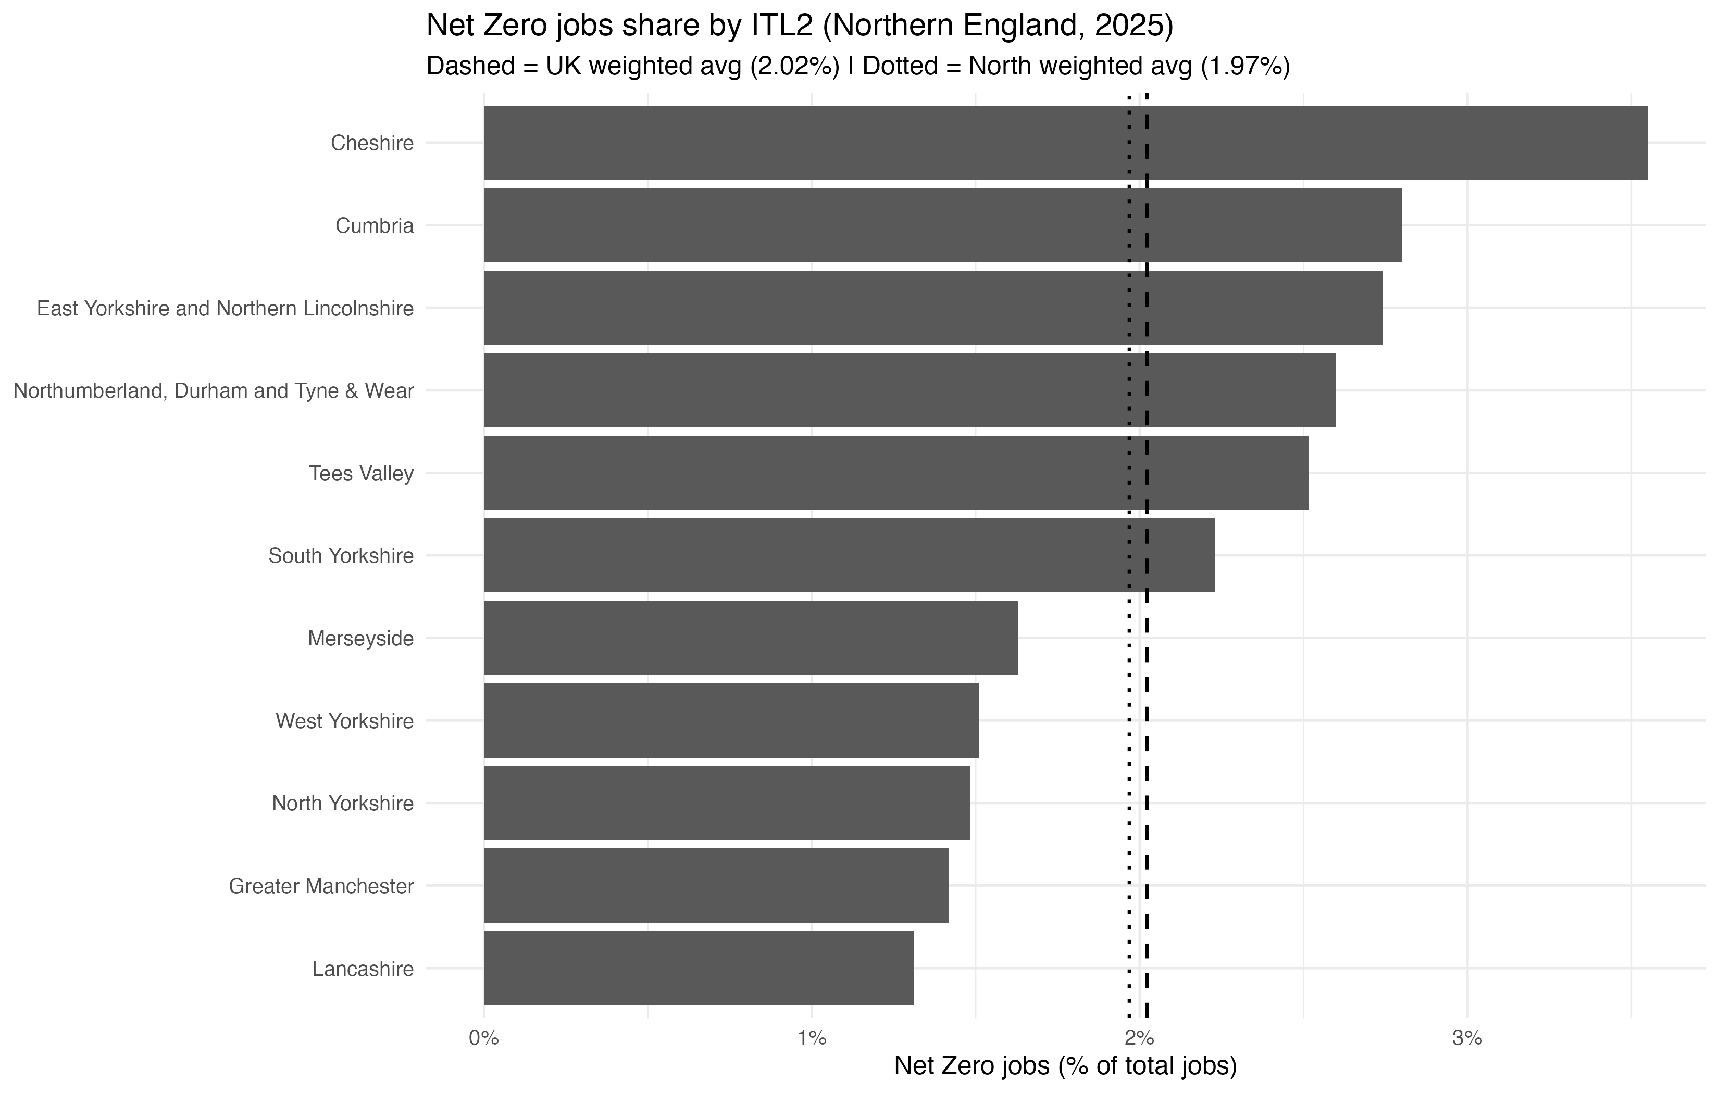
This near parity in employment intensity averages masks substantial variation across ITL2 areas, with a small number of highly specialised places exhibiting much higher net zero employment shares.
The contrast between employment and output shares is significant. While the North does not have a higher concentration of net zero jobs than the national average, it does generate a larger share of net zero output relative to its economic size. This indicates that net zero activity in the North is, on average, more capital-intensive and more strongly associated with high-value production rather than labour-intensive activity.
However, this aggregate picture conceals very considerable internal variation, both geographically and structurally. Differences in industrial composition, energy infrastructure and asset location result in sharply divergent net zero profiles across ITL2 areas, with important implications for policy and investment.

3.1 ITL2 distribution: scale and specialisation
At ITL2 level, the net zero economy in the North of England exhibits a wide range in employment intensity, reflecting the uneven distribution of energy assets, industrial activity and supporting supply chains across the region.
While most ITL2 areas cluster relatively tightly around the regional average, a small number of places display materially higher levels of net zero specialisation. Cheshire records the highest net zero employment share in the North at approximately 3.55%, meaning that more than one in thirty jobs in the area is linked to net zero activity. This places Cheshire well above the regional distribution and highlights the influence of large, asset-based sites within the local economy.
Other ITL2 areas with clearly above-average net zero employment shares include:
- Cumbria, reflecting the role of energy generation and environmental activity
- East Yorkshire and Northern Lincolnshire, linked to energy, ports and industrial logistics
- North East Combined Authority area, associated with energy infrastructure and industrial supply chains
- Tees Valley, where industrial decarbonisation and energy activity play a central role
Together, these areas form a group of relatively specialised net zero economies within the North, despite differing industrial structures and labour market sizes.
At the lower end of the distribution, large and diverse economies such as Merseyside (1.6%), West Yorkshire (1.5%) and Greater Manchester (1.4%) record net zero employment shares below the regional average. In these areas, net zero activity is present at scale in absolute terms, but represents a smaller share of total employment due to the breadth of their wider economic base.
The pattern for net zero output differs in important ways from employment. Net zero GVA shares across Northern ITL2 areas range from under 2% to over 5% of total GVA, with a weighted North-wide average of 2.79%, compared with a GB average of 2.59%.
This indicates that, while net zero employment intensity in the North is broadly in line with the national position, net zero activity contributes a larger share of economic output in the region than nationally. In other words, net zero activity in the North is, on average, more capital-intensive and value-generating than in Great Britain as a whole.
The highest net zero GVA shares at ITL2 level are observed in, Tees Valley (5.3%), North East (4.9%), Cumbria (3.6%), East Yorkshire and Northern Lincolnshire, (3.6%) and Cheshire (3.4%).
These areas are characterised by energy generation, heavy industry and industrial decarbonisation activity, all of which generate high levels of output relative to employment.
By contrast, West Yorkshire (1.9%), Lancashire (2.0%) and Greater Manchester (1.8%) record net zero GVA shares below the North-wide average, despite their large absolute economic scale. This reflects a broader based economy and less dominated by large, capital-intensive assets.
Taken together, the ITL2 evidence points to a structural distinction within the North’s net zero economy:
- Employment intensity is moderate and unevenly distributed, with a small number of specialised areas
- Output intensity is consistently stronger, driven by energy and industrial assets
- The gap between employment and output shares suggests that net zero activity in the North plays a disproportionately important role in value creation, even where it is not the dominant source of jobs
This distinction is critical for policy. Areas with high net zero output but moderate employment intensity may benefit most from interventions focused on supply chain expansion, skills deepening and local value capture, while areas with lower output intensity may require different approaches to stimulate private investment and scale activity.

3.2 ITL3 distribution: geographic concentration
The uneven distribution of net zero activity observed at ITL2 level becomes significantly more pronounced at ITL3 level. This reflects the highly localised nature of many net zero assets and activities, including energy generation, industrial decarbonisation, ports, logistics and specialised manufacturing.
Across the 40 ITL3 areas in the North of England, net zero employment shares range from below 1% to over 6% of total employment. The weighted North-wide average is 1.97%, broadly in line with the GB average of 2.02%, but the dispersion around this average is substantial.
Most ITL3 areas cluster between 1% and 3%, but a relatively small number of places exhibit markedly higher levels of net zero employment intensity. These high-intensity areas tend to be closely associated with major energy, industrial or logistics assets rather than reflecting broad-based labour market specialisation.
At the upper end of the distribution, Warrington records the highest net zero employment share in the North, with net zero activity accounting for almost 7% of all jobs. Other ITL3 areas with above-average net zero employment shares include: Cumberland (4.3%), Barnsley (3.8%), Darlington (3.6%), North and North East Lincolnshire (3.5%), Sunderland (3.4%), and, Cheshire West and Chester (3.4%).

Figure 3.3: Concentration of net zero employment across ITL3 areas
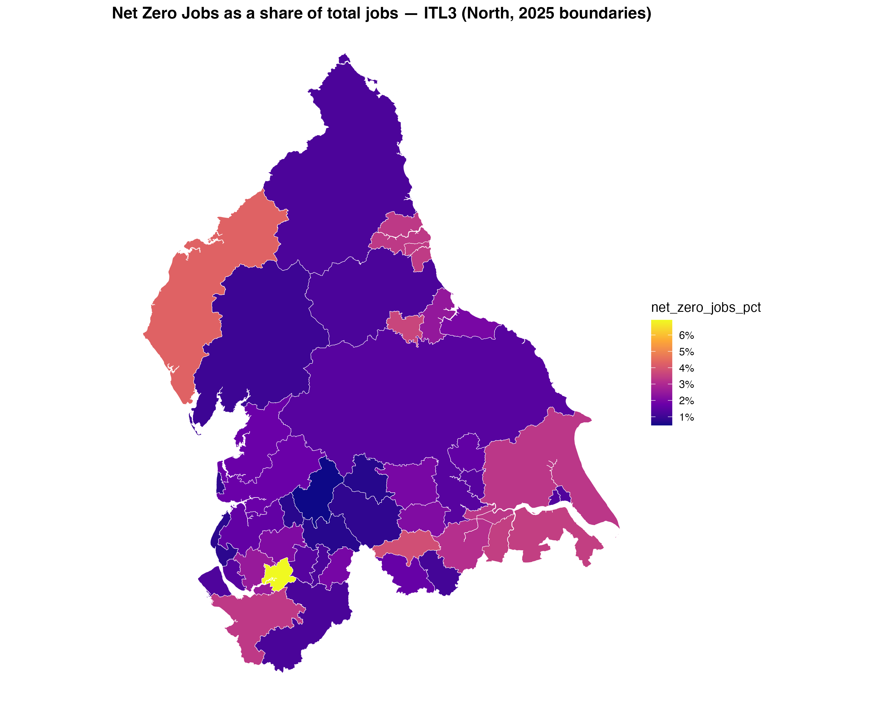
A similarly uneven, but not identical, pattern is observed for net zero output. Net zero GVA shares across Northern ITL3 areas range from around 1% to over 6% of total GVA, with a weighted North-wide average of 2.79%, exceeding the GB average of 2.59%.
The highest net zero GVA shares are recorded in: Sunderland (6.9%), Tyneside (6.8%), Warrington (6.3%), Darlington (6.0%), Cumberland (5.9%), East Merseyside (5.9%), South Teesside (5.2%).
These areas are strongly associated with capital-intensive net zero activity, including power generation, industrial decarbonisation, chemicals and energy infrastructure. In several cases, net zero output intensity substantially exceeds net zero employment intensity, indicating high levels of productivity and value generation per job.
By contrast, a number of ITL3 areas with moderate or above-average net zero employment shares generate a smaller share of net zero GVA. This divergence highlights differences in industrial composition, capital intensity and value capture, rather than simple differences in scale.

Figure 3.4: Concentration of net zero output across ITL3 areas
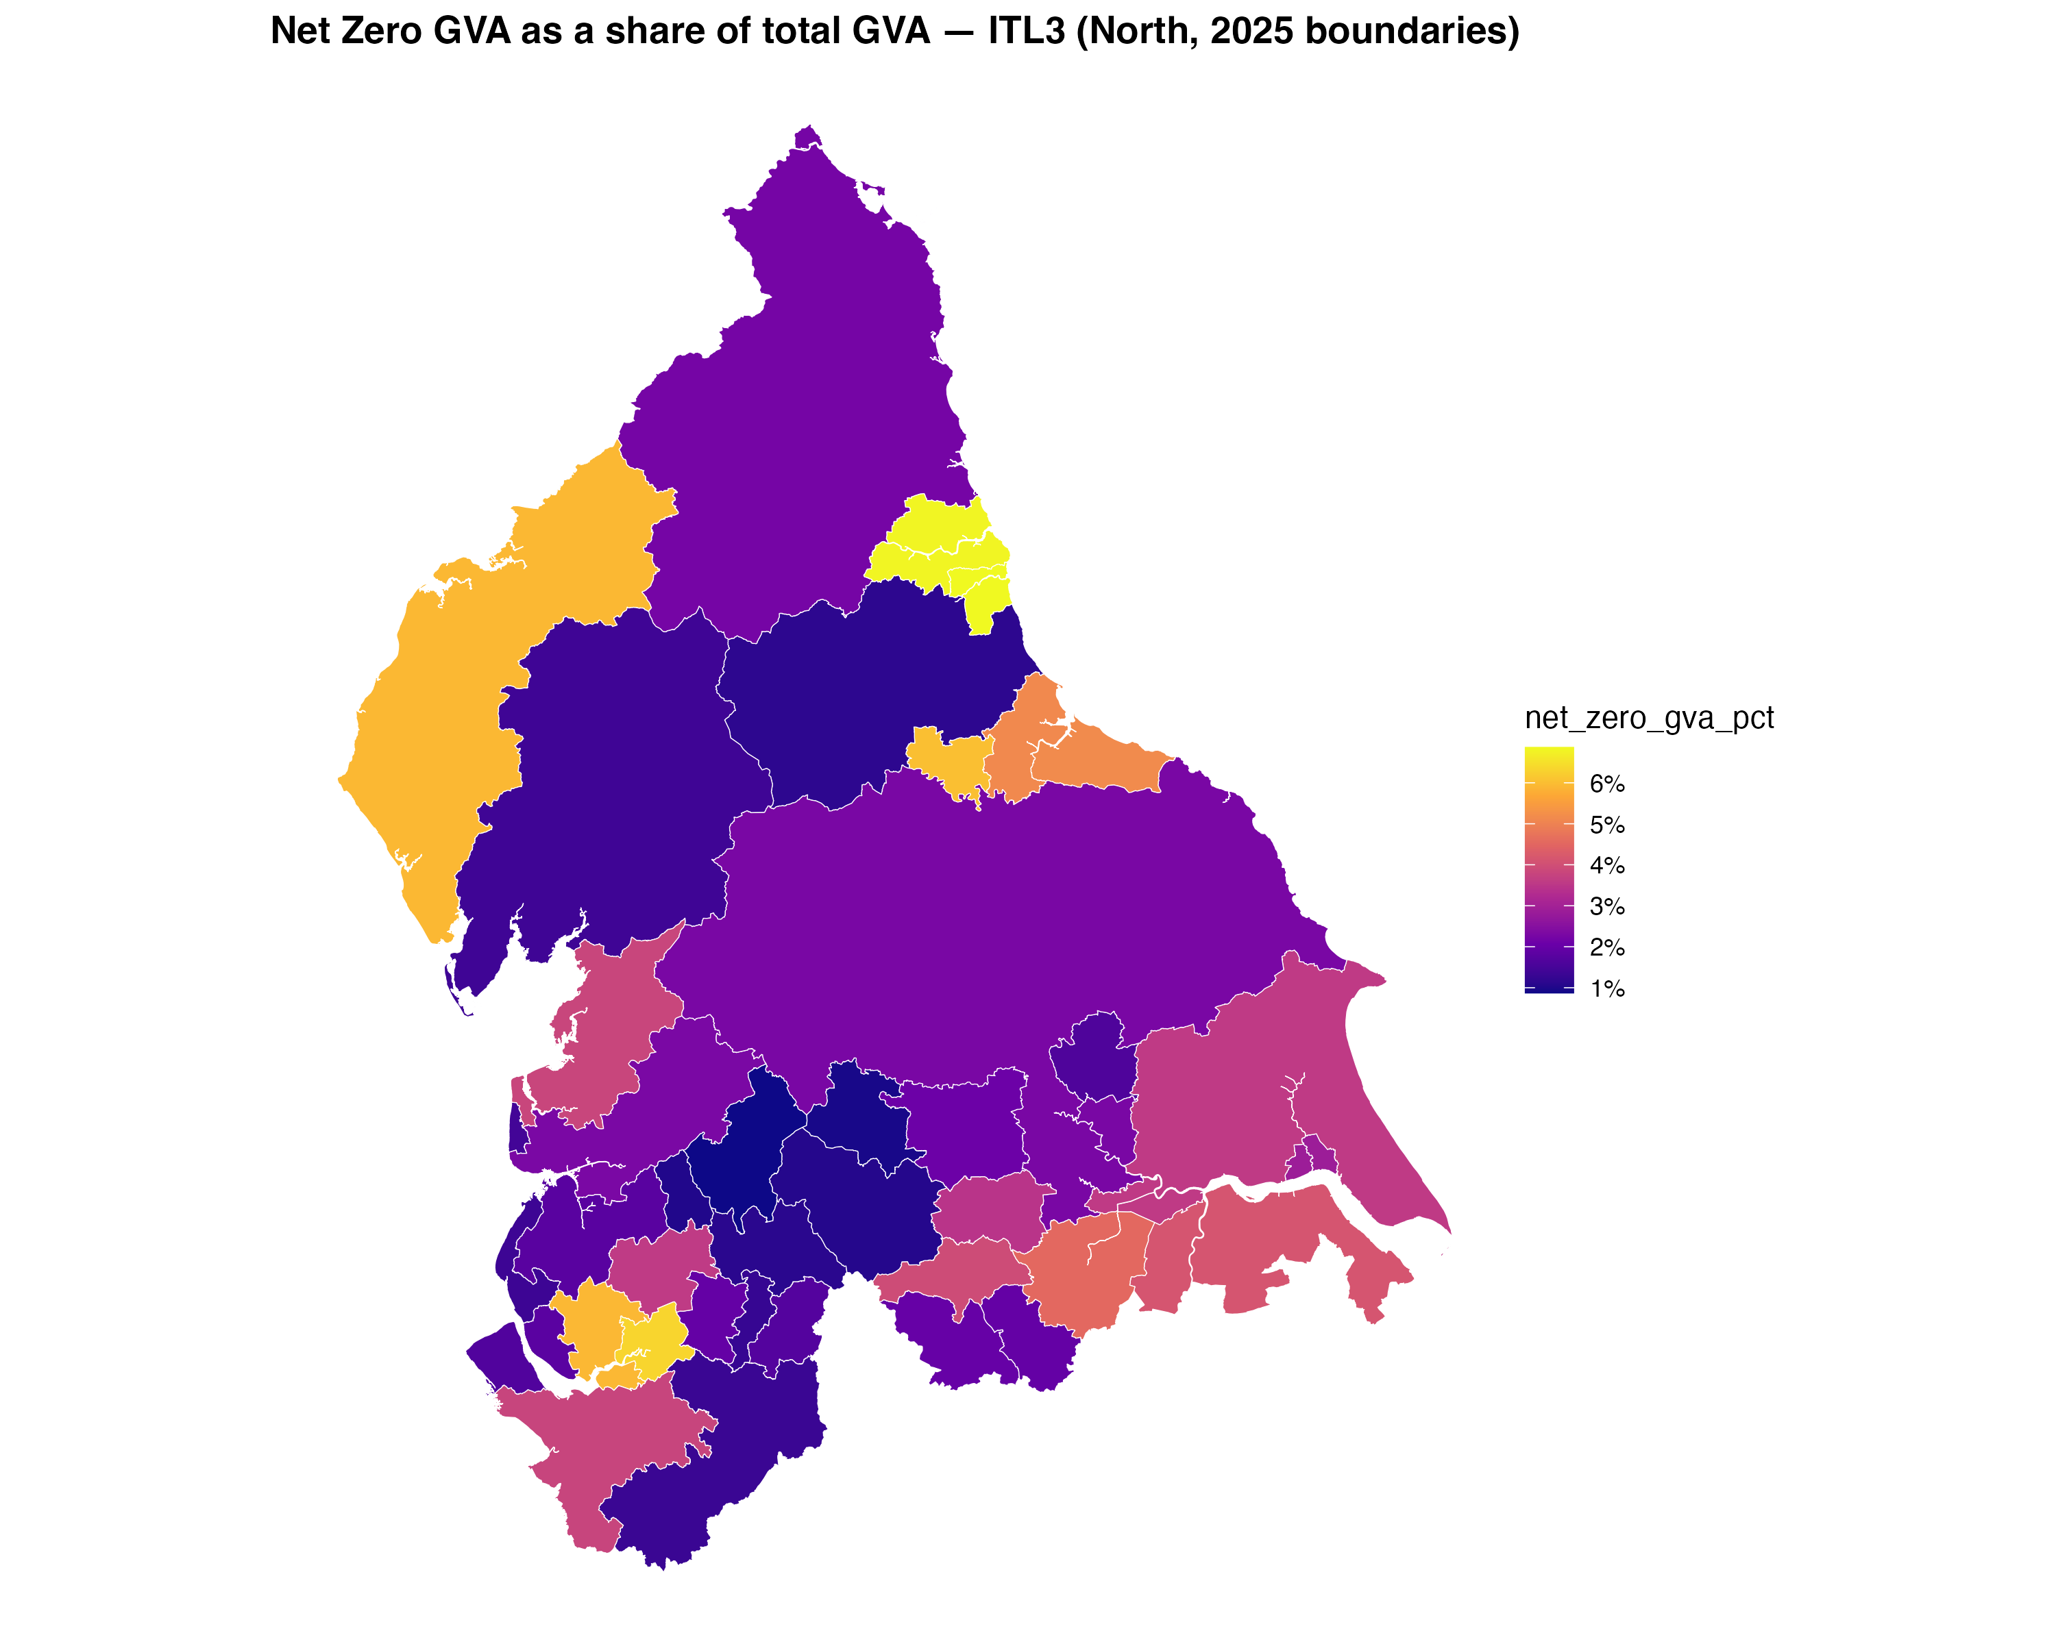
The ITL3 analysis reinforces three key conclusions.
First, the net zero economy in the North is highly concentrated geographically, with a limited number of ITL3 areas accounting for a disproportionate share of employment and output.
Second, employment and output concentrations do not fully align. Some areas specialise in employment-intensive net zero activity, while others specialise in high-value, capital-intensive production. This distinction is critical for understanding local economic impacts and policy needs.
Third, large urban economies tend to exhibit lower net zero intensity, not because net zero activity is absent, but because it represents a smaller share of a more diversified economic base.
Taken together, the ITL3 evidence points to a net zero economy that is deeply place-specific, shaped by the location of major assets, infrastructure and industrial clusters. This reinforces the case for place-based policy approaches, tailored to the specific role each area plays within the wider Northern net zero economy.

4: Productivity and value in the net zero economy
Productivity analysis provides the clearest insight into the economic role played by net zero activity across the North of England. On a weighted basis, net zero GVA per job in the North stands at £93,614, compared with a Great Britain average of £97,099, indicating a modest productivity gap at the regional level.
However, this regional average conceals very substantial variation between places. Differences in industrial structure, asset intensity and position within net zero supply chains result in sharply divergent productivity outcomes across the North.
Figure 4.1: Net zero GVA per job by ITL2, compared with GB average
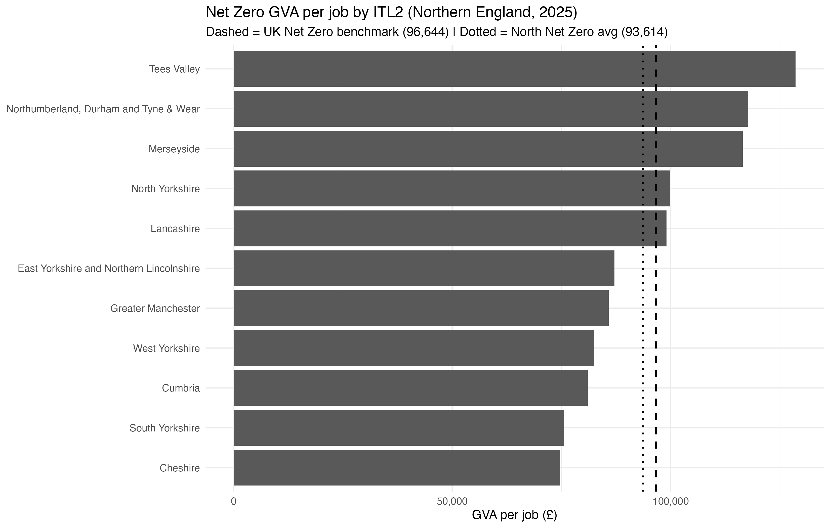

4.1 ITL2 productivity distribution
At ITL2 level, net zero productivity varies widely across the North of England, ranging from £74,644 per job to £128,590 per job. This dispersion highlights the fundamentally different economic roles played by net zero activity across sub-regional economies.
The most productive ITL2 areas include:
• Tees Valley (£128,590 per job)
• North East (£117,663)
• Merseyside (£116,463)
These areas are characterised by capital-intensive net zero activity, including energy generation, industrial decarbonisation and large-scale infrastructure, where output is high relative to employment.
At the lower end of the distribution, Cheshire (£74,644) and South Yorkshire (£75,610) record net zero productivity well below the North-wide average. In these areas, net zero activity is more employment-intensive and less strongly associated with high-value capital assets.
Importantly, this pattern does not imply weaker economic relevance. Instead, it reflects different functional roles within the net zero economy, with some ITL2 areas specialising in labour-intensive operational activity and others in high-value generation.

4.2 ITL3 productivity distribution
Variation in net zero productivity becomes even more pronounced at ITL3 level. Net zero GVA per job ranges from very low values in employment-intensive areas to exceptionally high values in locations dominated by capital-intensive assets, reinforcing the highly localised nature of net zero value creation.
The most productive ITL3 areas include:
• Westmorland and Furness
• Rotherham
• South Teesside
These areas generate very high levels of net zero output with relatively small workforces, indicating strong value capture and high capital intensity.
By contrast, Cheshire West and Chester sits at the opposite end of the productivity spectrum. Despite having one of the highest net zero employment shares in the North, it generates relatively low GVA per job. This reflects the concentration of employment-heavy net zero activity, rather than a lack of economic significance.

4.3 Relationships between employment, output and productivity
The relationship between net zero employment, output and productivity further underlines these structural differences.
Across ITL3 areas, net zero employment share and net zero GVA share are positively correlated, indicating that places with more net zero activity tend also to generate more net zero output. However, the relationship between employment intensity and productivity is weak and, in places, negative.
This confirms that hosting large numbers of net zero jobs does not automatically translate into higher productivity or greater value capture. Instead, different places occupy different economic positions within the net zero system - from operational delivery to asset ownership and value generation.

4.4 Implications for economic structure
Taken together, the evidence supports the identification of four distinct economic roles within the net zero economy in the North of England:
- Employment-intensive areas, hosting large net zero workforces relative to their total workforce with relatively low value per job
- Value-intensive areas, generating high output with smaller workforces
- Balanced areas, combining above-average employment intensity and productivity
- Marginal areas, where net zero activity remains limited on both dimensions
These roles are structurally embedded, reflecting differences in asset ownership, industrial mix and supply-chain position. They have direct implications for investment strategy, skills policy and how the economic benefits of the net zero transition are distributed spatially.

Figure 4.3: net zero economic typology of ITL2 areas in the North of England
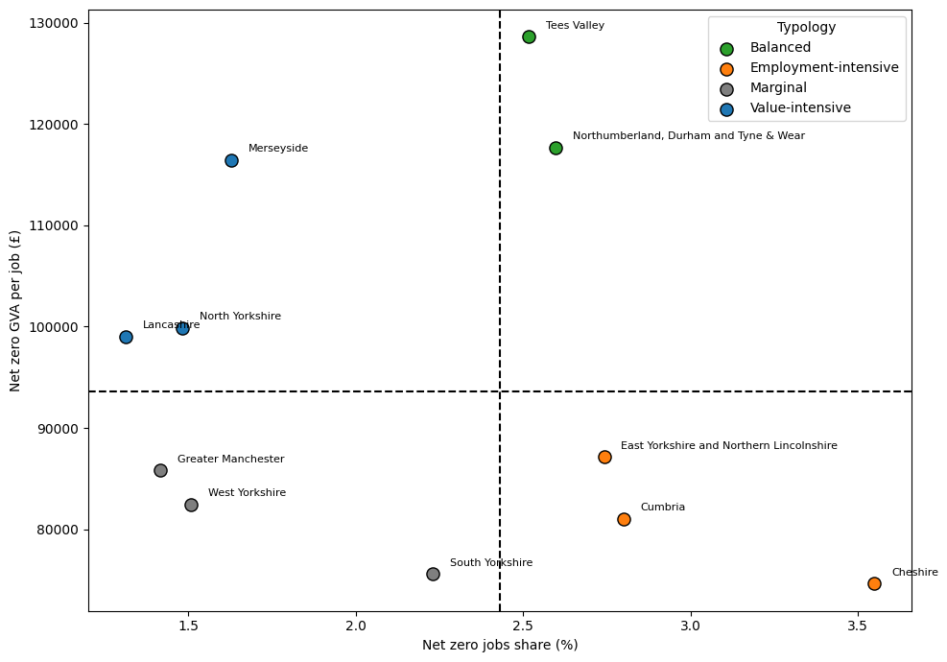
Each point represents an ITL2 area in the North of England, plotted by net zero jobs as a share of total employment (x-axis) and net zero GVA per job (y-axis). The dashed lines denote the North of England ITL2 mean values for net zero employment intensity (2.432%) and net zero productivity (£93,614 per job). The figure identifies four broad economic roles within the net zero economy: areas that are employment-intensive, value-intensive, balanced in terms of employment and productivity, and areas where net zero activity remains relatively marginal on both dimensions

At ITL2 level, the typology highlights clear strategic differentiation. Some areas combine strong employment and productivity performance, while others specialise either in employment-intensive or value-intensive net zero activity. West Yorkshire and Greater Manchester fall below the average on both dimensions, indicating a more marginal net zero role at present, given the breadth of their much larger economies.

Figure 4.4: net zero economic typology of ITL3 areas in the North of England
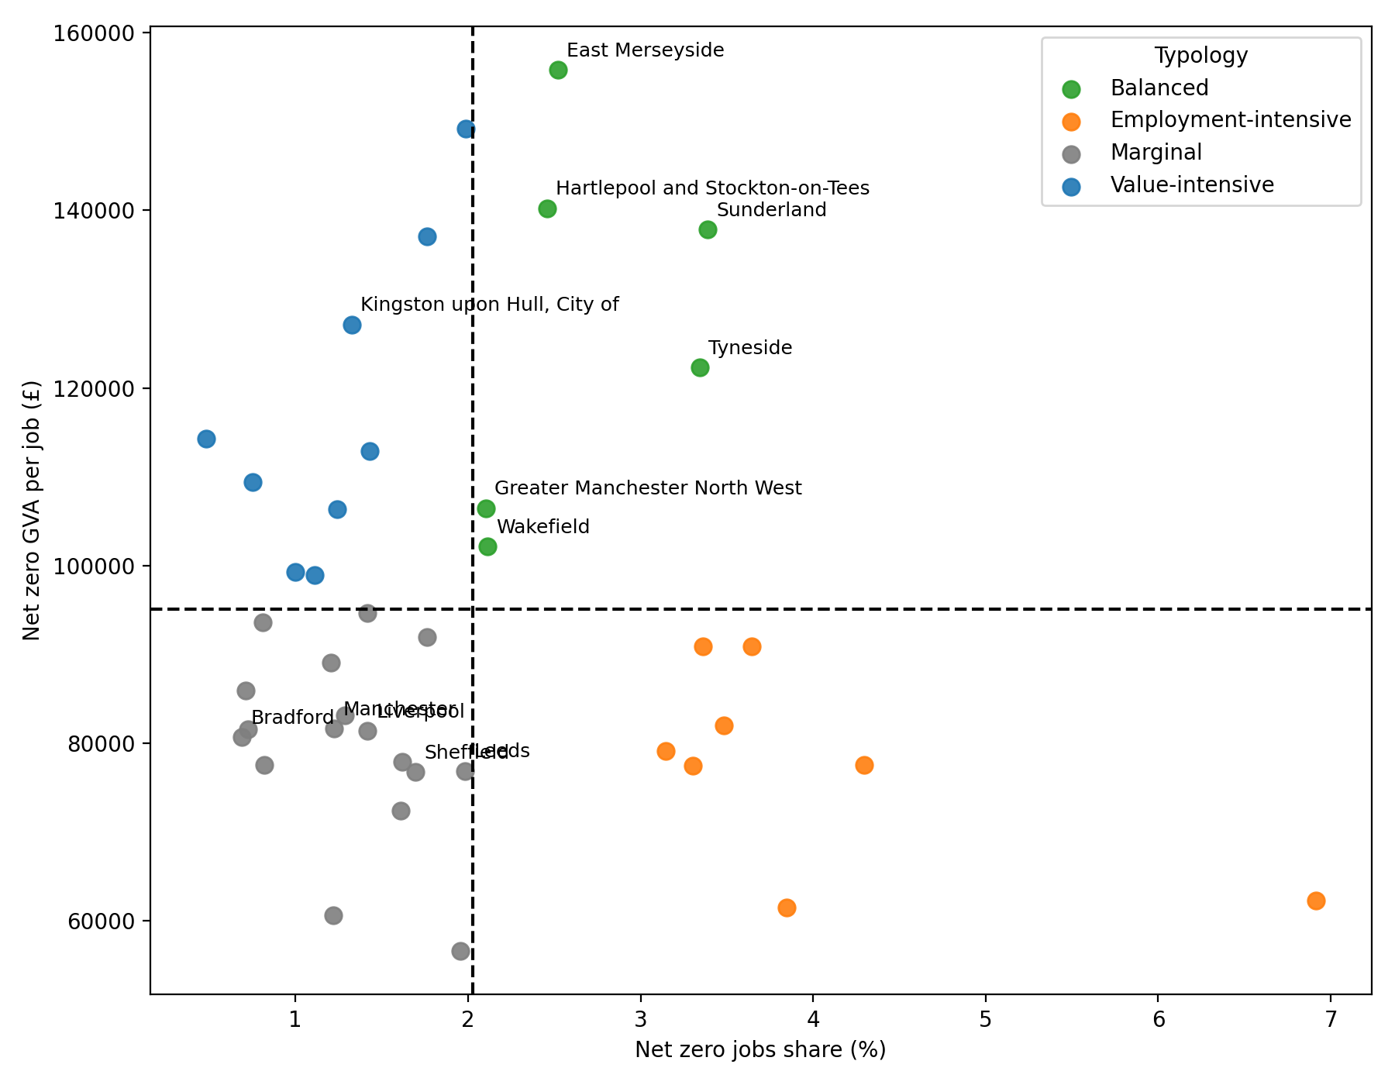
Each point represents an ITL3 area in the North of England, plotted by net zero jobs share (x-axis) and net zero GVA per job (y-axis). The dashed lines denote the North of England ITL3 mean values for net zero employment intensity and net zero productivity, dividing areas into four quadrants. The figure highlights four distinct economic roles within the net zero economy at a more granular spatial scale: employment-intensive, value-intensive, balanced, and marginal.
At ITL3 level, the pattern becomes significantly more fragmented. Employment-intensive net zero activity is highly concentrated in a small number of places, most notably Cheshire West and Chester, reflecting the influence of specific large-scale assets. In contrast, high-productivity net zero activity is more widely distributed across the North. Several areas - including South Teesside, Rotherham and Westmorland and Furness - combine relatively high productivity with meaningful employment intensity, indicating strong local value capture.
Major urban economies such as Manchester and Liverpool fall within the marginal quadrant, reflecting the fact that while net zero activity is present in absolute terms, it accounts for a relatively small share of both employment and output within highly diversified city economies.

5: Investment in the net zero economy
The analysis in Sections 3 and 4 demonstrates that the net zero economy in the North of England is not uniform in either scale or economic character. Instead, it is structured around a set of distinct economic roles that vary systematically across places. These roles are visible at both ITL2 and ITL3 levels and reflect differences in industrial structure, asset bases, skills, and position within national and international supply chains.
This has important implications for how policy and investment should be designed and targeted. A single, uniform approach to supporting net zero growth risks being inefficient at best and counterproductive at worst. Instead, policy should recognise that different places face different challenges and opportunities, and that the economic returns to intervention will vary accordingly.

5.1 Strategic roles at ITL2 level
The ITL2 quadrant analysis (Figure 4.3) provides a strategic overview of how net zero activity is embedded across the North. Four broad patterns are apparent.
First, a small number of ITL2 areas combine above-average net zero employment shares and above-average productivity, placing them in the balanced quadrant. These areas, including the North East, are well positioned to capture both employment and value from net zero activity. They typically host a mix of industrial assets, services, innovation capacity and supply chain depth.
In these areas, policy priorities should focus on scaling and acceleration. This includes support for inward investment, expansion of existing firms, and the strengthening of innovation ecosystems that allow firms to move up the value chain. Public investment in enabling infrastructure, including transport, digital connectivity and energy networks, is likely to crowd in private capital by reducing delivery risk and improving commercial viability.
Second, some ITL2 areas are characterised by employment-intensive but lower-productivity net zero activity, most notably Cheshire. These areas host a relatively large share of the North’s net zero workforce, but generate relatively low value per job. This pattern reflects the presence of labour-intensive activity and, in some cases, a reliance on established industrial processes.
In these places, the challenge is not job creation but value capture and progression. Policy interventions should therefore focus on skills upgrading, workforce progression and innovation adoption, rather than simply expanding employment. Investment in training, reskilling and management capability can help raise productivity and wages, while targeted support for process innovation and digitalisation can improve value added without reducing employment.
Third, several ITL2 areas fall into the value-intensive quadrant, including Cumbria, Merseyside and North Yorkshire. These areas generate high levels of net zero GVA per job but support relatively smaller net zero workforces. This pattern is often associated with capital-intensive activity such as energy generation or specialised engineering.
For these areas, the key risk is that high-value activity remains weakly embedded in the local economy. Policy should therefore focus on anchoring value locally, for example by strengthening local supply chains, supporting local SMEs to participate in procurement, and ensuring skills provision aligns with the needs of high-value employers. Without this, the economic benefits of net zero activity may leak out of the region.
Finally, some ITL2 areas, including West Yorkshire and Lancashire, fall below the average on both employment share and productivity. In these areas, net zero activity currently plays a relatively marginal role in the economy due to its size and diversity.

5.2 Local differentiation at ITL3 level
While the ITL2 analysis provides strategic clarity, it also masks substantial variation within regions. The ITL3 quadrant analysis (Figure 4.4) reveals a much more fragmented landscape, with sharp contrasts between neighbouring areas.
At ITL3 level, employment-intensive net zero activity is highly concentrated in a very small number of places, most notably Cheshire West and Chester. This concentration means that a significant share of the North’s net zero workforce is exposed to a narrow set of local economic conditions. From a policy perspective, this raises questions regarding resilience, progression and long-term sustainability.
Balanced ITL3 areas, such as South Teesside, Rotherham and Westmorland and Furness, stand out as places where net zero activity delivers both employment and high productivity. These areas often combine industrial assets with strong value capture and are likely to offer the highest short-term economic returns to investment. However, they may also face acute constraints, including grid capacity, planning bottlenecks or skills shortages, that could limit further growth.
Major urban economies such as Manchester and Liverpool fall within the marginal quadrant at ITL3 level. This reflects the fact that, while net zero activity is present in absolute terms, it accounts for a relatively small share of both employment and output within highly diversified city economies. Net zero functions in these areas are often embedded within wider professional, technical and service-based sectors, rather than forming a distinct or specialised economic focus.
In contrast, a large number of ITL3 areas fall into the marginal quadrant, with both low employment shares and low productivity. These areas often include parts of larger urban economies where net zero activity is currently underdeveloped. For these places, the net
zero transition represents a longer-term opportunity rather than an immediate driver of growth.

5.3 Aligning investment approaches to place-based roles
The diversity of economic roles identified in the quadrant analysis has clear implications for how investment should be structured.
In balanced areas, blended investment models that combine public capital, private finance and institutional investment are likely to be most effective. These areas can absorb investment at scale, but require coordinated action to address infrastructure and skills constraints.
In employment-intensive areas, the priority should be improving productivity and value capture rather than expanding headcount. This suggests a focus on skills, innovation support and management capability, rather than traditional job-creation incentives.
In value-intensive areas, policy should work to expand local linkages and ensure that high-value activity generates wider economic benefits. This includes support for supply chain development, local procurement and knowledge spillovers.
In marginal areas, early-stage public investment and risk-sharing mechanisms will often be necessary to unlock private capital. Without this, market forces alone are unlikely to deliver meaningful net zero growth.

5.4 Implications for public and private investment
The evidence additionally supports the importance of the relationship between public and private investment. As highlighted in the Cambridge Econometrics analysis of public–private investment splits, public investment plays a key role in de-risking projects, particularly in capital-intensive and early-stage net zero activities.
In the North, this de-risking role is especially important in areas where net zero activity is either highly concentrated or underdeveloped. Strategic public investment in infrastructure, skills and project development can unlock private capital, but only if it is aligned with the core economic role of each place.
A failure to differentiate risks either over-subsidising activity that would have happened anyway, or under-supporting areas where market failures are most acute.

5.5 From analysis to delivery
Taken together, the quadrant analysis delivers a framework for moving from descriptive analysis to actionable policy. It allows decision-makers to distinguish between places where the priority is scaling, upgrading, or capacity-building.
Crucially, it also highlights that success in the net zero transition should not be judged solely by the number of jobs created. In many parts of the North, the greater prize lies in improving productivity, capturing value locally and embedding net zero activity within resilient regional economies.
The next section builds on this framework by examining how these findings can inform delivery mechanisms, governance arrangements and the sequencing of investment over time.

6: Case studies: net zero delivery in the North of England
The scale and composition of the net zero economy in the North of England is defined by a small number of key strategic assets and industrial clusters. As shown in Sections 3 and 4, net zero activity in the North is spatially concentrated, capital-intensive and uneven in its employment and productivity characteristics. The case studies set out below illustrate how these patterns translate into delivery on the ground, and how public and private investment interact in practice.
Together, they demonstrate why a place-based approach to net zero delivery is essential, especially in regions where large anchor assets underpin both decarbonisation and economic value creation. There are a number of opportunities which are pan Northern in scale, or which cross combined authority boundaries including on the Humber Estuary.

Bioenergy with carbon capture at Drax Power Station
Drax Power Station in North Yorkshire is one of the most significant energy assets in the country providing power for millions of homes and conversion to operate with carbon capture could see the power station plays a central role in national net zero pathways. The site has already undergone a major structural transition, moving from coal-fired generation to large-scale sustainable biomass. The proposed deployment of bioenergy with carbon capture and storage represents the next phase of this transition and illustrates the economic and delivery challenges associated with capital-intensive net zero technologies.
The deployment of carbon capture at Drax requires substantial private investment in plant, equipment and operational capability. However, private capital alone is insufficient to deliver the project. Carbon capture depends on the availability of shared transport and storage infrastructure, as well as on policy mechanisms that provide revenue certainty and manage long-term risk. These factors create a clear role for public investment in early-stage development, coordination and risk reduction.
The wider economic effects for the North are nonetheless significant. Drax supports a substantial number of direct and indirect jobs, many of them highly skilled, and its supply chains extend across the region. The development of carbon capture capability strengthens the North’s position in a strategically important technology, creating expertise that is transferable across power generation and industrial decarbonisation.
Crucially, the economic benefits extend beyond the site itself. As highlighted in the typology analysis in Section 4, high-productivity net zero assets can act as anchors within regional economies, generating demand for specialist services, attracting inward investment and supporting complementary activity. The Drax example illustrates how targeted public intervention can unlock wider private investment and long-term economic value in places where market failures would otherwise constrain delivery.

Industrial decarbonisation and carbon capture in the Humber
The Humber is one of the most important industrial clusters and one of the most emissions-intensive regions. It hosts a concentration of energy generation, chemicals, refining and manufacturing activity that is critical to national supply chains. Decarbonising this cluster is therefore central to achieving net zero, but it also represents a major opportunity to secure the long-term competitiveness of industry in the North.
As shown in the ITL2 and ITL3 analysis, parts of the Humber combine relatively high net zero employment shares with strong productivity performance. This reflects the scale of industrial activity in the area and the presence of energy and emissions-intensive sectors where decarbonisation investment has a material economic impact.
Industrial decarbonisation in the Humber depends on a portfolio of technologies, including carbon capture and storage, hydrogen production and electrification. Delivering these at scale needs integrated investment across firms, sectors and locations. Individual businesses are unlikely to invest in decarbonisation technologies if shared infrastructure does not exist, or if policy uncertainty undermines commercial viability. This creates a clear coordination problem that private markets alone cannot resolve.
Associated British Ports has achieved planning consent to build a new terminal, the Immingham Green Energy Terminal (IGET), that will play a pivotal role in the Viking CCS Cluster, one of the UK’s most significant industrial decarbonisation initiatives. By developing large‑scale seaborne CO₂ transport infrastructure, this terminal will provide a flexible, high‑volume route to move captured emissions from hard to abate industrial processes across the UK and North West Europe to long‑term offshore storage, supporting high quality jobs, national decarbonisation and realising economic growth through exports.
Viking CCS brings together major industrial partners to deliver an end‑to‑end CO₂ capture, transport, and storage system. Its aim is to reduce emissions from the Humber - one of the UK’s most carbon‑intensive regions - as well as from dispersed industrial sites that lack access to local storage. At peak construction, the project could create up to 8,000 skilled jobs and will generate £7billion GVA for the UK economy, making it a key driver of industrial transition and regional economic growth.
ABP’s terminal will serve as a national hub for receiving shipped CO₂ and transporting it to Viking’s Southern North Sea storage sites. With Europe facing sequestration shortfalls, it also enables the UK to offer CCS as an export service. Shipping captured CO2 is a vital step towards decarbonising energy generation and heavy industry and creates a market for a new energy commodity. The UK has world leading geological capacity for storing captured carbon.
Ensuring this project can play its full part in the UK’s energy transition will require clear policy on carbon shipping, cooperative international arrangements, and dependable long‑term investment frameworks.
The economic importance of this approach is considerable. Investment in industrial decarbonisation in particular can help safeguard existing employment, create new high-value roles and prevent the erosion of industrial capacity in the North. It additionally reinforces the region’s position as a location for future low-carbon manufacturing and energy-intensive industries.
The Humber case highlights a wider lesson for net zero delivery. Large-scale decarbonisation is inherently spatial and systemic. Public investment is not simply a funding mechanism, but a tool for alignment, enabling private capital to support outcomes that are economically efficient and socially desirable but would not otherwise be delivered.

Lessons for net zero delivery in the North
Taken together, these case studies reinforce a number of important points emerging from the analysis earlier in the report. Firstly, the most economically significant net zero opportunities in the North are closely tied to large, place-specific assets and clusters. Secondly, while private investment is essential, it is rarely sufficient on its own, given the presence of coordination failures, infrastructure constraints and early-stage risk. Third, the economic benefits of net zero investment extend well beyond just individual projects, shaping regional supply chains, skills demand and long-term competitiveness.
These examples underline the importance of a strategic, place-based approach to net zero delivery in the North of England led by Mayoral Combined Authorities and with co-ordination and support from the Northern Growth Corridor and nationally. Aligning national policy, regional leadership, the Public Financial Institutions and private capital is critical if decarbonisation objectives are to be achieved in a way that also supports productivity, resilience and sustainable economic growth.

7: Barriers to growth in the net zero economy
Despite the scale of opportunity, growth in the net zero economy is not automatic. The analysis in previous chapters highlights a number of structural barriers that, if left unaddressed, will limit the pace of transition and constrain the economic benefits for the North of England.
One of the most significant barriers is investment risk and uncertainty. Many net zero projects involve high upfront capital costs, long payback periods and exposure to regulatory and policy change. While private capital is available in principle, it is often reluctant to invest at scale without greater certainty over future market conditions, pricing and policy support. This is particularly acute for first-of-a-kind projects and shared infrastructure, where risks cannot be easily diversified.
Grid capacity and infrastructure constraints present a further challenge. In several parts of the North, electricity network capacity is already limiting the deployment of new generation, storage and industrial electrification. Delays to grid connections increase costs and create uncertainty, undermining investor confidence. It is hugely welcome that there are significant projects being led by National Grid across the country, including in the North of England. The Great Grid Upgrade is building capacity from Scotland to rest of the country through the North as well as across the North. There is also significant requirements for the development of distribution networks alongside these investments in transmission which the National Energy System Operator must set out requirements for.
Skills and workforce availability are also emerging as binding constraints. Many net zero activities require specialist technical skills, including in engineering, construction, digital systems and process optimisation. While the North has a strong industrial workforce, the scale and speed of transition risk outpacing current skills pipelines. Without coordinated action on training, reskilling and workforce planning, skills shortages could slow deployment and increase costs.
Planning and regulatory processes can also act as barriers, notably for large or complex projects. Lengthy planning timelines, inconsistent decision-making and limited local capacity can delay investment and increase uncertainty. For projects that require coordination across multiple sites or jurisdictions, these problems are amplified. Improving operational procedures while upholding adequate safeguards will be important for accelerating delivery.
There are also place-based barriers linked to the uneven geography of the net zero economy. Areas with high net zero employment but lower productivity may struggle to attract higher-value activity without focused action. Conversely, areas with high-value net zero activity may generate limited local employment benefits unless supply chains and skills development are actively supported. Without a place-sensitive approach, the transition risks reinforcing existing disparities within the North.
Finally, institutional complexity can undermine effective delivery. Responsibility for net zero policy, funding, and regulation is spread across multiple levels of government and Public Financial Institutions, such as the National Wealth Fund. While this reflects the cross-cutting nature of the challenge, it can make coordination difficult and slow decision-making.
These barriers can be overcome. They reflect the scale and complexity of the net zero transition rather than a lack of opportunity. Addressing them will demand ongoing public leadership, strategic investment and close collaboration with the private sector. The following section sets out the policy implications of this analysis, and the priorities for supporting growth in the net zero economy in the North of England.

8: Policy implications for the net zero economy in the North of England
The analysis in this report shows that the net zero economy is already a significant and distinctive part of the North of England’s economic landscape. It plays a disproportionately important role in the North relative to the region’s overall economic size than in Great Britain as a whole, but it is also highly uneven within the region. This has important implications for policy design and delivery.
First, policy needs to recognise the central role of the North in achieving national net zero objectives. Many of the sectors and assets that must decarbonise at pace are concentrated in the region. National delivery, therefore, depends on effective action in the North in places like Sunderland and Tyneside which lead the North in the relative importance of Net Zero to their economies. This strengthens the case for a place-based approach that aligns national ambition with regional strengths, rather than relying on uniform, one-size-fits-all interventions.
Second, public investment must be used strategically to unlock private capital. The evidence shows that private investment will provide the majority of funding for the net zero transition, but it will not do so without clear signals, reduced risk and enabling infrastructure. Institutions need to deliver their respective roles; National Wealth Fund which is returns focused, government departments themselves providing grant, the place leadership of combined authorities and GB Energy a strategic equity investor and market shaper. Public funding should therefore focus on areas where it has the greatest leverage; including shared infrastructure, early-stage deployment and first-of-a-kind projects. This is particularly important for capital-intensive activities such as energy, industrial decarbonisation and carbon capture where the Humber has missed out so far on the levels of commitment which will in the end be needed.
Third, policy should differentiate between the roles that different places play within the net zero economy. Some areas are centres of large-scale employment, others are centres of high value activity, and a smaller number combine both. Effective policy needs to reflect these differences. In employment-intensive areas, priorities may include skills, workforce progression and supply chain development where GB Energy currently has £300m of a total £1bn fund available and we need to encourage take up in the North, both in key areas such as the Humber and the North East as well as in the corridor across the Pennines. In high value areas, the focus may be on innovation, capital investment and anchoring activity locally. Treating all places in the same way risks underperforming on both growth and inclusion.
Fourth, productivity must be treated as a core objective of the net zero transition, not a secondary consideration. Job creation is important, but the long-term economic benefits of net zero will depend on the value generated by those jobs. Policy should therefore support the diffusion of high value activity, encourage innovation and help regions move up the value chain. The success of Rolls-Royce SMR, built in part upon applied research at the AMRC in South Yorkshire, is a strong case in point. This includes making sure that cities and urban centres are able to capture value from net zero activity even where large-scale deployment occurs elsewhere.
Fifth, addressing enabling constraints is essential to accelerating delivery. Investment in grid capacity, planning capability and skills infrastructure is not ancillary to net zero delivery. It is foundational. Without action in these areas, even well-funded projects will face delays and cost overruns. Coordinated approaches to skills planning, workforce development and infrastructure investment will be critical.
Skills shortages are compounded by a lack of long-term policy certainty. Where major projects face delay or uncertainty, employers and training providers are unable to plan with confidence, making it harder to build and sustain the skills pipelines needed to deliver net zero at scale.
Finally, governance and coordination matter. The net zero transition cuts across sectors, places and institutions. Effective delivery demands explicit roles, aligned incentives and mechanisms for collaboration between national government, pan Northern, combined authority leadership and the private sector. Strengthening these relationships will improve delivery and reduce the risk of fragmented or inconsistent action.
Taken together, these implications point to a clear conclusion. The net zero transition represents a major economic opportunity for the North of England but realising that opportunity will require deliberate choices. Strategic public investment, place-based policy and effective coordination can ensure that the transition supports productivity, competitiveness and inclusive growth. The growth plan to be published in the Spring by government must put these issues front and centre, with encouragement to key players like the National Wealth Fund to make northern investment including on a place-based basis.

Appendix A: Methodology

Our list of net zero companies has been compiled using the same methodology as our 2024 report Net Zero by 2050. The starting point is The Data City’s Machine Learning list function, which identifies companies operating within a defined industry vertical based on a representative training set. As described by The Data City: “Companies are ranked by how representative they are of the companies selected in the training set.”
This initial list was then refined using expert judgement. Several companies were removed where their primary activities did not align with what would typically be understood as net zero economic activity, including major fossil fuel producers and their subsidiaries. This approach ensures the final list reflects companies whose core business activities are directly linked to net zero technologies, services, and supply chains.
Changes in the number of companies and associated measures (such as employment, turnover, and GVA) relative to the 2024 report may therefore reflect refinements to methodology, classification, or data updates rather than underlying changes in the size of the net zero economy itself. As a result, this report does not present direct comparisons with the Net Zero by 2050 analysis.
To assess the geographic distribution of economic activity, company-level employment, turnover, and GVA are split equally across all a company’s known operating sites. While this represents a simplifying assumption, it provides a consistent and transparent method for estimating local economic impact and avoids attributing all activity to registered head office locations.
Where indicators such as net zero employment as a share of total employment, or net zero GVA as a share of total GVA, are presented, total employment figures are drawn from the Office for National Statistics’ Business Register and Employment Survey (BRES), while total GVA figures are taken from ONS Regional GVA statistics.
Finally, where changes to official statistical geographies (such as updates to ITL boundaries) mean that published datasets are not directly comparable, geographies have been reconstructed using official lookup tables. This ensures consistency across datasets and avoids distortions arising from boundary revisions.
All results should therefore be interpreted as indicative estimates rather than precise measures of local activity.
The ITL2 region of Northumberland, Durham and Tyne and Wear has been referred to as North East CA for presentational reasons.

Appendix B: Northern ITL2 Areas Full Table
ITL2 Area | No of Net Zero Sites | GVA (£bn) | Turnover (£bn) | Employees | GVA per job (£) | Proportion of total jobs within the ITL2 area from net zero (%) | Proportion of total GVA within the ITL2 area from net zero (%)
Cheshire | 923 | 1.4 | 11.0 | 19,064 | 74,645 | 3.6 | 3.4
Cumbria | 371 | 0.5 | 1.9 | 6,664 | 81,037 | 2.8 | 3.6
East Yorkshire and Northern Lincolnshire | 576 | 1.0 | 5.3 | 10,943 | 87,130 | 2.7 | 3.6
Greater Manchester | 1,658 | 1.8 | 9.6 | 20,914 | 85,827 | 1.4 | 1.8
Lancashire | 653 | 0.9 | 3.3 | 8,677 | 99,035 | 1.3 | 2.0
Merseyside | 654 | 1.3 | 3.8 | 10,973 | 116,464 | 1.6 | 3.0
North Yorkshire | 656 | 0.6 | 6.8 | 5,930 | 99,900 | 1.5 | 2.1
North East CA | 1,082 | 2.6 | 10.5 | 21,820 | 117,663 | 2.6 | 4.9
South Yorkshire | 742 | 1.0 | 4.1 | 12,986 | 75,611 | 2.2 | 2.8
Tees Valley | 366 | 0.9 | 3.4 | 6,897 | 128,590 | 2.5 | 5.3
West Yorkshire | 1,048 | 1.4 | 15.1 | 16,868 | 82,466 | 1.5 | 1.9
North | 8,729 | 13.3 | 74.8 | 141,734 | 93,614 | 2.0 | 2.8

Appendix C: Northern ITL3 Areas Full Table
ITL3 Area | No of Net Zero Sites | GVA (£bn) | Turnover (£bn) | Employees | GVA per job (£) | Proportion of total jobs within the ITL3 area from net zero (%) | Proportion of total GVA within the ITL3 area from net zero (%)
Barnsley | 191 | 0.2 | 1.4 | 3,229 | 61,516 | 3.8 | 3.9
Blackburn with Darwen | 53 | 0.0 | 0.3 | 521 | 81,579 | 0.7 | 1.0
Blackpool | 54 | 0.0 | 0.2 | 510 | 93,571 | 0.8 | 1.4
Bradford | 172 | 0.1 | 0.4 | 1,371 | 80,705 | 0.7 | 0.9
Calderdale and Kirklees | 216 | 0.2 | 0.6 | 2,060 | 77,560 | 0.8 | 1.1
Cheshire East | 278 | 0.2 | 1.0 | 2,500 | 89,034 | 1.2 | 1.3
Cheshire West and Chester | 344 | 0.5 | 2.8 | 5,913 | 90,889 | 3.4 | 3.8
Chorley and West Lancashire | 140 | 0.1 | 0.3 | 1,471 | 77,932 | 1.6 | 1.8
Cumberland | 174 | 0.4 | 1.5 | 5,583 | 77,506 | 4.3 | 5.9
Darlington | 41 | 0.2 | 0.7 | 2,004 | 90,913 | 3.6 | 6.0
Doncaster | 219 | 0.3 | 1.2 | 4,121 | 79,149 | 3.1 | 4.5
Durham | 292 | 0.1 | 0.9 | 2,293 | 60,633 | 1.2 | 1.1
East Lancashire | 94 | 0.1 | 0.2 | 563 | 114,255 | 0.5 | 0.9
East Merseyside | 215 | 0.8 | 2.3 | 4,894 | 155,784 | 2.5 | 5.9
East Riding of Yorkshire | 229 | 0.3 | 2.3 | 4,325 | 77,478 | 3.3 | 3.6
Greater Manchester North East | 193 | 0.2 | 0.6 | 1,789 | 85,907 | 0.7 | 1.1
Greater Manchester North West | 204 | 0.5 | 1.5 | 4,772 | 106,468 | 2.1 | 3.6
Greater Manchester South East | 419 | 0.2 | 1.0 | 4,026 | 56,637 | 2.0 | 1.7
Greater Manchester South West | 498 | 0.5 | 2.0 | 4,787 | 94,612 | 1.4 | 2.0
Hartlepool and Stockton-on-Tees | 170 | 0.4 | 1.5 | 2,827 | 140,245 | 2.5 | 5.1
Kingston upon Hull, City of | 81 | 0.2 | 0.7 | 1,673 | 127,148 | 1.3 | 2.9
Lancaster and Wyre | 104 | 0.2 | 1.3 | 1,641 | 137,030 | 1.8 | 3.8
Leeds | 563 | 0.8 | 12.8 | 9,970 | 76,881 | 2.0 | 2.1
Liverpool | 273 | 0.3 | 1.0 | 4,085 | 81,346 | 1.4 | 1.8
Manchester | 344 | 0.5 | 4.4 | 5,540 | 81,645 | 1.2 | 1.3
Mid Lancashire | 208 | 0.4 | 1.2 | 3,970 | 91,987 | 1.8 | 2.3
North and North East Lincolnshire | 266 | 0.4 | 2.3 | 4,944 | 82,031 | 3.5 | 4.1
North Yorkshire | 522 | 0.5 | 6.0 | 4,029 | 112,857 | 1.4 | 2.3
Northumberland | 137 | 0.1 | 1.0 | 1,379 | 106,330 | 1.2 | 2.2
Rotherham | 103 | 0.1 | 0.3 | 1,111 | 98,938 | 1.1 | 2.0
Sefton | 68 | 0.1 | 0.2 | 668 | 109,376 | 0.8 | 1.4
Sheffield | 229 | 0.3 | 1.1 | 4,525 | 76,722 | 1.7 | 2.0
South Teesside | 155 | 0.3 | 1.2 | 2,066 | 149,184 | 2.0 | 5.2
Sunderland | 168 | 0.5 | 2.9 | 3,965 | 137,856 | 3.4 | 6.9
Tyneside | 485 | 1.7 | 5.7 | 14,183 | 122,339 | 3.3 | 6.8
Wakefield | 97 | 0.4 | 1.3 | 3,468 | 102,134 | 2.1 | 3.5
Warrington | 301 | 0.7 | 7.2 | 10,650 | 62,248 | 6.9 | 6.3
Westmorland and Furness | 197 | 0.1 | 0.4 | 1,081 | 99,281 | 1.0 | 1.4
Wirral | 98 | 0.1 | 0.3 | 1,326 | 83,117 | 1.3 | 1.7
York | 134 | 0.1 | 0.7 | 1,901 | 72,442 | 1.6 | 1.6
North | 8,729 | 13.3 | 74.8 | 141,734 | 93,614 | 2.0 | 2.8

